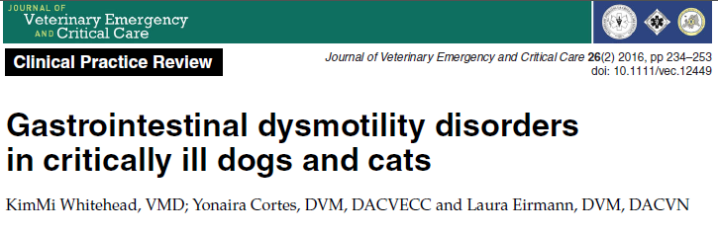
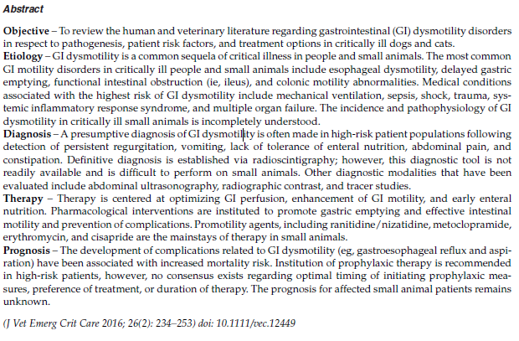
Take-Homes:
- Manifestations and Complications of GIDM include Ingesta or food bolus stasis and Disruption of absorption, which leads to GERD, Esophagitis, Aspiration, Bacterial overgrowth, abdominal distention, fluid shifts, and delayed nutrition
- Treatment of GIDM include early enteral nutrition, fluid therapy aimed at avoided hypo or hypervolemia, correction of systemic abnormalities, and pharmacotherapies

- The most common GI motility disorders in critically ill human and small animal veterinary patients:
  - esophageal dysmotility
  - delayed gastric emptying
  - functional intestinal obstruction (ie, ileus)
  - colonic motility abnormalities
- GI tract excitatory neurotransmitters
  - **Acetylcholine**
    - Primary neurotransmitter of parasympathetic system
  - Substance P
  - Neurokinin A
  - Serotonin
- GI tract inhibitory neurotransmitters
  - Vasoactive intestinal peptide (VIP)
    - Very inhibitory peptide
  - Somatostatin
    - somato-Stasis
  - Nitric oxide
    - NO movement
  - GABA

- Esophagus
  - Dogs - all skeletal muscle
  - Cats - distal smooth muscle
- Average small intestinal transit time of
  - 3–5 hours in healthy dogs
  - 2–3 hours in healthy cats

GIDM

- Complications
  - aspiration pneumonia
  - Esophagitis
  - feeding difficulties
  - increased risk of bacterial translocation and sepsis
  - increased intraabdominal pressure (IAP)
- Drugs that induce esophageal inhibition
  - Ketamine
  - Benzodiazepines
  - Opioids
- Delayed gastric emptying theories
  - Decreased motor activity “pump failure”
  - Increased inhibitory input “Excessive feedback”
    - Appears to be gaining support
- Risk Factors
  - Primary GI disease
  - Secondary
    - Peritonitis
    - Pancreatitis
    - Stress
    - Electrolyte derangements
    - Metabolic/endocrine disturbances
    - Drugs
      - Opioids
      - Alpha-2s
      - Vasopressors
    - Diabetes
    - Hypoperfusion
    - Hypoxemia
    - Obesity
    - SIRS/Sepsis
    - Neoplasia
    - TBI
- Manifestations and Complications of GIDM
  - Ingesta or food bolus stasis
    - GERD
    - Esophagitis
    - Aspiration
    - Bacterial overgrowth/translocation
      - In people with SIRS,investigators found that GIDM was associated with altered gut flora as well as with higher septic mortality
    - Bloat/distention
  - Disruption of absorption
    - Fluid sequestration
      - Hypovolemia
    - Delayed nutrition
- Diagnostics
  - Nothing very good, many things have been studied
  - Tends mostly to be clinical suspicion
- Treatment
  - Treatment of underlying condition
  - Early nutrition
    - Improving blood flow to the gut
    - protecting the GI mucosa
    - reducing the risk of translocation of intestinal bacteria
    - stimulating motility
    - promoting secretion of various gut hormones and growth factors
  - Judicious fluid therapy
    - Minimize gut edema
  - Early ambulation
    - No supporting evidence
  - Correction of metabolic derangements
  - Normothermia
  - Multimodal pain management
  - Pharmacological intervention
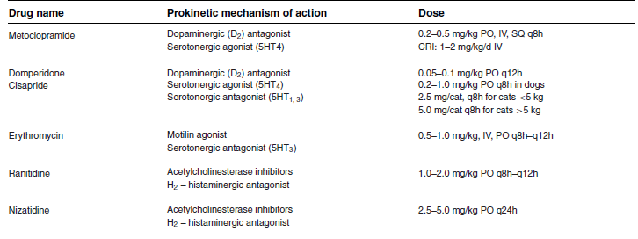
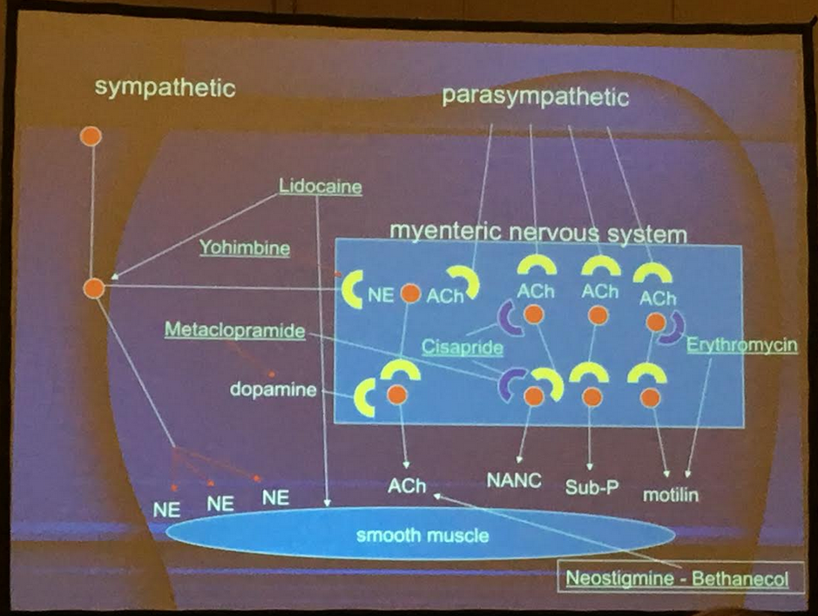

Questions:

- Match the following GI medications with the mechanism of action (note, some drugs may have multiple matches)

Metoclopramide Acetylcholinesterase inhibitor

Erythromycin Motilin agonist

Lidocaine Direct smooth muscle stimulation

Cisapride Dopaminergic antagonism

Ranitidine serotonergic agonism (5HT₄)

Serotonergic antagonism (5HT₃)

Histamine antagonism (H₂)

2. The average small intestinal transit time in the healthy dog is _______, compared with the healthy cat, which is _____.

- 3-5 hours; 4-6 hours
- 3-5 hours, 2-3 hours
- 2-3 hours, 3-5 hours
- 4-6 hours, 3-5 hours

3. Fill in the boxes
GI stimulatory neurotransmitters | GI Inhibitory neurotransmitters

4. Name 6 risk factors for GI dysmotility according to both human and veterinary research

Questions:

- Match the following GI medications with the mechanism of action (note, some drugs may have multiple matches)

Metoclopramide Acetylcholinesterase inhibitor
(ranitidine)

Erythromycin Motilin agonist
(Erythromycin)

Lidocaine Direct smooth muscle stimulation
(Lidocaine)

Cisapride Dopaminergic antagonism
(Metoclopramide, cisapride)

Ranitidine serotonergic agonism (5HT₄)
(metoclopramide, cisapride)

Serotonergic antagonism (5HT₃)
(metoclopramide, cisapride,
erythromycin)

Histamine antagonism (H₂)
(Ranitidine)

2. The average small intestinal transit time in the healthy dog is _______, compared with the healthy cat, which is _____.

- 3-5 hours; 4-6 hours
- 3-5 hours, 2-3 hours
- 2-3 hours, 3-5 hours
- 4-6 hours, 3-5 hours

3. Fill in the boxes
GI stimulatory neurotransmitters | GI Inhibitory neurotransmitters
Acetylcholine | Vasoactive intestinal peptide
Substance P | Nitrous Oxide
Neurokinin A | somatostatin
Serotonin | GABA

4. Name 6 risk factors for GI dysmotility according to both human and veterinary research
Primary GI disease, Peritonitis, Pancreatitis,Stress,Electrolyte derangements, Metabolic/endocrine disturbances,Opioids, Alpha-2s, Vasopressors, Diabetes, Hypoperfusion, Hypoxemia, Obesity, SIRS/Sepsis, Neoplasia, TBI

