Small animal gastroenterology - Chapter 7 p.241-245

Key Points
- The liver has a dual blood supply (hepatic a and portal v)
- The total blood flow to the liver accounts for about 20–25% of the cardiac output
- With deficient hepatic oxygenation, the liver adapts by an increased efficiency of oxygen uptake from approximately 40% up to nearly 100%

Summary
- Anatomy
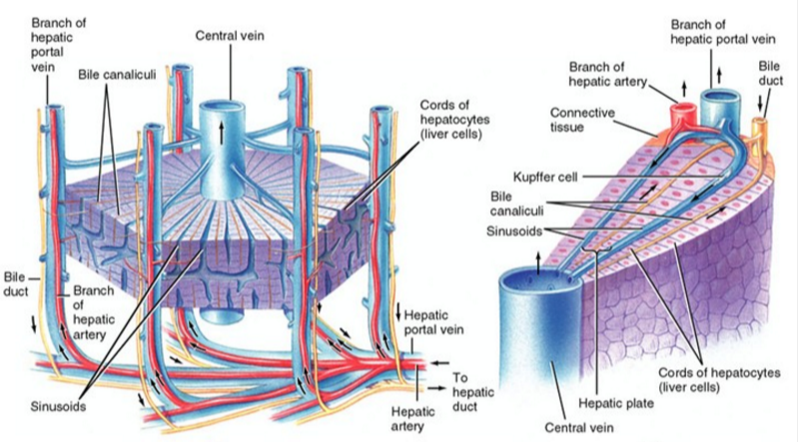
  - The shape of the liver in dogs and cats is different from that of most other mammals such as cattle, horses, and humans
  - The domesticated carnivores have deeply incised lobes, which are individually recognizable, whereas they are largely fused in other species
  - The deeply separated lobes, which connect at the hilus of the liver, make it relatively easy to resect an entire liver lobe in dogs and cats
  - The largest liver lobe is the left lateral lobe, which encompasses 30–40% of the entire liver mass
    - Easiest one to approach for the collection of liver biopsies
  - In dogs, the liver lies entirely within the rib cage and, therefore, is normally not palpable
  - In healthy cats, the ventral border of the liver can often be palpated and the feline liver is always palpable when enlarged
  - The stomach is in contact with the visceral surface of the liver
    - Changes in size or shape of the liver cause displacement of the stomach
    - This is one possible explanation why vomiting is often a major clinical sign in patients with liver disease
- Biliary system
  - The biliary system is a branched tree, which serves as a collection system for bile from each individual hepatic cell
  - In each hepatic lobule, the hepatocytes are organized in liver cell plates, which radiate around a central vein
    - These hepatocyte plates connect the central vein with several portal areas
    - Blood flows from the portal areas to the central vein, while bile flows from the central areas to the portal areas and the common bile duct
  - The lateral membranes connecting adjacent liver cells contain a specialized region, the canalicular membrane
  - The space between the canalicular membranes of adjacent cells is sealed by tight junctions and forms the smallest branches of the biliary system, the canaliculi
    - This excretory region of the hepatocyte membrane constitutes 15% of the hepatocellular surface
    - Most molecules are excreted across this membrane by their own specialized transporters, which can actively excrete against a very high concentration gradient
  - Bile is excreted by hepatocytes into the canaliculi, which then transport the bile to the portal tracts where they enter the canals of Hering
    - These short connecting ducts are in part lined by hepatocytes, in part by cuboidal cholangiocytes
    - Some of the cells of the canal of Hering are the stem cells of the liver, which can differentiate into hepatocytes as well as cholangiocytes, and thus function as stem cells for all the main cell types of the liver
      - These hepatic progenitor or stem cells are also called oval cells
      - All hepatocytes have an enormous capacity to divide and thus allow for regeneration of the liver mass after loss due to damage
  - The common bile duct runs to the duodenum and enters the major duodenal papilla 3–6 cm caudal to the pylorus
  - The junction of the common bile duct and the duodenum (Vater’s papilla), is located close to the head of the pancreas and is surrounded by the muscular sphincter of Oddi
  - Cats: the pancreatic duct and the common bile duct merge and enter the duodenum together on the major duodenal papilla
    - This may explain why in cats concurrent pancreatitis and cholangiohepatitis/cholangitis occur quite frequently
  - Dogs: the bile duct and the pancreatic duct usually end separately in dogs
    - The gallbladder is connected with the common bile duct via the short cystic duct
  - The gall bladder provides the main storage facility for bile and concentrates the bile approximately tenfold
  - Bile is also concentrated in the larger bile ducts
  - In healthy dogs and cats, a completely filled gallbladder contains around 1 ml of bile/kg body weight
    - Less than half of the bile produced is stored and concentrated
    - The remainder is immediately transported into the duodenum via the common bile duct
    - Stimulation of the muscular wall of the gall bladder to contract (by cholecystokinin released from the duodenal mucosa) produces a gradual release of bile that lasts for several hours
      - The bile then enters the duodenum by rhythmic relaxations of the sphincter of Oddi
    - Emptying of the gall bladder is very variable and almost never complete
      - An empty gall bladder during ultrasonography is an abnormal finding
      - Opioid drugs can cause complete closure of the sphincter of Oddi, so that during anesthesia the gall bladder may appear dilated; this usually resolves after anesthesia
- Blood Supply
  - Arterial blood comes from the hepatic artery, while venous blood is supplied through the portal vein
  - Outflowing blood is collected by a number of hepatic veins that enter into the inferior vena cava near the diaphragm
  - The total blood flow to the liver accounts for about 20–25% of the cardiac output (100–130 ml/min/100 g liver tissue)
  - The portal vein accounts for 70% of the total blood flow to the liver and separates into two main branches entering the liver at the hilus
    - The right branch of the portal vein supplies the right side of the liver, while the bigger and longer left branch supplies the left and central portions of the liver
  - The biliary system is only supplied with arterial blood
  - Sinusoidal blood enters the central veins, also known as terminal hepatic veins (THV), in the liver lobule
    - The central veins then drain into branches of the hepatic vein
    - Several branches of the hepatic vein then enter into the caudal vena cava
  - In patients with diseases that are associated with a severely decreased or total lack of portal blood flow (i.e., congenital portosystemic shunts, portal vein thrombosis), the arterial blood flow may increase by 100% though total hepatic blood flow still remains subnormal
    - Changes in arterial blood flow do not affect portal blood flow
  - When the oxygenation of the liver becomes deficient (decreased erythrocyte oxygen binding or hypoperfusion), the liver adapts by an increased efficiency of oxygen uptake from approximately 40% up to nearly 100%
    - Hypoxia does not affect the total perfusion of the liver or the ratio between arterial and portal blood supply
  - Due to the large volume and the compliance of the hepatic vascular bed approximately 10–15% of the total blood volume is contained in the liver
    - This may increase by 100% in patients with severe congestive heart disease
    - The large hepatic blood reservoir helps compensate for acute blood loss
  - Histological level:
    - The arteries and portal vein branches enter the liver via the portal areas
      - Portal blood is distributed from the larger portal veins throughout the acinus and drains into the sinusoids via short perpendicular inlet venules, which have a sphincter function and regulate the portal blood flow into the capillary bed
    - Acini: the functional hemodynamic units of the liver
      - Anatomically descriptive units
      - The portal vein is at the center of the acinus with several central veins (THV) at the periphery
      - The liver circulatory units are divided into three zones
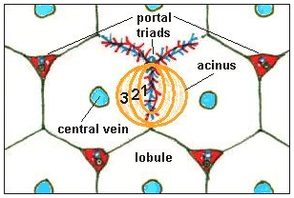
        - Zone 1: Closest to the portal area, receives blood with the highest contents of oxygen, growth factors, and nutrients
        - Zone 3: Farthest from the portal area, receives blood with the lowest concentrations of these compounds
        - With sudden hypoxia or shock:
          - Without sufficient time for compensation by increasing the oxygen binding of red blood cells or a more efficient oxygen uptake by the liver, the hepatocytes located in Zone 3 become necrotic
            - Results in centrolobular (Zone 3) hepatocellular necrosis
            - Increases in serum hepatic enzymes
    - Predominant cell type of the liver is the epithelial cell or hepatocyte
      - Hepatocytes make up 60% of the all the cells in the liver
      - They are also the largest cell type found in the liver and make up 80% of the liver volume
    - Other cell types that are present in the liver:
      - Endothelial cells
      - Bile duct epithelial cells
      - Kupffer cells
      - Fat-storing cells (stellate cells)
  - The perisinusoidal space represents the beginning of the hepatic lymphatic system and leads lymph in a direction opposite to that of the blood flow, but in conjunction with the bile flow
  - The liver is an important guardian against toxic substances entering the body from the GI tract
    - The sinusoidal cells (endothelial and Kupffer cells) are very efficient in removing endotoxins and particles, such as bacteria
    - Many detoxifying metabolic functions of the hepatocytes
    - Biliary excretion of toxic substances, make
- Physiology
  - The liver has an enormous reserve capacity
  - Removal of up to 70% of the normal liver can be sustained without any clinical effect
  - Liver cells can divide more than 40 times
    - Theoretically has the capacity to completely renew itself a number of times
    - However, the regenerative capacity is decreased when the liver is diseased
      - With disease, there is a tendency to produce hepatic fibrosis
  - The supply of portal blood is essential for maintaining hepatic functional mass and regeneration
  - Animals with congenital portosystemic shunts experience a reduced hepatic growth resulting in an undersized and hypofunctional liver
    - Usually grows to its normal size and weight within two weeks after surgical ligation of the shunt
  - The liver is also capable of hematopoiesis

QUESTIONS
- The portal triad consists of what three structures?
- Which liver lobe is the most ideal to sample (for diffuse hepatic disease), and why?
- Why does the liver have such great regenerative capacity?
ANSWERS
- The portal triad consists of what three structures?
  - Hepatic a., portal v., bile duct
- Which liver lobe is the most ideal to sample (for diffuse hepatic disease), and why?
  - Left lateral as it is largest, and the periphery is devoid of vessels or important structures
- Why does the liver have such great regenerative capacity?
  - Some of the cells of the canal of Hering are the stem cells of the liver, which can differentiate into hepatocytes as well as cholangiocytes, and thus function as stem cells for all the main cell types of the liver

