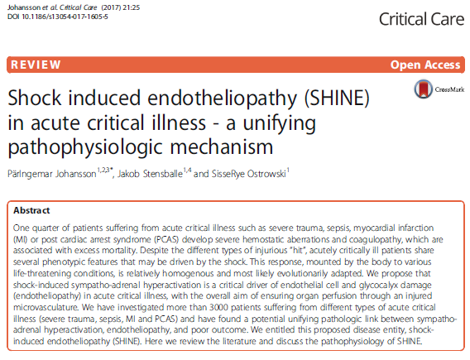
- Endothelial cells form the innermost lining of all blood vessels and lymphatic vessels
- Functions:
  - Vasomotor control
  - Maintenance of blood fluidity
  - Regulated transfer of water, nutrients and leukocytes across vascular wall
  - Innate and acquired immunity
  - Angiogenesis
- Endothelium is anticoagulated by:
  - natural anticoagulants
  - glycocalyx, negatively charged surface, rich in heparonoids and interacts with antithrombin)
  - Tissue factor pathway inhibitor (TFPI) and protein C/thrombomodulin syst
  - Endothelial release of tissue-type plasminogen activator (tPA) and urokinase-type plasminogen activator
- Shedding, degradation and/or release of the glycocalyx from the injured endothelium induces profound hypocoagulability in acutely critically ill patients with shock
- Shock-induced endotheliopathy (SHINE)
  - Traumatic shock
  - Septic shock
  - Cardiogenic shock and cardiac arrest

- SHINE may be a unifying pathophysiological mechanism, linked to outcome
  - Sympatho-adrenal hyperactivation – Endothelial phenotype
- Chemical sympathectomy and beta blockade attenuate endothelial damage in rats

