Respiratory Acid Base Disorders in the ICU

- Respiratory acidosis leads to increased CBF and ICP
- Respiratory acidosis leads to translocation of K+ from inside the cell to outside the cell and release of calcium from albumin
- Respiratory acidosis leads to bronchodilation and hypoxic pulmonary vasoconstriction

Respiratory Effects

- ↑ P_{a}CO₂ reflects ↑ P_{A}CO₂ and ↓ P_{A}O₂ (opposite for ↓ P_{a}CO₂)
  - P_{a}CO₂ > 80 mmHg at FiO₂ of 21% indicates life threatening hypoxemia
  - P_{a}CO₂ > 60 mmHg is considered severe hypercapnia
    - In order to improve V/Q mismatch and optimize gas exchange
      - Bronchodilation
      - ↑ hypoxic pulmonary vasoconstriction
    - ↓ P_{a}CO₂ will also cause bronchodilation but will inhibit hypoxic pulmonary vasoconstriction
  - ↓ pH
    - respiratory acidosis: shift of oxyhemoglobin curve to the right
    - respiratory alkalosis: shift of oxyhemoglobin curve to the left
- Mechanical Ventilation
  - ARDS “lung protective ventilation” to limit alveolar ventilation. This causes respiratory acidosis and ↑ P_{a}CO₂ (permissive hypocapnia)
    - Small tidal volume
    - Moderate to high end expiratory pressures
  - Permissive hypocapnia also utilized in asthma and COAD

Nervous System

      - ↓ pH
        - Alters CBF, neuronal function, consciousness and may cause seizures
      - ↑ P_{a}CO₂
        - cerebral vasodilation
        - ↑ CBF
        - ↑ ICP
        - P_{a}CO₂ > 90-120 mmHg leads to hypercapnic narcosis
          - Obtundation, loss of consciousness
      - Alkalosis would lead to vasoconstriction and ↓ ICP
- Brain Disease considerations for CC
        - Loose central control of ventilation, consider mechanical ventilation
        - Consider therapeutic hypocapnia for ↑ ICP
          - Human trials show brain ischemia and poor outcomes
          - Transient therapeutic hypocapnia P_{a}CO₂ ≥ 25 mmHg
Cardiovascular System

      - ↓ pH
        - ↓cardiac contractility, increased vasodilation
      - ↑ P_{a}CO₂
        - ↑ catecholamine release leading to systemic vasoconstriction and increased CO
      - This combination leads to an unpredictable effect

Electrolytes

- Acidosis causes translocation of K+ from intracellular to extracellular in exchange for H+ leading to increase in [K+] extracellular
- Acidosis leads to release of ionized calcium from albumin leading to an increase in [iCa]
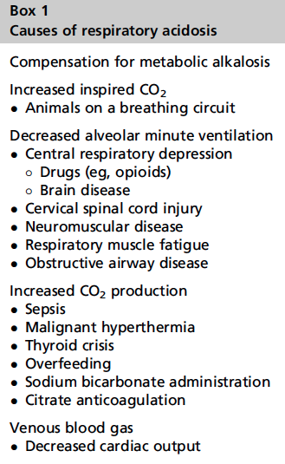
Immunomodulatory

- Unclear if harm versus benefit
- ↓ WBC migration, ↓ phagocytosis, ↓proinflammatory cytokine release

Respiratory acidosis

- Alveolar ventilation inadequate relative to CO2 production
  - Monitor with drugs that cause respiratory depression (fentanyl CRI) or with conditions causing respiratory fatigue
  - Monitor ETCO₂ in intubated patients
- Treatments
  - Supplement O2 if P_{a}CO₂ > 60 mmHg
  - Mechanical ventilation if severe, sustained, progressive
  - Treat underlying disease

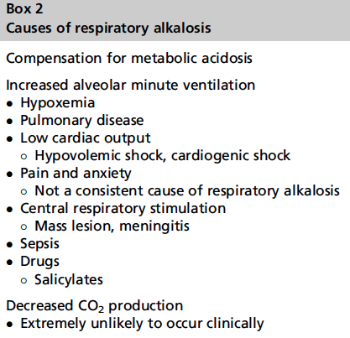
Respiratory Alkalosis

- Alveolar ventilation excessive to production of CO₂
  - More frequent than respiratory acidosis
  - Usually due to increase in alveolar ventilation
  - Central respiratory center or chemoreceptor stimulation
  - Monitor blood gas and SpO₂
- Treat the primary cause

Questions:

- In a patient that presents for dyspnea of 24 hours duration with a P/F ratio of < 100 mmHg and radiographs consistent with pulmonary edema that is not cardiac in nature, what mechanical ventilation strategies should be used?

- An elevated P_{a}CO₂ is detected on the arterial blood gas for a patient who presents obtunded with a cervical spinal cord injury. How did the elevated P_{a}CO₂ contribute to altered mentation?
- In a patient that presents for dyspnea of 24 hours duration with a P/F ratio of < 100 mmHg and radiographs consistent with pulmonary edema that is not cardiac in nature, what mechanical ventilation strategies should be used?
  - Lung protective ventilation
    - Low tidal volume
    - Moderate to high end expiratory pressures
- An elevated P_{a}CO₂ is detected on the arterial blood gas for a patient who presents obtunded with a cervical spinal cord injury. How did the elevated P_{a}CO₂ contribute to altered mentation?
  - Increases in CBF and ICP

