ROSE Page 355

KEY POINTS
- Correction of alkalosis in volume depleted patient requires administration of reabsorbable anion (Cl-) eg as NaCl, HCl or KCl
  - Administration of non-absorbable anions will not be effective
- Hypokalemia tends to increase net acid excretion and so promotes metabolic alkalosis
- After several days respiratory compensation results in alterations in bicarb reabsorption and so pH becomes like it is not compensated

CHLORIDE DEPLETION:
- Often occurs with metabolic alkalosis
- Chloride is lost through vomiting, diuretics etc
- Hypochloremia -> decreased filtered Cl- -> enhanced H+ secretion and bicarb reabsorption
- In volume depletion sodium reabsorption is enhanced
  - When there is no remaining chloride to reabsorb in the urine sodium reabsorption is accompanied by H+ or K+ secretion to maintain electroneutrality (primarily in collecting tubules)
  - Therefore if hypochloremic there is a net enhanced H+ secretion and bicarb reabsorption, so metabolic alkalosis persists
- In euvolemic patient there will be less drive to reabsorb sodium, and so chloride reabsorption may be adequate for electroneutrality
- When hypovolemic with metabolic alkalosis administering acid may not correct alkalemia if the anion is non-absorbable
- More appropriate method of correcting alkalemia is to enhance bicarb excretion
  - Expand volume with NaCl -> excretion as sodium bicarbonate

- Local Cl- concentration may also influence bicarb secretion in collecting tubule, and H+ secretion in distal nephron
  - Increasing tubular Cl concentration increases the inward gradient for chloride
    - This increases the activity of Cl-Bicarb exchanger
    - Therefore decreased chloride results in decreased bicarb secretion, favoring alkalosis
  - Decreased tubular Cl concentration increases the activity of H+-ATPase pump, resulting in increased acid secretion

PLASMA POTASSIUM SECRETION
- Reciprocal relationship between plasma K+ concentration and bicarb reabsorption
  - Decreased plasma potassium results in extracellular shift
    - H+ and Na+ then enter cell -> intracellular acidosis of renal tubular cells
- Enhanced H+ secretion & bicarb reabsorption -> systemic alkalosis
  - NH4+ may be substituted for K+ on NaK2Cl
    - In hyperkalemic patients this may be inhibited and so ammonia excretion is increased
  - NaKATPase is stimulated in hypokalemia and so potentiates distal hydrogen secretion -> alkalosis

PARATHYROID HORMONE
- PTH is stimulated when there is a net acid load
- Diminishes proximal bicarbonate reabsorption by reducing luminal Na+H+ exchanger activity and sodium bicarbonate cotransporter
  - Additional bicarb is then mostly reabsorbed
  - Phosphate excretion is enhanced (and buffered with H+) -> net acid excretion
- PTH also promotes bone buffering

AFFECT OF ARTERIAL PH ON VENTILATION
- CO2 levels act as primary stimulus to respiration
  - Primarily in chemosenstive areas in brain stem respiratory center
  - O2 is sensed in peripheral chemoreceptors of carotid body

RESPIRATORY COMPENSATION
- Metabolic acidosis can cause minute ventilation to increase 6x
  - Carotid bodies sense reduction in pH
  - As PCO2 falls CSF pH actually initially elevates as CO2 rapidly crosses BBB but HCO- does not
    - -> diminished ventilator response
  - As academia persists cerebral pH will fall, so full hyperventilation can be seen within 12-24hrs
- Reverse is true in metabolic alkalosis
- Can compensate to decrease the danger or pH disturbances

LIMITATIONS
- Eventually changes in PCO2 alter renal bicarb reabsorption, so after several days extracellular pH is the same as it would be without compensation

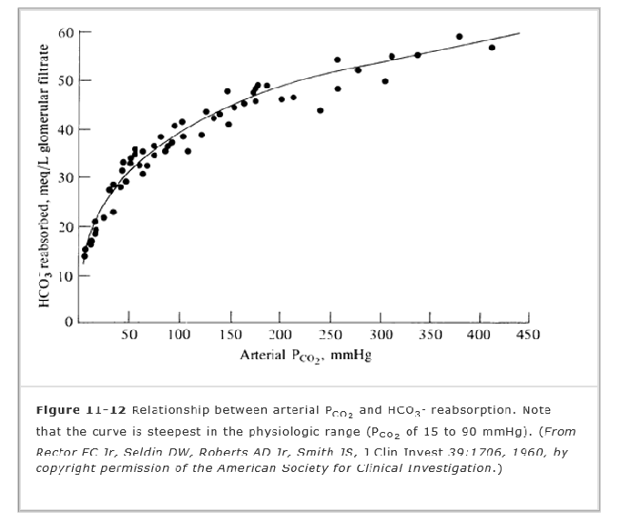

QUESTIONS:
- A 2 year old FS golden retriever has had a duodenal obstruction diagnosed on abdominal ultrasound, and was transferred to your hospital for further care and surgery. On presentation she is assessed to be hypovolemic and her venous blood gas shows a hypochloremic metabolic alkalosis. Explain the physiologic mechanism by which her alkalosis is likely to persist if she is not adequately volume resuscitated.
- Describe 1 way in which hypokalemia may potentiate an alkalosis
- TRUE or FALSE: Parathyroid hormone secretion is enhanced when there is a net acidosis
- Why is respiratory compensation for a metabolic acidosis less effective in neutralizing pH after 5 days of acidosis?

ANSWERS:
- Hypovolemic patients resorb sodium. To maintain electroneutrality this must be accompanied by (1) chloride resorbtion or (2) cation secretion. With enhanced sodium resorbtion there is not enough chloride in urine to match this (110 mEq/L vs 150mEq/L) and so there is a net increase in H+ secretion.

- Stimulation of NAKATPase resorbing cations, so increased H+ secretion OR extracellular potassium shift -> intracellular shift of H+/Na+ -> increased gradient between cells and tubule -> Increased H+ secretion OR Substitution of NH4+ on NAK2Cl pump so decreased secretion of ammonia

- True

- Lower pCO2 levels results in decreased bicarb reabsorbtion

