1. You are presented with a 5 year old male castrated pit bull terrier that has been diagnosed with acute hemorrhagic diarrhea syndrome. The patient has been stabilized in the ER and is now euvolemic and euhydrated. A fecal smear reveals the following:
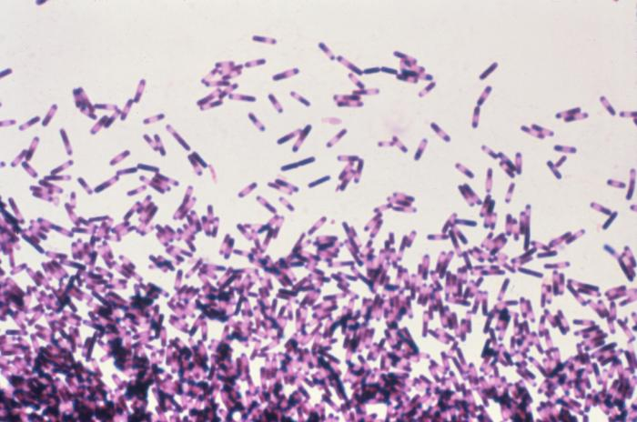

The patient has had a previous hypersensitivity reaction to metronidazole. Which of the following would be an appropriate antimicrobial choice?

- Cepodoxime PO
- Amikacin IV
- Vancomycin PO
- Doxycycline PO

2. Please provide a short explanation regarding the proposed mechanism for the synergistic effects of beta lactam antibiotics and amikacin
3. Doxycycline has anti-inflammatory properties due to its inactivation of which of the following:
- Nuclear factor kappa-B
- IL-6
- Matrix Metalloproteinase
- TNF-alpha

Answers:
1 – c
2 – Amikacin has to obtain intracellular access to be effective as an antimicrobial, and the ability of the drug to enter bacterial cells is enhanced by the cell wall defects caused by beta lactam antibiotics
3 - c

