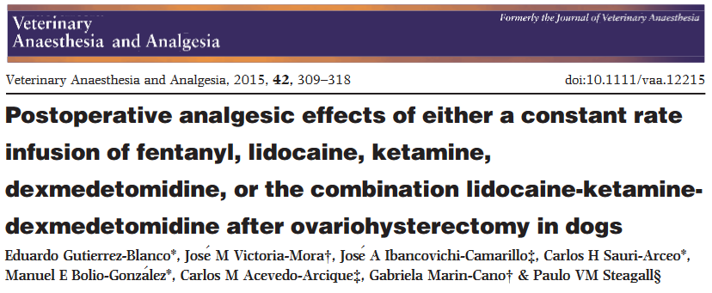

Major Take-homes

- Fentanyl was only sole agent that provided sufficient post-op analgesia for spay dogs

Study Design
- Fent at 10mcg/kg bolus, 5mcg/kg/hr intraop, 2.5mcg/kg/hr post op
- Ketamine at 1mg/kg bolus, 40mcg/kg/min intraop, 10mcg/kg/min post op
- Dexmed 1mcg/kg bolus, 3mcg/kg/hr intraop, 1mcg/kg/hr post-op
- Lidocaine (2mg/kg, 100mcg/kg/min, 25mcg/kg/min) + ketamine (same as above) + dexmed (same as above)

Pain assessed with Glascow, melbourne and numerical rate scaling pain systems

Conclusion:
“At the doses administered and based on the prevalence of rescue analgesia, LKD and FENT provided effective analgesia in this study. LIDO, KET and DEX may not be effective as a sole analgesic for treatment of postoperative pain in dogs after ovariohysterectomy.”

