Pathophysiology of the Hepatobiliary System

SUMMARY
- BUN is synthetized in the liver primarily through the urea cycle, with a backup scavenging glutamine cycle, which becomes more active in the face of acidosis
- Creatinine levels can be decreased due to liver methylation reactions in the liver
- Hypoalbuminemia in liver disease is multifactorial due to decreased or suppressed synthetic capacity, increased distribution into ascites, malnutrition, negative acute-phase protein
- Hypokalemia and hypophosphatemia can be present in liver disease

Influence of Liver Function on Blood Urea Nitrogen and Serum Creatinine
Urea Synthesis
- Liver detoxifies waste N in 2 biochemical cycles, converting its primary waste product ammonia (NH3) to an excretable for (Urea).
- Hepatic NH3 detox occurs in designated acinar zones
  - Urea cycle: Occurs in Zone 1 – Periportal, produce the majority of urea synthesis, low affinity, high capacity system, dominates in the face of alkalosis
  - Glutamine cycle: Occurs in Zone 3 – Perivenous, backup system – scavenging residual NH3, high affinity, low capacity system, dominates in the face of acidosis
    - Detox of NH3 through glutamine synthesis occurs in muscle and is temporary, except in kidney where glutamine is metabolized to release NH3 into urine
- Bun is directly affected by hepatic urea synthesis, it can also be affected by
  - Dietary protein restriction
  - Expanded volume of distribution for urea: hypoalbuminemia, third-space fluid accumulation, splanchnic and systemic vasodilation
  - Increased water turnover - PU/PD
Creatinine Synthesis
- Creatine is derived from arginine and lysine, synthesized through 2 steps:
  - Glycine amidinotransferase – in several organs
  - Transfer of a methyl group from SAMe – in the liver
- Insufficient methylation reactions > subnormal serum creatinine concentrations
- 98% creatine in muscles

Hypoalbuminemia in Liver Disease
- Serum Alb < 1.5 g/dL alters Starling’s forces and favors loss of fluid from the vascular space
- Multifactorial
  - Decreased synthetic capacity or suppressed by inflammatory mediators
    - Supression is inversely proportional to the rate of acute-phase protein synthesis
  - Increased distribution into ascites
  - Malnutrition
  - Negative acute-phase protein
- Not accompanied by hypoglobulinemia, globulins are usually increased due to:
  - α-globulin increase due to increased systemic exposure to gut-derived antigens, microorg. and debris normally removed by Kuppfer cells
  - Increase in acute-phase proteins
  - Haptoglobin, fibrinogen, antithrombin III tend to be abnormally low in end stage liver failure
- Protein C decreases in PSS and severe hepatic insufficiency
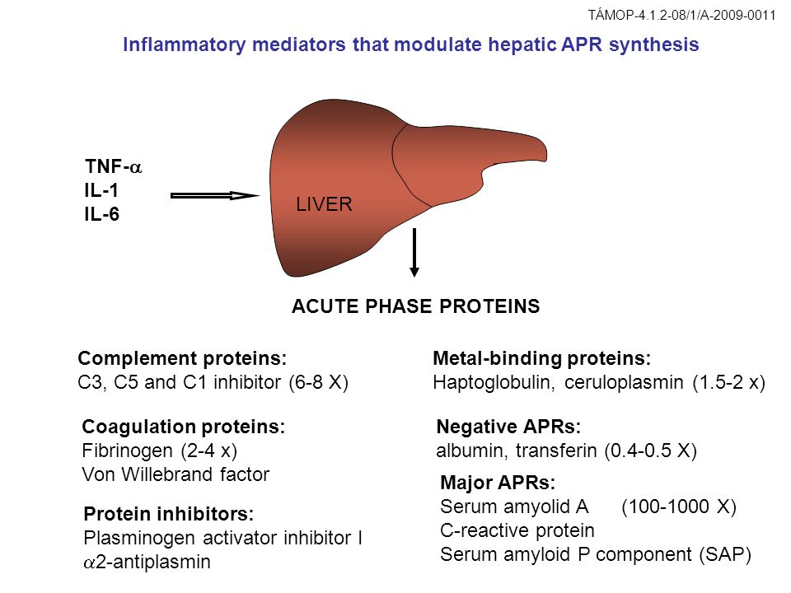
Serum Electrolytes
Hypokalemia in Liver Disease
- Hypokalemia is asscociated with hepatic insufficiency due to
  - Insufficient energy intake
  - Enteric losses
  - Loop diuretic use
  - Secondary hyperaldosteronism
- Hypomagnesemia can complicate hypokalemia by potentiating kaliuresis through its effects on aldosterone
- Prognosis for cats is worse with hepatic lipidosis and hypokalemia
- In people infusion of KCl in hypokalemic patients improved CNS function in early HE
- Renal ammoniagenesis is stimulated by low serum potassium concentrations
- K deficiency:
  - Stimulates H+ secretion in the distal nephron and may stimulate HCO3 production by increasing collecting duct expression of an H+/K+ ATPase that facilitates reabsorption of K in exchange for H
  - Increases luminal electronegativity in the proximal tubule stimulating HCO3 secretion
Hypophosphatemia in Liver Disease
- Hyperphosphatemia is predictive of poor recovery in people
- Cats with HL are at increased risk of developing hypophosphatemia, especially when associate with DM or pancreatitis
- Hypophosphatemia is thought to reflect intracellular shifts of P in liver disease
- Can produce clinical signs (<1.5 mg/dL) weakness, vomiting, gastric atony, hemolysis, bleeding tendencies, hemolytic anemia and neurologic signs
- Mechanism of hemolysis: hypophosphatemia results in depletion of RBC phosphorus and RBC ATP, this leads to RBC mb abnormalities converting RBC from a deformable, biconcave disc to a rigid spherocyte or echinocyte, increasing RBC destruction in microvasculature
- Muscle weakness may be severe enough to affect ventilation > resp failure and acidosis

Questions:

- Draw how the following acute phase proteins increase or decrease their plasma concentrations over time.
- C- reactive protein
- Haptoglobin
- Fibrinogen
- Albumin
- Transferrin
- Serum amyloid A

- What is the mechanism of action of hypophosphatemic hemolytic anemia?

- T or F: Cats with hepatic lipidosis and diabetes mellitus have an increased risk of developing hypophosphatemia

Answers:

- Draw how the following acute phase proteins increase or decrease their plasma concentrations over time.
- C- reactive protein
- Haptoglobin
- Fibrinogen
- Albumin
- Transferrin
- Serum amyloid A

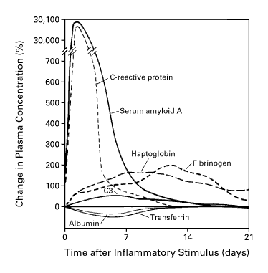
- What is the mechanism of action of hypophosphatemic hemolytic anemia?
Hypophosphatemia results in depletion of RBC phosphorus and RBC ATP, this leads to RBC mb abnormalities converting RBC from a deformable, biconcave disc to a rigid spherocyte or echinocyte, increasing RBC destruction in microvasculature

- T or F: Cats with hepatic lipidosis and diabetes mellitus have an increased risk of developing hypophosphatemia

