Oral Activated Charcoal in the Treatment of Intoxications

Summary
- Use activated charcoal as soon as possible
- Consider multiple doses of activated charcoal due to enterohepatic recirculation, absorption of secreted metabolites, desorption

Activated charcoal is an insoluble powder produced by pyrolysis of organci materal that can adsorb a variety of drugs and toxic agents to its surface
Factors affecting the antidotal efficacy of activated charcoal
- Effects of physicochemical properties
  - Pore size and surface area of charcoal > larger pores = increased adsorption capacity
  - Modern activated charcoal have a large surface area 1000-3500 m²/g (usual antidotal dose for adults has an area of more than 10 football fields!)
- Effects of pharmaceutical formulation
  - Water suspensions are superior to coated charcoal tablets as an antidote
- Effects of chemical nature and formulation of agents ingested in intoxications
  - Rapid absorbing formulations
  - Slow release formulations – use with sorbitol may decrease serum drug concentrations further
- Effects of charcoal dose
  - According to the mass law there is an equilibrium between free and adsorbed toxin
  - The higher the charcoal toxin ratio, the more complete is the adsorption
  - At a ratio of 10: I, 90 to 100%of most substances are adsorbed in optimum in vitro conditions
  - Too large doses may produce vomiting and aspiration pneumonia or other side effects depending on additional ingredients (NaHCO3, sorbitol or ethanol)
- Effect of pH
  - Compounds are best absorbed to charcoal in their undissociated form
    - Acids at a low pH and Bases at a high pH
    - Changing the gastric pH had no significant effect on antidotal efficacy
- Gastointestinal contents
  - Impairs adsorption of drugs to activated charcoal
  - Food somewhat impairs adsorption capacity, but gives charcoal more time to adsorb drugs in the GI tract by slowing gastric emptying
  - Ethanol in vitro affects affects adsorption, but not in vivo
- Effects of stability of the charcoal-toxin complex
  - Binding is reversible
  - Single dose activated charcoal can lead to prolonged half-life since it adsorbs and later desorbs, potentially being available for absorption again
  - Use of repeated doses of charcoal increases its efficacy

- Time-Effect relationship
  - Should be given as soon as possible – 1st aid kit in people
  - Rate of absorption of toxins is directly related to rate at which these pass from the stomach to the intestines
  - Absorption of drugs in life-threatening overdosages may be prolonged, hence there is no exact time at which charcoal should not be administered to prevent GI absorption in intoxications
- Effects of purgatives and whole-bowel irrigation
  - Minimal evidence that there is substantial benefit from use of purgatives
  - Use of sorbitol was beneficial, however 2/9 subjects developed adverse effects
  - Whole-bowel irrigaton with oral activated charcoal may enhance efficacy – no studies

Mechanism of Enhanced Drug and Toxin Elimination by Multiple Charcoal Doses
- Interruption of enterhepatic recirculation accelerated rate of drug elimination
- Adsorption of active metabolites or conjugates excreted through gastric juices, bile, pancreatic secretions and other GI fluids should also be considered
- Desorbtion should also be considered and multiple doses administered

Toxicity and Side Effects of Activated Charcoal
- Ingestion of large quantities can produce vomiting – aspiration pneumonia
- Both diarrhea and constipation has been seen
- 1 case of charcoal containing empyema
- Electrolyte disturbances

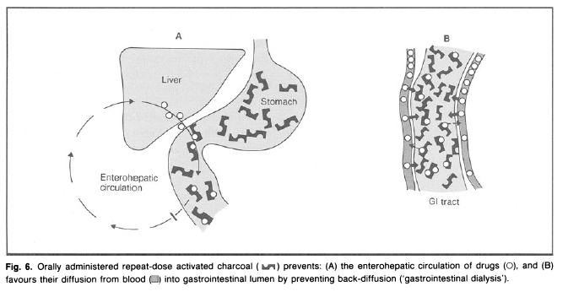

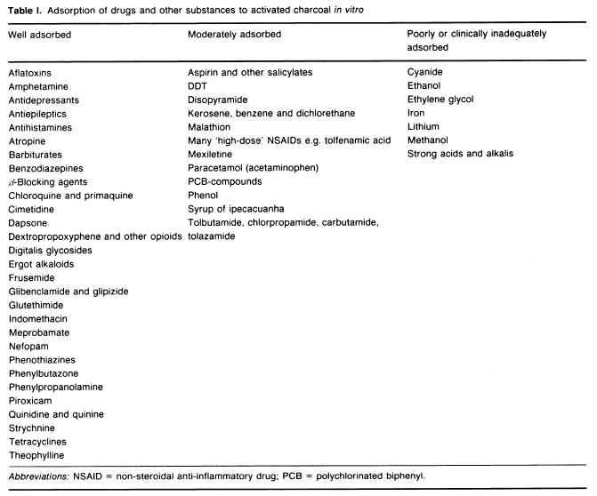

Questions
- What are 3 reasons to consider multiple doses of activated charcoal?
- What is the mechanism of action of activated charcoal induced hypernatremia?
- The following Increase or Decrease adsorption capacity of activated charcoal
Larger pores
Food
Sorbitol
Ratio of 10: I activated charcoal to toxin

Answer
- What are 3 reasons to consider multiple doses of activated charcoal?
- Interruption of enterhepatic recirculation accelerated rate of drug elimination
- Adsorption of active metabolites or conjugates excreted through gastric juices, bile, pancreatic secretions and other GI fluids should also be considered
- Desorbtion should also be considered and multiple doses administered

- What is the mechanism of action of activated charcoal/sorbitol induced hypernatremia?
Loss of hypotonic fluid

- The following Increase or Decrease adsorption capacity of activated charcoal
Larger pores Increase
Food Decrease/Increase
Sorbitol None
Ratio of 10: I activated charcoal to toxin Increase

