Opening pressures and atelectrauma in acute respiratory distress syndrome
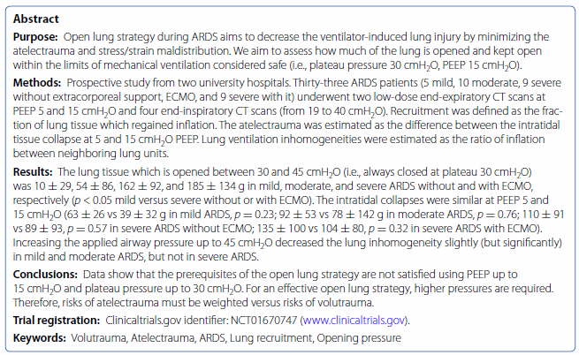
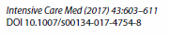
Background:
- Lung protective strategy = high PEEP, low tidal volume
- Determined by lung model, Editorial, experiments on isolated rat lungs later confirmed in patients with ARDS
- Tidal volume reduction has shown benefit, however high PEEPs maybe not so much
- So, maybe atelectrauma is not that much of a thing or the pressures obtained from high PEEP are still not high enough
Prospective study with CT scan to determine lung homogeneity under different PEEPs
- CT Scans at 5cmH2O PEEP with plateaus at 19 and 40
  - Calculated difference in uninflated tissue at PEEP and plateau pressure
- CT scans at 5 and 15cmH2O PEEP with same tidal volumes giving plateaus of 19 and 27
Results:
- Small difference between amount of inhomogeneity in different PEEPS, especially in moderate and severe ARDS and there is still lots of atelectrauma possibly happening.
Conclusion:
Even with PEEPs up to 15, there is still lots of inhomogeneity especially in moderate and severe ARDS and to overcome this, larger tidal volumes and/or higher PEEPs are needed which could result in volutrauma. Authors suggest that the volutrauma is worse than the atelectrauma

