Ocular Emergencies
8/18 Board Review

Key Points
- Luxation of the globe needs immediate protection either by retracting lids over the globe or covering with a lubricating oil
- Lid lacerations require near-perfect appositional technique
- Intraocular FB may not need to be retrieved (bullets/pellets)
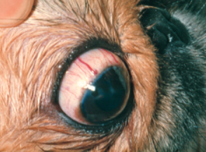

Luxation of the globe
- Luxation: diaplacement of the globe between the palpebral fissures
- Proptosis: forward displacement of the globe
- Exophthalmos: abnormal protrusion of the globe
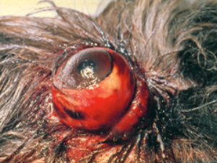
- Arterial supply typically remains intact, while the venous drainage is severed
  - Results in conjunctival edema and erythema
- Severe damage to the cornea due to lack of tear film, exposure to the environment, and physical irritation of entropined haired palpebral contact
- Therapy
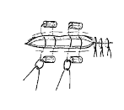
  - Owners to pull palpebrae over the globe or apply salad oil/lubricant and discourage self-mutilation
  - Lateral canthotomy (with or without anesthesia pending mental state)
  - Temporary tarsorrhaphy with mattress sutures and simultaneous globe replacement
    - Do not need to clip hairs around the globe
  - Removal of sutures (medial to lateral) in 10-12 days
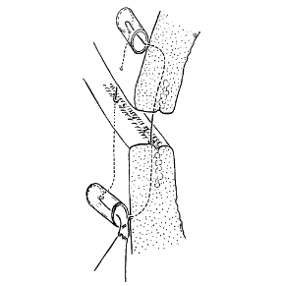
    - If evidence of re-luxation, leave remaining sutures in place for an additional 1-2 weeks
    - Abx, anti-inflammatories, atropine if needed post suture removal
- Tearing of the ocular muscles and damage to the optic nerve is not uncommon
  - Do not try to find and repair torn ocular muscles as likely will not be possible and may result in more trauma
- Prognosis for vision is favorable if luxation present <1-2h (<15m for Pekingese)
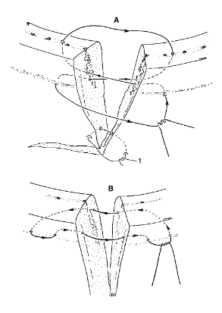
- Complications that may lead to blindness, pthisis bulbi
  - Avulsion of the medial extrinsic muscles or the optic nerve
  - Retinal detachment
  - Hyphema
  - Contusion of the globe
- If very severe damage to the muscles and the optic nerve is present, direct enucleation is usually the best solution
Lid Laceration
- If full-thickness, the wound will increase in size due to contraction of the orbicularis oculi mm
- Near-perfect apposition is required
- General anesthesia, thorough irrigation of the wound margins and globe
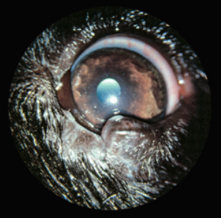
- Minimal debridement indicated due to already scant amount of tissue present
- Figure-of-eight suture pattern, using 5-0 or 6-0 non-absorbable monofilament with a tapered needle
- 1-2mm from lid margin and exiting via the meibomian glands
  - Absorbable only if aggressive patient or significant risk with anesthesia
- Conjunctival lacerations seldom need surgical repair
- Abx (topical or systemic)
Penetrating Ocular FB
- Commonly thorns, splinters, claws or teeth
- If corneal perforation present, then Ophthalmologist referral is warranted for possible object retrieval, corneal suturing and treatment of uveitis
- If corneal wound is not present (older lesion), consider treatment for uveitis only
Chemical burns
- Acids and alkalis, such as battery acid, detergents, and quick-lime, can cause very severe corneal burns
- Profuse, diffuse edema of the cornea
- Conjunctiva is edematous and has hemorrhagic defects
- Acids are slightly less dangerous because they cause precipitation of protein which hinders a deeper penetration into the cornea
- Alkalis penetrate quickly and cause severe damage to the cornea and the deeper structures
  - Results in irreversible damage to those structures involved, leading to complete scarring of the cornea and irreparable damage to the anterior uvea
- Immediate irrigation the eye with liberal amounts of lukewarm tap water, or any other water available
  - *******The first seconds/minutes are the most important
- With alkali burns, vinegar or boric acid solutions may be useful
- In clinic: apply local anesthesia and then irrigate the eye for 5–10 minutes with lukewarm 0.9% NaCl or with an EDTA solution
  - Examine the conjunctival sac for possible residues of the injurious material
- Rx abx , atropine eye drops and (if fluorescein staining is negative) topical steroids

Questions
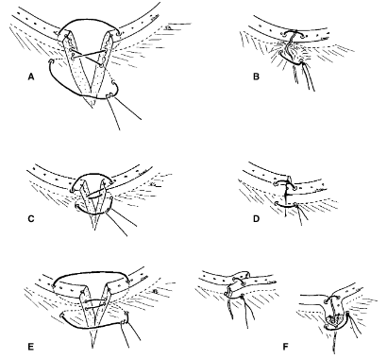
- What are the errors with each of the following lid laceration repairs?

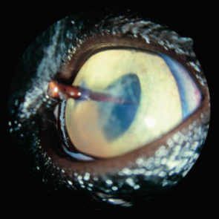
- What is your recommendation for this patient?

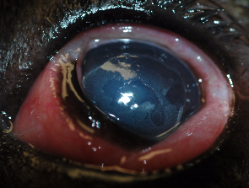
- A patient (adult mc mixed breed dog) presents to you with a history of acute onset eye abnormalities following unsupervised time in the garage. His looks like this:
  - What are the abnormalities present?
  - What do you suspect happened?
  - What are your recommendations for treatment?

Answers
- What are the errors with each of the following lid laceration repairs?
  - Unequal distance of FO8 suture from lid margin
  - Unequal distance of suture from globe
  - Suture too far from wound margin

- What is your recommendation for this patient?
  - Referral to an Ophthalmologist for anesthetized removal and immediate suturing of corneal wound

- A patient (adult mc mixed breed dog) presents to you with a history of acute onset eye abnormalities following unsupervised time in the garage. His eye looks like this:
  - What are the abnormalities present?
    - Chemosis- severe
    - Corneal edema
    - Corneal ulceration
    - Palpebral swelling
    - Conjunctival hyperemia
    - Epiphora
  - What do you suspect happened?
    - Chemical burn
  - What are your recommendations for treatment?
    - Topical anesthesia
    - Copious irrigation with 0.9%NaCl
    - Fluorescein dye test
    - Topical anti-inflammatories
    - Atropine topical

