Nutritional Considerations for the Dialytic Patient

Summary
1. A variety of nutrients are lost through dialysis and should be replaced appropriately
2. Critically ill renal patients have high catabolic rates and protein should not be restricted and should be increased during the days dialysis is performed

Protein Energy Malnutrition in Dialyzed Patients
- Anorexia 2ary to uremic toxicity
- Nausea and vomiting at the beginning of dialysis, especially if flow rates are rapidly increased
- Concurrent diseases and endocrine abnormalities (insulin resistance, hyperglucagonemia and hyperparathyroidism) > catabolic state
- Kidneys synthesize cysteine, tyrosine, arginine and serine > loss can promote wasting
- Dialysis also removes
  - Free amino acids (0.09-0.17 g/kg BW in humans per session)
  - Peptides or bound amino acids
  - Water soluble vitamins
- Blood loss
  - Frequent blood draws
  - Occult GI bleeding from uremic syndrome
  - Sequestration in hemodialyzer and tubing
Nutritional Assessment
- Protein energy nutritional status at start of chronic dialysis is a good predictor of longevity (humans)
- Study 276 critically ill dogs > negative energy balance in 73% of hosp days > 22% due to poorly written orders
- Records should note how much patient has eaten vs how much was offered, and as much detail about type of food, times a day, frequency of intake, etc. (also treats)
- Daily weights, in dialysis patients interpret with BCS and muscle cachexia score
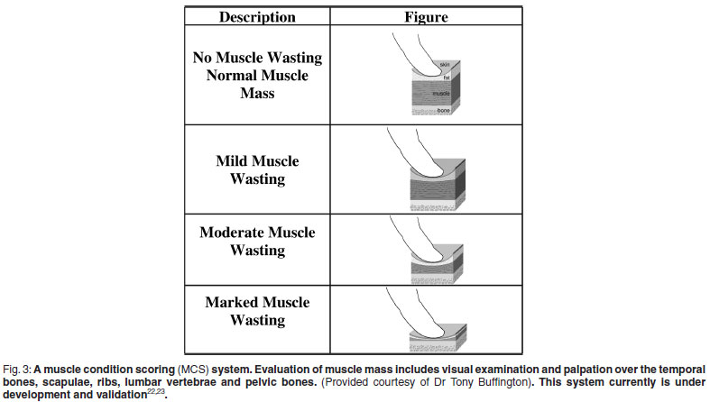

- Initial lean body mass usually first noted in epaxial, gluteal, scapular or temporal muscles
- Bioelectrical impedance analysis (BIA) electrical method of assessing body composition (total body water, fluid volumes, body cell mass and fat free mass)

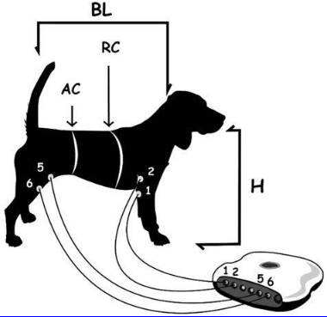
https://www.researchgate.net/publication/277080146_Indirect_assessment_of_total_body_water_in_adult_beagle_dogs_by_single-frequency_bioelectrical_impedance_analysis_SF-BIA

- Biochemical indicators of malnutrition:
  - Hypoalbuminemia
  - Decreased BUN
  - Hypocholesterolemia
  - Anemia
  - Lymphopenia

Methods of Administration
- Dialysis can reduce uremic toxins that produce anorexia, hence after a session they may want to eat more readily
- Odorous foods, warm food, positive reinforcement >petting while eating
- Offer fresh food each time, discard uneaten food
- Appetite stimulants ca be considered > may not be effective **Entyce, ghrelin agonist
- Enteral feeding > NG, esophagostomy, gastrotomy tube
  - Helps maintain GI barrier and prevent bacterial translocation
  - Renal liquefied diet or commercial liquid diet??

Kopple, Joel D. "National kidney foundation K/DOQI clinical practice guidelines for nutrition in chronic renal failure." American journal of kidney diseases 37.1 (2001): S66-S70.
“Protein intake should be doubled on the days CKD patients undergo dialysis”

**Normal Canine protein daily intake 2-4 g/kg/day, kidney patients 2 g/kg/day – Loftus personal comm

- Parenteral feeding
- PPN > 5% dextrose, 8.5% amino acids (without electrolytes), 20% intralipid
  - 50% RER
  - Final osmolality 300-600 mOsm/kg to prevent thrombophlebitis
  - Adjunct to supplement oral intake
  - Strict aseptic formulation
- TPN > 50% dextrose, 8.5% amino acids with electrolytes, 20% intralipid
  - hyperosmolar, needs central line
  - Not recommended to do through hemodialysis catheter > increases risk of thrombosis and infection
- Amino acid and glucose rich dialysate > diffuse into body
- Addition of amino acids, glucose and lipids at venous side of extracorporeal circuit
  - Controversial
  - Effect on morbidity or mortality?
  - Not reported in vet med

Energy
- Too few calories compromise nitrogen balance > loss of lean body mass
- Normal RER calculations apply
- Normal renal diets usually have high fat content to provide high palatability and twice the energy per g than carbs
Protein
- Protein intake should be matched with catabolism (tends to be high in kidney patients)
- Urea nitrogen appearance rate (UNA) = estimate Total Nitrogen Output (TNO)
  - Amount of urea that appears in body fluids and all body outputs (urine, dialysate, draining tracts, diarrhea)
  - TNO= (1.3 x UNA) +1.3
  - UNA (g/d) =
Urinary urea nitrogen (g/d) + Change in body urea nitrogen (g/d) + dialysate urea nitrogen (g/d)
  - Change in body urea nitrogen (g/d) =
[(BUNf - BUNi g/L/d) x BWi (kg) x 0.6 L/kg]+[(BWf - BWi kg/d) x BUNf (g/L) x 1.0 L/kg]
- i and f are the initial and final values for the period of measurement, 0.6 estimate of fraction of water, 1 is the fractional distribution of urea in the weight that is gained or lost (100%)
  - Non-urea nitrogen losses 0.031 g nitrogen/kg/day (severe diarrhea, exudative lesions, peritonitis)
  - To calculate dietary protein intake (g/d), TNO x 6.25
  - Protein requirement in humans is 30% higher in dialysis patients to compensate for substrate loss during sessions – unknown how much is needed in animals
    - Canine adult minimal requirement, 2.62 g/kg BW0.67
    - Feline adult minimal requirement, 3.97 g/kg BW0.67
    - Taurine supplementation (also removed during dialysis)

Vitamins, Minerals and Acid-Base Balance

- Phosphate binders
- Sodium restriction
- Potassium supplementation or restriction
- B vitamin supplementation
- Bicarbonate supplementation through dialysate, fluids or orally
- Iron supplementation

Additional Nutrients of Interest
- L-carnitine – facilitates transfer of long-chain fatty acids into mitochondria for energy generation – decreased in dialysis
- Supplementation is recommended in humans with clinical symptoms or dialysis complications (intradialytic arrhythmias, hypotension, low cardiac output, weakness, muscle cramps, refractory anemia, etc)

Sethi, Sidharth Kumar, et al. "Nutritional management in the critically ill child with acute kidney injury: a review." Pediatric Nephrology (2016): 1-13.

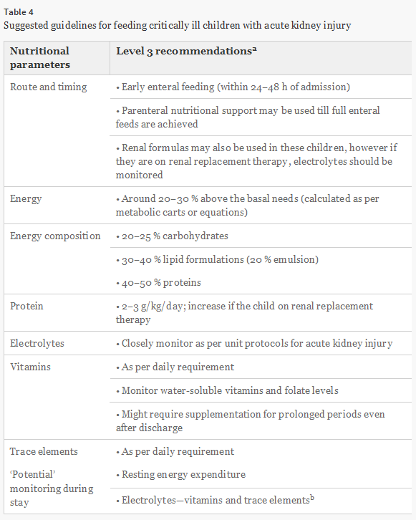

“Usually, such protein catabolism will account for a loss of approximately 0.2 g/L filtrate and, depending on the filtered volume, will result in a total loss of 10–15 g amino acid per day, representing about 10–15 % of total amino acid intake..

…For chronic HD patients, the Kidney Disease Outcomes Quality Initiative (K/DOQI) recommends the recommended dietary allowance for age plus an increment of 0.4 g/kg/day to achieve positive nitrogen balance. This recommendation is based on work done in adults on HD who failed to maintain nitrogen balance on 1.1 g protein/kg/day.”

Questions

- Name 5 indicators of malnutrition that can be seen on bloodwork.

- A 15 yo NM DSH is undergoing dialysis sessions for his acute on chronic pyelonephritis. He is anorexic, has severe muscle wasting, is urinating and his bloodwork is as follows:
pH: 7.13
HCO3: 11
pCO2: 27
BE: -13
USG: 1013
Prot: +++
Urine pH: 8

HCT 15%
TS: 5.2 g/dL
BUN: 132
Creat 8.8
P: 15.6
Na: 153
K: 4.2

What is your nutrition and fluid plan for this cat?

Answers:
- Name 5 indicators of malnutrition that can be seen on bloodwork.
  - Hypoalbuminemia
  - Decreased BUN
  - Hypocholesterolemia
  - Anemia
  - Lymphopenia

- A 15 yo NM DSH is undergoing dialysis sessions for his acute on chronic pyelonephritis. He is anorexic, has severe muscle wasting, is urinating and his bloodwork is as follows:
pH: 7.13
HCO3: 11
pCO2: 27
BE: -13
USG: 1013
Prot: +++
Urine pH: 8

HCT 15%
TS: 5.2 g/dL
BUN: 132
Creat 8.8
P: 15.6
Na: 153
K: 4.2

What is your nutrition and fluid plan for this cat?

Fluids: Low sodium fluid +/- K supplementation +/- Vit B supplementation
HCO3 supplementation through fluids, PO or through dialysate

Nutrition: Enteral if possible normal diet or liquid diet (no protein restriction), maintenance RER

Phosphate binders
Iron supplementation
+/- Vit B supplementation
Daily protein intake 3.97 g/kg BW^{0.67}

