Metabolic Alkalosis

Summary
- Metabolic alkalosis is characterized by a 1ary increase in plasma HCO3, decreased H+, increased pH and a 2ary or adaptive increase in PCO2
- Causes: Loss (Cl-rich fluid from GI or kidneys, diuretics), Administration of an alkali (rare, unless there is impaired renal HCO3 excretion)

Classification of Metabolic Alkalosis
- Chloride-responsive metabolic alkalosis (more common)
  - ECF volume depletion + renal retention of Na and Cl
- Chloride-resistant metabolic alkalosis
  - ECF volume normal to increased, Cl ingested is excreted in urine

Development of Chloride-Responsive Metabolic Alkalosis
- Development phase
  - Loss of H+ is associated with an increased concentration of HCO3 → increased HCO3 filtered load through kidneys
  - Natriuresis, kaliuresis and bicarbonaturia follow
  - Bicarbonaturia is transient (usually hypovolemia is concurrent and body will continue to preserve HCO3 while volume depleted)
- Maintenance phase
  - Aldosterone
    - Increased by ECF volume depletion, resulting in increased distal Na/H and Na/K exchange → Increased Na and decreased K
  - Hypokalemia
    - Leads to transcellular shift of H+ from ECF to intracell fluid in exchange for K ions → worsening alkalemia
    - This now decreased intracell pH then stimulates renal ammoniagenesis by stimulating glutaminase, leading to renal acid excretion → worsening alkalemia
    - May decrease GFR, impair Cl reabsorption in distal nephron, enhancing lumen electronegativity, facilitating H+ excretion

Response of the Body to Metabolic Alkalosis
- Acute Buffer Response
  - 32% titrated by intracellular buffers
    - 2% entered rbc in exchange for Cl (chloride shift)
    - 4% converted to carbonic acid by H+ from lactic acid released from cells (increased lactic acid production by phosphofructokinase in the face of alkalemia)
    - 26% titrated by H+ release from intracell proteins and phosphates, while Na and K enter cells to maintain electroneutrality
  - 68% remains in ECF compartment
    - 1% buffered by plasma proteins
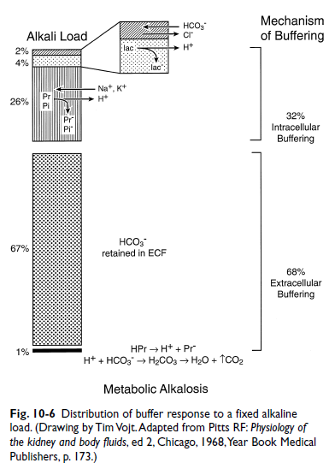

- Respiratory response to Metabolic Alkalosis
  - Decrease in H+ stimulates chemoreceptor → decreased alveolar ventilation
  - Alveolar hypoventilation protects pH in the presence of increased plasma HCO3
    - For each 1 mEq/L increase in HCO3, there is an adaptive 0.55-0.77 mmHg increase in PCO2
    - Associated with some degree of hypoxemia (PaO2 60-70 mmHg)

- Renal Response to Metabolic Alkalosis
  - Kidneys rapidly and effectively excrete administered alkali
  - Metabolic alkalosis will persists if:
    - Decreased GFR (decreased filtered load of HCO3)
    - Continued high rate of alkali administered
    - Renal stimulus to retain Na in the presence of a relative Cl deficit

Clinical Features of Metabolic Alkalosis
- Associated to underlying disease process
- Hypokalemia signs (muscle weakness, cardiac arrhythmias, decreased urine concentration, GI dysmotility)
- Muscle twitching (alkalosis increases the # of neg charges on protein, allowing > Ca to be bound, leading to decreased iCa)
  - 4 mEQ/Kg of NaHCO3 resulted in 10% decrease in iCa and 8% decrease in toal Ca, changes lasted 3 hours with no clinical signs
  - Shifts O2 Hb dissociation curve to the left (Bohr effect), impairing O2 release from Hb; this may not be clinically relevant as 2,3 DPG concentration increases within 6-8h of metabolic alkalosis shifting the curve back to the right

Diagnosis of Metabolic Alkalosis
- Causes of Metabolic Alkalosis
  - Chloride-responsive
    - Administration of alkali
      - NaHCO3 transiently increases arterial PCO2, pH, base excess and [bicarb], renally excreted and hyperventilation normalizes acid-base
      - Other sources of alkali: metabolized lactate, ketoacids, citrate
    - Gastric fluid loss
      - Due to hypovolemia and Cl deficit, kidneys cannot reabsorb Na with Cl, hence reabsorb Na in Na/K+ and Na/H+ exchange → more alkalosis and hypokalemia → Paradoxical aciduria
      - Must deliver Cl to fix alkalosis
    - Diuretic administration
      - Equal losses of Na and Cl in urine, but since [Cl] it is more affected
      - Loop diuretics inhibit NaCl reabsorption in the thick ascending limb of the loop Henle by competing with Cl for the Na/K/2Cl
      - Unlikely complications if drinking and eating Cl rich diet
    - Post-hypercapnia
      - In chronically hypoventilating patients, where ventilation rapidly improves (mech vent) blood pH increases rapidly
      - HCO3 has been increased through adaptive changes in renal HCO3 reabsorption, takes several hours for the kidneys to decrease Na/H exchange and begin excreting HCO3
      - Cl provision is needed
  - Chloride-resistant
    - Primary Hyperaldosteronism
      - Increased Aldosterone → Na retention → volume expansion → Hypertension, HyperNa, HypoK → metabolic alkalosis resistant to Cl → Excretion of Na and Cl
    - Hyperadrenocorticism
      - High cortisol and steroid secretion may increase Na and decrease K and produce metabolic alkalosis (theory)
    - Miscellaneous
      - Penicillin, ampicillin (as Na salt) can lead to hypokalemia and metabolic alkalosis
      - Refeeding alkalosis, when glucose is administered after prolonged fasting
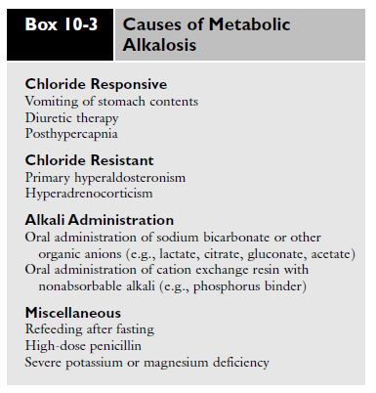

Treatment of Metabolic Alkalosis
- Replace Cl deficit, with sufficient K and Na (K phosphate will not correct alkalosis)
- Definitive treatment of underlying disease process
- Avoid O2 in patients with metabolic alkalosis, may impair ventilation and further aggravate hypercapnia
- Acid suppressants may be useful as they decrease gastric acid secretion (less losses)
- Heart failure patients on loop diuretics, KCL CRI
- Discontinue administration of alkali

