Medical treatment for pyometra in dogs

- Indications
  - Breeding bitches
  - Poor conditions or very old bitches in whom anesthesia would be dangerous
  - $$
  - To improve medical status prior to surgery
- Contraindications
  - Fever
  - Hypothermia
  - Peritonitis
- Options
  - General : E-collar to prevent ingestion of vaginal discharge (EWWWWW !), IVFT, ATB (potentiated penicillin)
  - Specific : Prostaglandins and/or antiprogestins
- Prostaglandins PGF2α
  - MOA : luteolytic and uterotonic** – for metritis or OPEN pyometra w/out uterus hypertrophy(closed : risk of peritonitis – forced passage of pus up the uterine tubes into ovarian bursae abdomen OR rupture)
  - Protocol
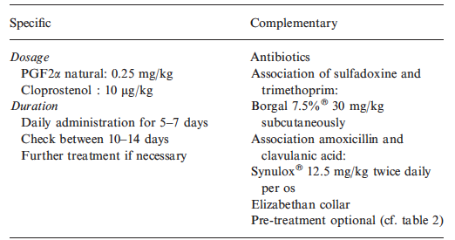
Give early in am and could keep in hospital because large amount of discharge… (EWWWWW !!!)
No improvement in clinical status (and may deteriorate) until day 2 of tx – lots of discharge and then resolve (purulent mucopurulent clear ; sometimes hemorrhagic at day 4-5)
Rapid reduction of uterus diam over first 48h
  - Side effects – dose dep
    - Hypothermia
    - Increased BM, +/- diarrhea
    - Salivation, vomiting
    - Depression, excitation, shivering
    - Could start with lower dose and gradually increase ; or use cloprostenol ; give before feeding, pre-tx with atropine or prifinium (antimuscarinic), metopimazine (D2 receptor antagonist)
  - Efficacy : complete resolution in up to 93% ; may need 2 series of tx ; fertility acceptable in 75-87% of cases (infertility with chronic inflammation with permanent hyperplasia), recurrence possible (mating post resolution to decrease recurrence)
- Progesterone antagonists : aglepristone = progesterone receptor antagonist)
  - MOA : to stop action of PG on uterus (competitive) – metritis, open or closed pyometra
  - Side effects : minimal - vomiting
  - Efficacy
    - Complete resolution w/in 4 weeks – metritis
    - Closed pyometra : opening of cervix after first 2 doses (so w/in 24h)
    - Better sucess when combined with cloprostenol
    - Mate bitches at the next heat (20% had recurrent at next heat…)

- True of False – aglepristone can be used in the management of closed pyometra

- What is the main desired effect of PGF2α in the treatment of pyometra ?

Answers
- True of False – aglepristone can be used in the management of closed pyometra
True
- What is the main desired effect of PGF2α in the treatment of pyometra ?
Ability to induce uterine contractions

