Macrophages and the Later Stages of Inflammation
Summary
- Macrophages are a the 2nd line of defense after neutrophils, ingesting and killing surviving microbes, ingesting dead neutrophils, limiting damage caused by neutrophil enzymes.
- Generate nitric oxide.
- Effectively remove foreign particles from the bloodstream and the respiratory tract.
- Responsible for beginning the healing process in damaged tissues.
- Secrete cytokines, causing a fever, excessive production (cytokine storm) can lead to lethal shock syndromes, excessive, chronic release of inflammatory cytokines can cause deposition of insoluble proteins (amyloid) in tissues
- M1 > inflammatory > IL-1, IL-6, IL-12, IL-23 and TNF-α
- M2 > anti-inflammatory > SLP1, IL-4, IL-10, IL-13, IL-1β and TGF-β

Macrophage Functions
- Sensors of Invasion
  - Possess toll-like receptors (TLR) and nucleotide-binding oligomerization domain-like receptors to detect invading bacteria and viruses
  - They produce cytokines: most important > IL-1, IL-12, IL-23 and TNF-α
- Phagocytosis
  - Monocytes bind to vascular endothelial cell intercellular adhesion molecule-1 using b2 integrins and emigrate through the vessel wall > macrophages
  - Macrophages are attracted by bacterial products , complement and alarmins (generated by damaged cells and tissues), as well as from chemoattractants from neutrophils
  - Destroy bacteria by oxidative and non oxidative mechanisms
  - Produce collagenase and elastase to destroy connective tissue, plasminogen activator that is a potent protease
- Generation of Nitric Oxide
  - Microbial products trigger macrophages (M1 cells) to synthesize inducible nitric oxide synthase (NOS2), this uses NADPH and O2 to act on L-arginine to produce nitric oxide and citrulline
  - Nitric oxide can then react with superoxide anion to produce peroxynitrite and nitrogen dioxide radical
  - M2 cells convert arginine to ornithine using arginase and produce cytokines that suppress immune response, promote blood vessel formation, tissue remodeling and repair
- Activation
  - Lipopolysaccharides, CpG DNA, microbial carbohydrates, shock hormones and alarmins

Removal of Foreign Material
- Liver > Kupffer cells that line the sinusoids of the liver
  - 2 stages:
    - Neutrophils phagocytose bacteria
    - Kupffer cells ingest and destroy these neutrophils
  - Have CD35, particles opsonized by C3 are preferentially removed in the liver
- Lungs > line the endothelium of lung capillaries
- Spleen is a more effective filter, but since it is smaller, traps less material
  - Splenic macrophages have CD64, particles opsonized with antibody are preferentially removed in spleen
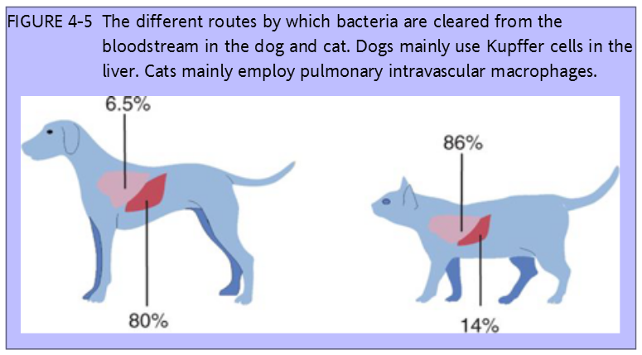
Intravenous administration of material
- Clearance of organisms is decreased if they are not opsonized by antibodies or if the bacteria has an antiphagocytic polysaccharide capsule or if steroids and drugs that depress macrophages are used
- Clearance is increased when macrophages are stimulated with bacterial endotoxins, estrogens and simple lipids
- If previous exposure has not occurred, 5-10 days before immune elimination, if previous exposure has occurred 2-3 days, if antibodies are present at the time of exposure immune elimination is immediate
Alternate route administration of material
- Damage and inflammation releases alarmins
- Neutrophils and macrophages migrate and phagocytose material
- Some will be captured by dendritic cells and used to trigger acquired immunity
- In skin dendritic cells are called Langerhans cells, which then present material to lymphocytes (intradermal is the most effective in stimulating an immune response)

Respiratory tract
- > 5 um stick to mucous layer of epithelium, then removed by coughing
- Smaller particles that reach alveoli are ingested by alveolar macrophages
- The system may be blockaded by smoking and chronic exposure to industrial dusts
Recovery from Inflammation
- M1 cells eventually convert into M2 cells with anti-inflammatory properties
- Secrete SLP1 (serine protease inhibitor), inhibits release and activity of elastase
- Ingestion of neutrophils promotes release of TGF-β > tissue repair
- Il-1β > activate and attract fibroblasts
- Chronic inflammation around foreign material can produce a granuloma
  - Consist of granulation tissue (accumulation of macrophages, lymphocytes, fibroblasts, loose connective tissues and new blood vessels
  - M2 secretes IL-1 which deposits collagen by fibroblasts and walls off the lesion
*Fun Fact: granulation tissue is derived from the granular appearance of this tissue when cut. The “granules” are in fact new blood vessels

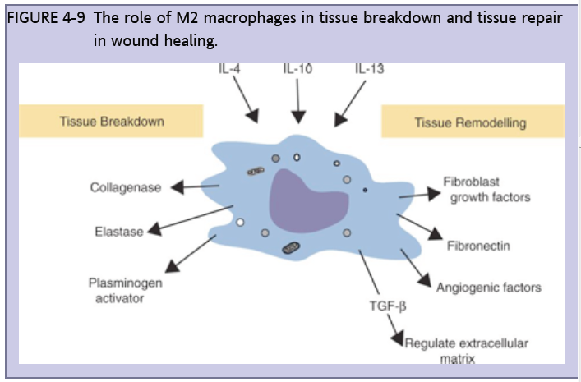

Sickness Behavior
- Feelings of sickness—malaise, lassitude, fatigue, loss of appetite, and muscle and joint pains—along with a fever, are components of innate immunity
- Microbial molecules acting on the TLRs of phagocytic cells stimulate the production of IL-1β, IL-6, and TNF-α, which affect the brain in 2 ways:
  - Direct nerve stimulation from damaged tissue, IL-1, receptors found on sensory neurons of vagus nerve, stimulation can trigger sickness responses in the brain and nausea
  - Circulating cytokines which diffuse into the brain or are produced there
    - IL-1, IL-6, and TNF-α all act on the brain to induce sleep, suppress appetite, and raise body temperature

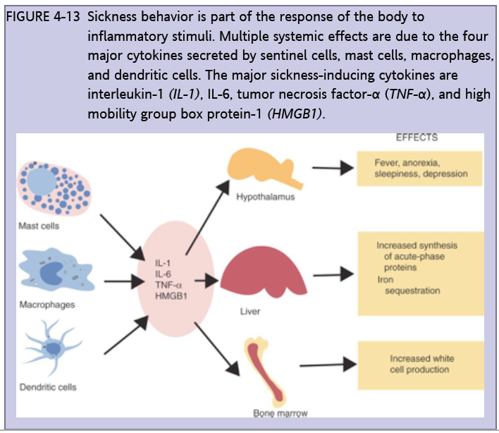

Metabolic Changes
- IL-1, IL-6, TNF-α enhance protein catabolism to use amino acids for antibody synthesis, eventually resulting in muscle wasting
- Weight loss, loss of adipose tissue

Acute-Phase Proteins (APP)
- Under the influence of IL-1β, TNF-α, and especially IL-6, liver cells greatly increase their protein synthesis and secretion > acute phase proteins
- Begins within a few hours of injury and subsides within 24 to 48 hours
- C-reactive protein is the major APP, one side binds to cell mb and bacteria, the other side binds to neutrophils through antibodies, promotes phagocytosis and removal of dead cells and microorganism
- Serum amyloid A is the major APP in cats, and 2nd in dogs, it is immunosuppressant, chemoattractant to neutrophils, monocytes and T cells

SIRS
- Large amount of cytokines and oxidants are release into circulation after severe infection or massive tissue damage
- Cytokine storm – most important is TNF-α, IFN-γ, IL-8, and IL-6

Protein Misfolding Disease
- Amyloidosis is deposition of insoluble proteins in tissue
  - amorphous, eosinophilic, hyaline proteins in cells and tissues
- May develop when infections or inflammation cause a sharp rise in the concentration of the acute-phase protein SAA
- Reactive amyloidosis is associated with chronic inflammation in diseases such as mastitis, osteomyelitis, abscesses, traumatic pericarditis, and tuberculosis

Questions

- T or F: Opsonized microorganisms are removed slower from circulation in comparison with non-opsonized microorganisms

- T or F: Deposition of amorphous, eosinophilic, hyaline proteins may occur after states of chronic inflammation

- T or F: Macrophages have both inflammatory and anti-inflammatory properties

- The main organ that clears microorganisms in dogs is __________________ and in cats _____________.

Answers

- T or F: Opsonized microorganisms are removed slower from circulation in comparison with non-opsonized microorganisms Faster

- T or F: Deposition of amorphous, eosinophilic, hyaline proteins may occur after states of chronic inflammation Amyloid

- T or F: Macrophages have both inflammatory and anti-inflammatory properties

- The main organ that clears microorganisms in dogs is Liver and in cats Lungs.

