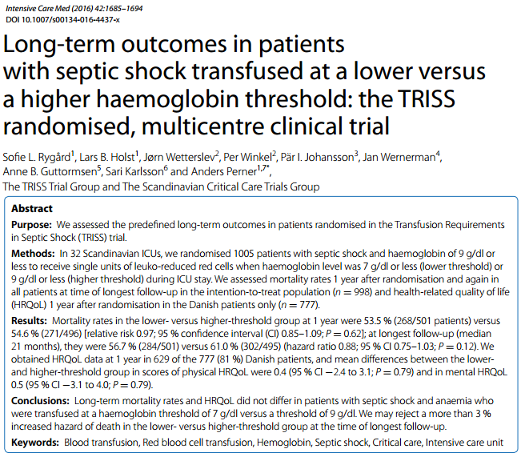
Intro: Most recent surviving sepsis recommends 7g/dl hemoglobin transfusion threshold to aim for 7-9g/dl but limited data to support and few people following recommendations
Short term TRISS results supported the 7g/dl trigger which showed no significant difference in outcomes at 90 days, use of life support, or ischemic events
Goal: Look at 1 year survival and quality of life for patients of TRISS trial
Results: 99.9% of patient follow-up
No significant difference between populations in regards to survival
No significant difference in QOL
Original TRISS showed no difference, while significantly reducing the amount of patients being transfused and amount of blood transfused
ONLY for septic shock!

Takeaways: More restrictive transfusions in septic shock are safe in both short term and long term

