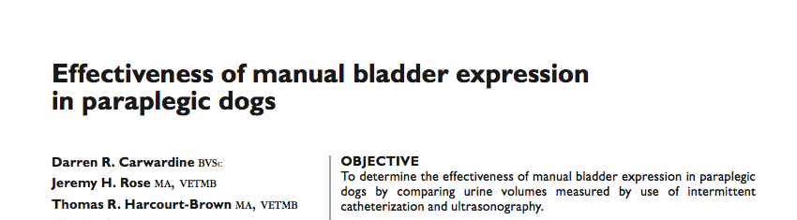
Key points:
- 21-38% dogs managed with manual bladder expression develop a UTI
  - Larger residual volume?
- Evaluated bladder residual volume (via ultrasound) with manual bladder expression, and correlated with weight (as thought to have decreased efficacy with animals of higher BW)
- Manual bladder expression was ineffective at completely emptying urine from the bladder
  - Physiologically normal residual urine volume was not achieved for any of the 93 manual bladder expression attempts
  - The 76 successful attempts typically resulted in 49% of the total urine volume being voided
  - Effectiveness of the procedure was not affected by body weight
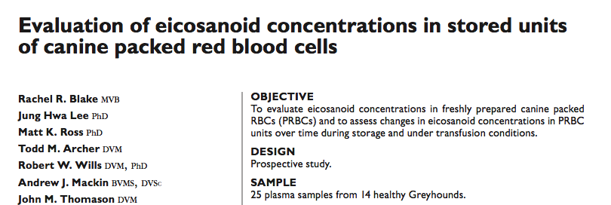
- Ultrasonographic estimation of bladder volume could be a useful predictor of actual bladder volume (but it was susceptible to wide variations among dogs)
Key Points
- Time 0, pre-transfusion and post-transfusion concentrations of arachidonic acid, prostaglandin F2, PGE2, PGD2, thromboxane B2, 6-keto-PGF, and leukotriene B4 were measured by liquid chromatography–mass spectrometry and analyzed statistically
- Eicosanoids are signaling molecules generated following the release of arachidonic acid from the phospholipid bilayers of cells, especially platelets and cells of the immune system. Once released, arachidonic acid is enzymatically oxidized into vasoactive molecules that have multiple biological functions, including stimulation of monocyte and macrophage cytokine production, antibody synthesis, platelet aggregation, vasoconstriction, and bronchoconstriction
- Several eicosanoids (including TXB2, PGF2α, 6-keto-PGF1α, and LTB4) were found to accumulate in canine PRBC units during refrigerated storage, transfusion at room temperature, or both

