Lens Related Emergencies

Summary

- Cats tend to have traumatic lens damage and infectious causes of uveitis resulting in cataract and lens instability
- Dogs, however, tend to develop cataracts and lens instability owing to inherited or metabolic (e.g., diabetes mellitus) diseases
- Majority of lens-related emergency treatments will require topical and systemic NSAIDs and measuring IOP

Sharp Trauma
- Common in adolescent dogs (45.5% with traumatic lens capsule laceration <1 year, 34% <5 months), cats of any age
- Recent study (10 cats) compared prophylactic lensectomy vs corneal repair without lensectomy vs medical management > medical management had more successful outcomes
- 3 most common causes of failure to treatment in that study were: 2ary glaucoma, endopthalmitis (inflammation of intraocular cavities), phthisis bulbi (shrunken, non-functional eye)
- Lens removal used to be recommended in patients with lens capsule tear >1.5 mm, newer study shows 1/3 of these cases are successful
- Topical and systemic NSAIDs prevent sequelae associated with negative outcomes and should be started as soon as possible
- Treatments: Topical and systemic NSAIDs, systemic broad spectrum antibiotics (Clavamox or Baytril), Topical parasympatholytic agent (Tropicamide bid, tid; Atropine bid), immediate referral
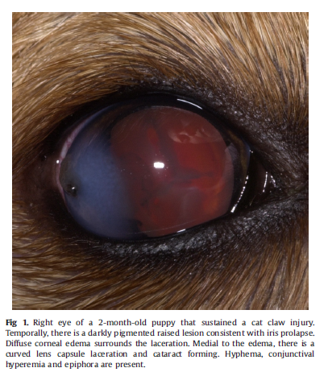

Septic Implantation Syndrome
- This is a type of phacoclastic uveitis where the penetrating trauma implants bacteria into the lens > suppurative endophthalmitis with lenticular abscess
- Wide time frame
  - Dogs: 1 week – 8 months, median duration 5 weeks
  - Cats: 10 days – 1 year, median 6 weeks
- Most frequently due to cat scratches
- Common bacteria (in order of most to least): Gram + cocci, Gram – organisms, Gram + rods and fungal hyphae
- Clinical signs: uveitis (subclinical or clinical), fibrinous exudate on the lens capsule at the site of penetrating injury, cataract, 2ary glaucoma (once established, not successfully treated)
- Treatments: Topical and systemic NSAIDs, Topical and systemic broad spectrum antibiotics, pain meds, enucleation if med manag fails

Spontaneous Lens Capsule Rupture
- Can occur in patients with rapidly progressive cataracts that become intumescent
- Clinical signs: active anterior uveitis (corneal edema, aqueous flare, conjunctival hyperemia, variable discomfort), shallow anterior chamber
- Common in diabetic cataracts in dogs > lipid flare may be the first sign of inflammation
- Treatments: Topical and systemic NSAIDs, rapid surgical intervention (phacoemulsification) to avoid blindness
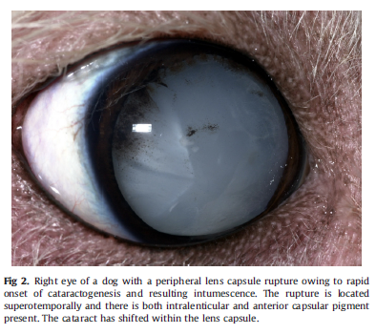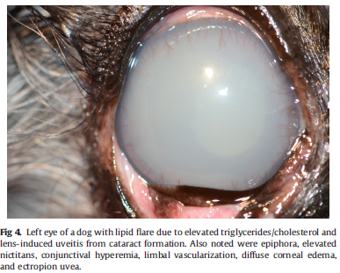

Blunt Trauma
- Unlikely to produce cataract, may cause damage to lens (posterior iris pigment imprinting on anterior lens capsule – Vossius ring), hyphema, uveitis
- Treatments: Topical and systemic NSAIDs, pain meds

Lens Instability
Anterior Lens Luxation
- Primary:
  - Middle aged (3-9 years)
  - Terriers, Shar-pei, Border collie, German Shepard
  - Siamese cats – very rare
  - Commonly asymmetric
  - Clinical signs: painful, blepharospasm, diffuse corneal edema, epiphora, elevated IOP, lens visible in anterior chamber
- Secondary:
  - Caused by chronic long standing hypermature cataracts, chronic glaucoma, older dogs
  - Feline lens luxation commonly due to uveitis and glaucoma, 7-9 years
- Treatments: Latanoprost, analog prostaglandin, controls IOP
  - Transcorneal reduction (coaching) in the posterior chamber
  - Intracapsular lens extraction
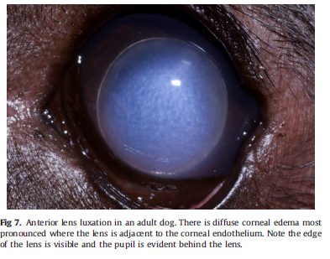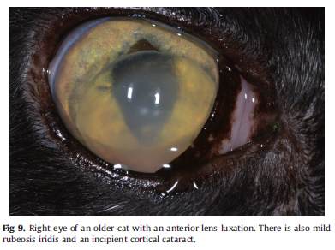

Cataract Surgery Related Emergencies
- Endopthalmitis – rare, 1.4% incidence in dogs by 3 months after Sx
  - Causes: chronic blepharitis, dermatitis, systemic infections (dental, UTI)
- Postoperative Ocular Hypertension – 23-50% incidence, transient increase IOP (>25 mmHg) that occurs within 72hr of Sx
- 2ary Glaucoma – 17% incidence, weeks to years after Sx (median 6 months), increased risk with hypermature cataracts at time of phaco
  - A large-scale study by Gelatt and MacKay that spanned 39 years found a 19.3% incidence of secondary glaucoma overall in dogs that had cataracts or cataract surgery, dogs that had cataract surgery were evaluated, there was a 5.1% incidence of secondary glaucoma. – WOW!!! 39 years!!!
  - Cocker spaniels, Boston terriers, Labrador retrievers, Bichon fries, Shih tzu, JRT have higher predisposition

Questions:
A 5-month old SF Irish Wolf Hound presents for a corneal laceration from a cat claw injury. Ophthalmologists are all away at eye camp and referral is not possible at this time.
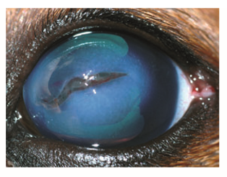
- Describe the abnormalities observed

- Describe what diagnostics should be performed

- What treatments are recommended?

- What are complications and prognosis for this injury

Answers:
- Describe the abnormalities observed
10 mm horizontal laceration of the lens capsule
Dense corneal edema
Epiphora
Formed anterior chamber without uveal prolapse or continuous aqueous leaks

- Describe what diagnostics should be performed
IOP
Fluorescein stain
Slit-lamp evaluation

- What treatments are recommended?
Medical management has better outcomes
- Thorough flushing with eye wash
- Topical and systemic NSAIDs
- Topical and systemic antibiotics
- Topical parasympatholytic agent
- Pain meds
Surgery
- Corneal repair
- Lensectomy

- What are complications and prognosis for this injury
Complications include 2ary glaucoma, endopthalmitis, phthisis bulbi, blindness, need for enucleation
Prognosis is favorable if seen within 72 hr and none of the previous complications are present

