Keratoconjunctivitis Sicca
Summary
- KCS is caused due to a deficiency in the aqueous component of the tear film > desiccation of conjunctiva and cornea
- Immune-mediated destruction of lacrimal glands is the most common etiology of bilateral canine KCS
- Early diagnosis and treatment with topical cyclosporine has a good response in the majority of dogs

Etiology
Immune-mediated
- Most common cause - bilateral
- West Highland terrier (females > males), Cavalier King Charles Spaniel, English Cocker Spaniel, Shih Tzu
Neurogenic
- Parasympathetic innervation to the lacrimal glands is lost
  - Preganglionic lesions
    - Otitis media or interna, petrositis, erosive lesions of the floor of the middle fossa of the skull
    - Facial nerve paralysis, Horner’s or vestibular disease can accompany otitis and petrositis
    - Trigeminal nerve dysfunction, facial anesthesia can accompany erosive lesions
    - Lesions involving the pterygopalatine fossa include periorbital myositis, cellulitis and dental abscessation
  - Postganglionic lesions
    - Orbital trauma
Other Causes
- Endocrine disease (diabetes mellitus, hypothyroidism, Cushing’s) - bilateral
- Drug- induced (sulfas, etodolac, topical atropine, topical/GA) - bilateral
- Surgical removal of the nictitans glands
- Infectious diseases (distemper, leishmaniasis) - bilateral
- Evisceration/Prosthesis and Irradiation

Clinical Presentation
General Signs
- Ocular discomfort
- Conjunctival hyperemia
- Mucopurulent ocular discharge
- Lack luster appearance to the corneal surface
- Sequelae: corneal neovascularization, corneal pigmentation, progressive corneal ulceration, blindness

Neurogenic Signs
- Ipsilateral dry nose – pathognomonic
- Horner’s syndrome
- Facial paralysis
- Vestibular disease
- Trigeminal dysfunction

Diagnosis
- Schirmer Tear Test: distal tip of strip contact the corneal surface
  - Type 1: measures both the reflex and basal aqueous tear production, do 1st to reduce effect of reflex tearing from eyelid manipulation and topical treatments (Fluoroscein)
  - Type 2: measures only basal tearing, following the application of topical local anesthetic
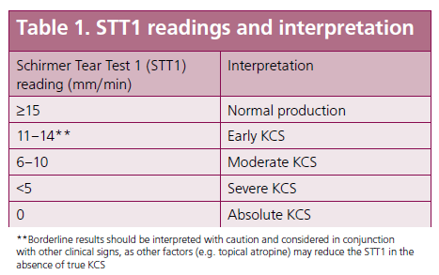
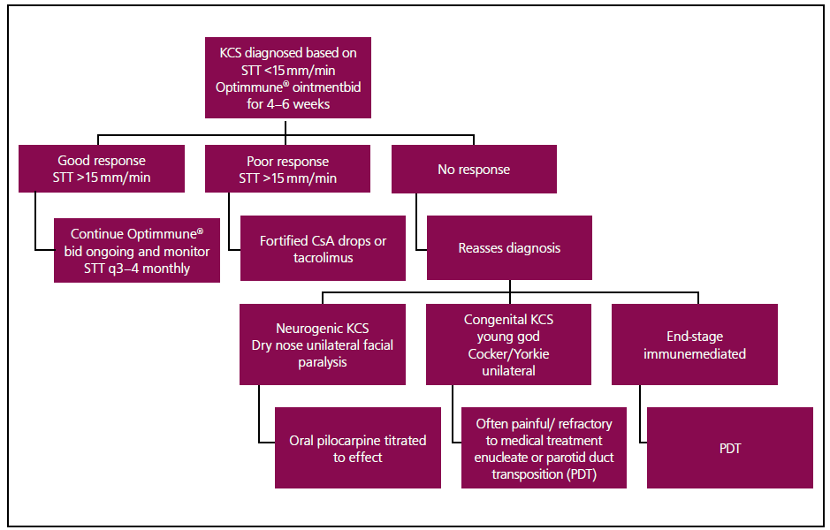

Treatment
Lacrimostimulants
- Topical Cyclosporine A (Optimmune) has immunomodulating and tear stimulating properties
  - Calcineurin inhibitor blocks the activation and proliferation of T lymphocytes
  - Mucinogenic effect – improves quality of the pre-ocular tear film
  - BID OU, can take up to 6 weeks to exert maximal effects
- Tacrolimus immunomodulatory agent
  - Macrolide antibiotic
  - Normally used for cases that are refractory to Cyclosporine A
  - Percutaneous absorption – wear gloves
  - BID OU
- Pilocarpine parasympathomimetic agent – neurogenic KCS
  - 1% solution PO at an initial dose of 1 drop/10 kg 2-3 times daily and titrated to effect
  - Hypersalivated, vomiting, diarrhea, cardiac arrhythmias
  - Irritating topically

Lacrimomimetics
- Many options, should be used early on in the disease until tear production has improved

Topical Antibiotics
- May benefit early on due to risks of 2ary infections

Surgical Intervention
- Parotid duct transposition (PDT)
  - Dogs with xerostomia (dry mouth) not good candidates
  - Saliva production test: small amount of lemon juice on the tongue and observe parotid papilla (buccal mucosa, dorsal to the caudal aspect of the maxillary carnasial tooth)
  - 51% complication rate, 93% success rate
- Episcleral Silicone Matrix Cyclosporine implants – testing phase

Questions
- T or F: An ipsilateral nasal dryness is pathognomonic of neurogenic KCS in dogs.

- Explain the difference between a SST 1 from a SST 2.

- What is the mechanism of action of Cyclosporine A?

Answers:
- T or F: An ipsilateral nasal dryness is pathognomonic of neurogenic KCS in dogs.

- Explain the difference between a SST 1 from a SST 2.
SST 1 measures both the reflex and basal aqueous tear production, SST 2 only basal

- What is the mechanism of action of Cyclosporine A?
Calcineurin inhibitor blocks the activation and proliferation of T lymphocytes
Mucinogenic effect – improves quality of the pre-ocular tear film

