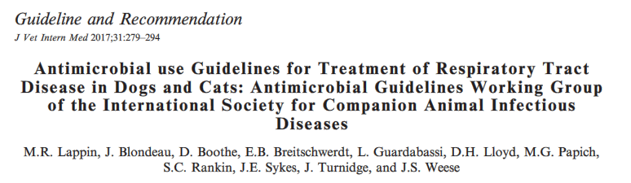
- For light reading

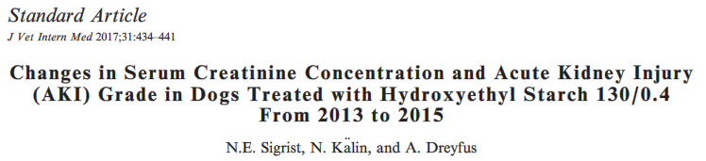
METHODS:
- Historical Cohort Study
- 94 dogs receiving HES during hospitalization, 90 unexposed dogs (selection criteria?)
- Looked at total amount of HES administered, HES mL/kg/day and days receiving HES
- Evaluated short term (within 10d of administration) and long term (11d-90d of administration) AKI (IRIS grades)
  - Classified as new AKI short term, AKI increase short term, and AKI increase long term
RESULTS:
- Median duration 4d, median total amount 69.4mL/kg, median dose of 20.7mL/kg/day
- AKI grade not statistically different long or short term
  - Those dogs on HES that did develop AKI did not have long term management as were euthanized in hospital for other reasons
- Also no statistic difference in subgroup with preexisting AKI
- After logistic regression the likelihood of increasing short term
- AKI grade increased as duration of receiving HES increased (by 18% per day)
  - Nothing else was significant
- No dogs that had follow up had persistent increase in AKI grade
DISCUSSION:
- In humans biggest concern is patients with severe sepsis/septic shock but this was likely a very small subset in this study
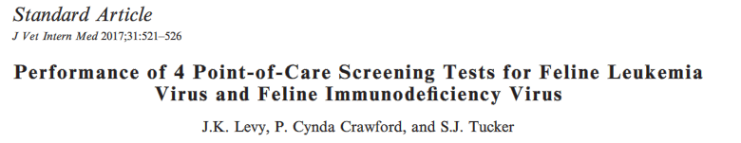
METHODS
- Prospective, blinded, used left over samples from shelters, research colonies and veterinary clinics
- Compared to gold standard
  - FeLV used 2 different ELISAs for antigen, samples were excluded if did not have same result on both
    - 146 antigen positive samples, 154 antigen negative
  - FIV virus isolation
    - 94 positive, 97 negative
- Tested the following:
  - SNAP Combo FeLV Ag/FIV Ab (ELISA)
  - WITNESS FeLV-FIV Test Kit (immunochromatography)
  - Antigen Rapid FIV Ab/FeLV Ag Test Kit (immunochromatography)
  - VetScan Feline FeLV?FIV Rapid Test (immunochomatography)
RESULTS
- SNAP more sensitive than the others for FeLV (correctly identified all), VetScan was the worst
  - Using everything but SNAP 83-94% of test positives in a low risk (1% seroprevalence) population will be false positives
- No significant differences in FIV
  - 50% of positives false in 1% seroprevalence population
- Negative tests for both are likely correct
- Don’t euthanized based on single positive result in low risk population

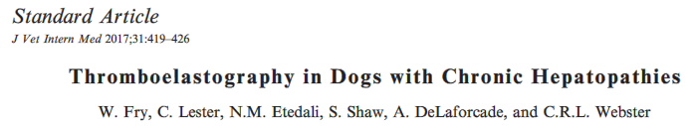
- Conventionally chronic hepatopathy in dogs thought to cause hypocoagulability based on conventional tests, but spontaneous bleeding is rare and thrombosis is reported
- Performed TEG on 21 dogs with chronic hepatopathy (both retrospective (10) and prospective)
- Included if had biopsy confirming chronic hepatopathy, OR had increased tBili, ALT & Ast with decreased albumin, cholesterol and BUN, plus ultrasound consistent with end stage liver disease
  - Scored 1-13 according to severity of signs and lab results
- No changes in PT/aPTT or d-dimers
- Kaolin activated TEG
  - Coagulablity (based on G) was normal in 42%, hypercoagulable in 33%, hypocoagulable in 24%
  - Fibrinogen was strongly correlated with G value
  - 5 were hyperfibrinolytic – some were hyper, hypo and normocoagulable
- Hypocoagulable states were associated with late stage CH including high clinical score and presence of portal hypertension
- Hyperfibrinolysis was associated with higher disease grade

