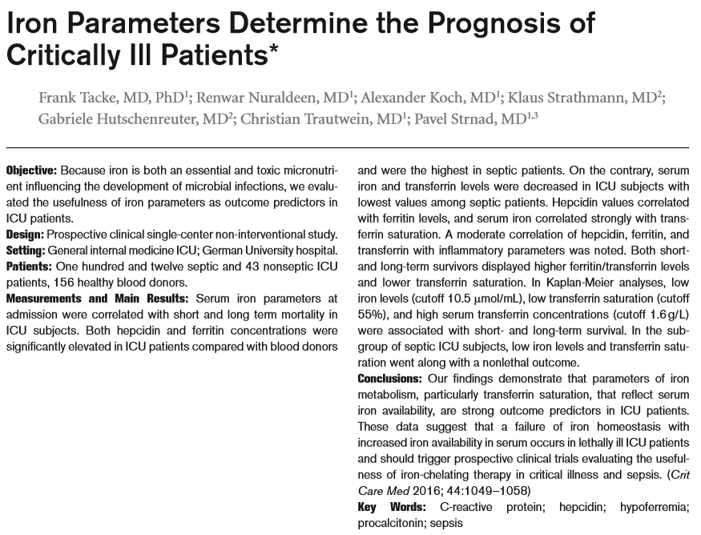
- Iron is essential for Hb production, energy metabolism and multiple signaling pathways
- Free iron is toxic > results in generation of reactive oxygen species, lipid peroxidation and endothelial damage
- Iron is sequestered by transferrin and kept in macrophages
- Ferritin are iron stores in tissue
- Serum ferritin is a marker of total iron load, increased iron burden results in elevated transferrin saturation (TSAT) and generation of the toxic non-transferrin bound iron to prevent this iron is controlled by hepcidin
- Hepcidin control iron uptake in intestines and it’s release from macrophages, it’s synthesis is stimulated by anemia, iron deficiency and inflammation
- Hypoferremia of inflammation > decreased serum iron concentration with iron sequestration within macrophages + increased ferritin and decreased transferrin levels
- No or weak correlation of low iron with need of transfusion
- High iron serum levels, low transferrin and high ferretin were strongly associated with ICU and long term mortality
- High TSAT >55% had a poor short and long term survival
- INR and TSAT are independently associated with short term, but not long term mortality
- High iron (cutoff 10.5 umol/L) and ferritin (cutoff 800 ng/mL) were good predictors of overall mortality
- Failure of iron homeostasis may explain the increase in TSAT in lethal ICU cases > catabolic state decreases iron consumption coupled with an increased iron release through recycling (low production but increased destruction of erythrocytes and other tissues)
- High TSAT is associated with
  - Formation of highly reactive non transferrin bound iron > toxic iron species
  - Toxic iron species are used by microorganisms and increase infection
  - Generation of ROS, lipid peroxidation and endothelial damage > MODS
- In a septic rat study use of antioxidants with deferoxamine (iron chelator) improved survival

TAKE HOME
- High iron levels and high TSAT in septic patients is a negative prognostic indicator

