Chapter 9 Feldman/Nelson
Beta-Cell Neoplasia: Insulinoma
Summary
- Neuroglycopenia and sympathoadrenal response account for clinical signs of insulinoma
- Baseline insulin or insulin glucose ratio are the main diagnostic tools

- Etiology
  - Malignant
  - Secrete insulin independent of hypoglycemia
  - Not completely autonomous, respond to stimuli such as increased BG
  - High incidence of multihormonal production
    - Pancreatic polypeptide
    - Somatostatin
    - Glucagon
    - Serotonin
    - Gastrin

- Malignant vs Benign Potential
  - Majority are malignant
  - Rare mitotic figures in most islet cell tumors
  - Malignancy is usually based on
    - identification of metastasis during surgery or necropsy
    - recurrence of hyperinsulinemia and hypoglycemia days to months after solitary mass removal
  - Most animals have microscopic or grossly visible mets at surgery
  - Mets: regional lymphatics (duodenal, mesenteric, hepatic, splenic), liver and peripancreatic omentum, lungs (very late in disease)

- Pathophysiology
  - Maintenance of Euglycemia
    - Glucose is the sole metabolic fuel for the brain
    - Glucose is derived from 3 sources:
      - Intestinal absorption after digestion of dietary carbs
      - Glycogenolysis - liver
      - Gluconeogenesis (from lactate, aminoacids and glycerol) – liver
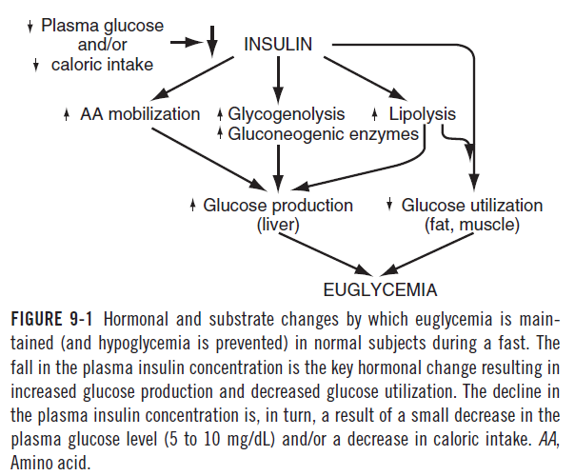
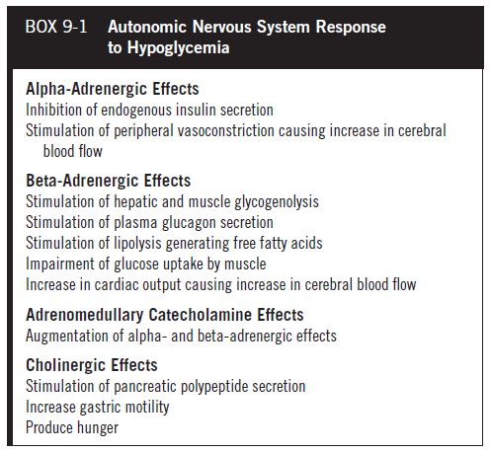
- Hypoglycemia and the Counterregulatory Response
- Brain, erythrocytes, bone marrow and renal medullaa are dependent on plasma glucose
- Hepatic glycogen reserves and gluconeogenesis in liver and kidney directly supply the brain with glucose
- Mobilization of fatty acids from triglyceride depots provide energy for skeletal and cardiac muscle, renal cortex, liver and other organs
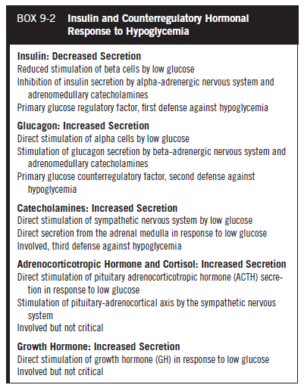
- Insulin Secretion in Dogs with Beta-Cell Neoplasia
  - Beta cells autonomously synthesize and release insulin despite hypoglycemia
  - Clinical signs is related to degree of hypoglycemia and the rate at which it occurs
  - Insulin not only mobilizes glucose into cells but also interferes with hepatic production of glucose

- Clinical Signs
  - Cerebral cortex is 1st area to be affected by hypoglycemia, then brainstem
  - CNS use of glucose is not insulin-dependent and uses diffusion

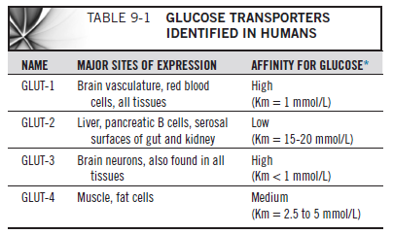

- In acute hypoglycemia, histologic alterations are most marked in the brain, however peripheral nerve degeneration and demyelination can occur
- Clinical signs occur due to lack of glucose to the brain and stimulation of the sympathoadrenal system
  - Neuroglycopenia: lethargy, weakness, ataxia, disorientation, abnormal behavior and seizures
  - Sympathoadrenal: muscle tremors, shaking, nervousness, restlessness, may precede neuroglycopenia
- Adaptation process to chronic severe hypoglycemia involves up-regulation of GLUT-1 on blood brain barrier
Clinical Features:
- Signalment:
  - Middle aged or older dogs, no gender predilection
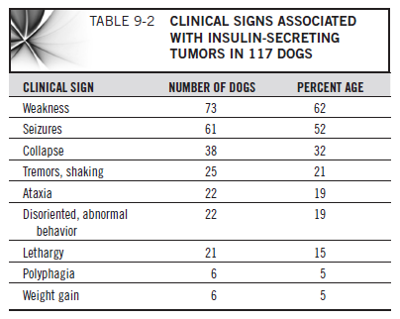
- Peripheral neuropathy
  - Paresis to tetraparesis, facial paresis to paralysis, sciatic hyporeflexia to areflexia, hypotonia, appendicular, facial muscle atrophy
- Bloodwork:
  - Hypoglycemia, hypoalbuminemia, hypophosphatemia, hypokalemia, high ALT and ALKP (mets?)

Differentials:
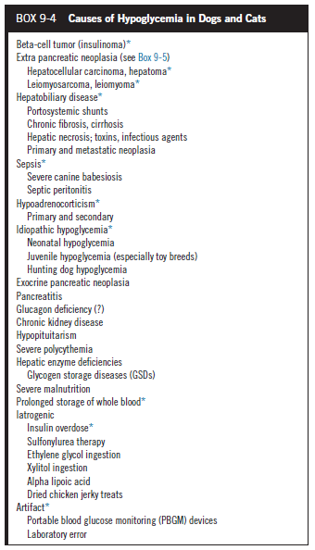
Criteria for confirming diagnosis:
- Whipple’s Triad:
  - Symptoms occur after fasting or exercise
  - During symptoms, BG is < 50 mg/dL
  - Symptoms are relieved by administration of glucose

- Insulin-Glucose Ratio:
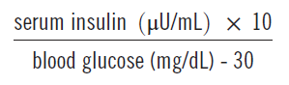
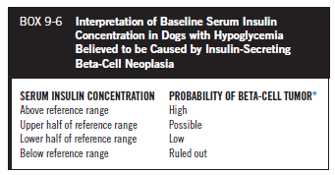

- Fructosamine Concentration
  - Below reference range support long periods of hypoglycemia
- Imaging
  - Ultrasound may identify a pancreatic mass, 35-69% sensitivity, 44% for mets in liver and LN
  - CT sensitivity 71% and for mets 40%
Treatment
- Surgery vs Medical Therapy
  - Surgical resection may be curative
  - Debulking may result in remission
  - Survival time is longer in patients undergoing surgery
  - Perioperative management
    - Frequent meals
    - Steroids
    - 2.5% - 5% dextrose before, during and after surgery
    - Glucagon CRI (stimulates hepatic gluconeogenesis)
  - Anesthetic considerations
    - Dexmedetomidine and medetomidine may produce hyperglycemia, decreased insulin, may decrease intraop glucose administration
    - Check BG q30min
  - Surgical considerations
    - IV methylene blue, stains insulinoma purple
    - (careful, may cause Heinz body anemia)
    - Postop complications: pancreatitis, diabetes mellitus, persistent postop hypoglycemia

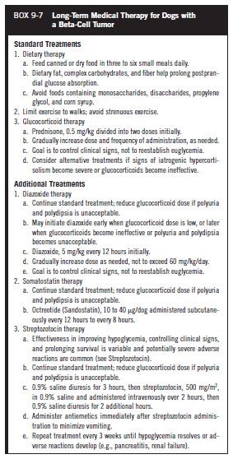
- Prognosis
  - Guarded to poor
  - Survival time 196 days with medical treatment, 785 days with surgery and medical treatment

Questions:
- What is whipple’s triad?

Answer:
  - Symptoms occur after fasting or exercise
  - During symptoms, BG is < 50 mg/dL
  - Symptoms are relieved by administration of glucose

