MAIN POINTS
- Insecticidal poisoning less common as newer insecticides are more specific in their mechanisms (insect specific).
- Most new insecticides cause dermal signs or gastritis. Typically self limiting. Treatment supportive.
  - Inappropriate use of permethrin resulting in toxicity is the most concerning newer insecticide toxicity.
- OP and carbamates are highly toxic.

ORGANOPHOSPHATES AND CARBAMATES
Mechanism of action
- Competitively inhibit acetylcholinesterase (AChE)
- Acetylcholine (ACh), with AChE bound, accumulates at nerve junctions in muscles, glands, CNS
- Smooth muscle - Excessive ACh causes excessive stimulation of muscle and glandular secretions
- Skeletal muscle - Excessive ACh is partly stimulatory (fasiculations) and inhibitory (muscle weakness)
- Inhibition of AChE by OPs is irreversible
- Inhibition of AChE by carbamates can be reversible

Exposure
- Available as sprays, pour-ons, oral anthelmentics, baits, collars, dips, dusts, granules, foggers
- Quickly absorbed after dermal, oral, and inhalation exposures

Clinical signs
- Onset of clinical signs - minutes to hours
- Causes depressed cholinesterase activity (Muscarinic, nicotinic, and CNS signs)
- Muscarinic signs: “SLUDDE” signs (salivation, lacrimation, urination, defecation, dyspnea, emesis), miosis, bradycardia. Dyspnea is due to increased bronchial secretions.
- Nicotinic effects: muscle tremors, fasiculations, weakness, ataxia, paresis progressing to paralysis
- CNS signs: hyperactivity, ataxia, seizures, and coma
- Death from respiratory or cardiac failure
- Delayed neurotoxic effects of OP (Cats > rodents more sensitive)
  - OP-induced delayed neuropathy (OPIDN): occurs 2-3 weeks after exposure. Causes hindlimb ataxia, hypermetria, proprioceptive deficits. Caused by phosphorylation of neurotoxic esterase (not from inhibition of AChE)
- Acute pancreatitis: can follow OP exposure, due to ACh release from pancreatic nerves and prolonged hyperstimulation of pancreatic acinar cells

Diagnosis
- Atropine test: 0.2 mg/kg IV and look for expected tachycardia and mydriasis
  - OP or carbamate tox requires 10x this dose for resolution of clinical signs of toxicity
- AChE activity (in plasma, serum, whole blood):
  - <50% of normal indicates significant exposure
  - <25% of normal + SLUDDE, nicotinic signs: toxicosis
- Identifying anticholinesterase insecticide in tissue or body fluids (GI tract, liver, skin, blood)

Treatment
- Asymptomatic: emesis (if oral ingestion), bathing with liquid dish detergent, activated charcoal
- Symptomatic
  - Seizure control: diazepam, barbiturates
  - Respiratory stabilization: oxygen or ET intubation
  - Atropine sulfate: 0.2 mg/kg (1/4 IV, rest IM or SQ) to control muscarinic signs. Blocks effects of accumulated Ach at synapse. Repeated as needed. No effect on nicotinic effects or CNS effects (seizures).
  - Glycopyrrolate: 0.01–0.02 mg/kg IV
  - Oximes to reverse the neuromuscular blockade and nicotinic signs.
    - Pralidoxime chloride (2-PAM; Protopam): 20 mg/kg IM or IV bid (repeat 3-4x)
    - Not used for carbamate tox

Prognosis
- Good unless signs of respiratory distress (increased pulmonary secretions, respiratory paralysis) or seizures present

PYRETHRINS/PYRETHROIDS
Pyrethrins are botanical insecticides. Pyrethroids are synthetic analogues

Mechanism of action
- Modulate gating kinetics by slowing the closing of Na+ gates

  - Type II pyrethroids: alpha cyano group.
    - Cause a longer duration of the sodium current in the axon
    - Signs: weakness and paralysis
    - More toxic than type I
  - Type I pyrethroids: no cyano group.
    - Signs: tremors and seizures
- Absorbed dermally, orally, and via inhalation
- Highly lipophilic and distribution to tissues is rapid
- Metabolized and eliminated primarily through the urine
- Paresthesia: results from direct action on sensory nerve endings
- Taste reactions: isopropyl alcohol in topical formulations

Clinical signs
- Cats: paresthesia, generalized tremors, shaking, ataxia, drooling, seizures, and death.
- Dogs: paresthesia (shaking of legs, mild muscle fasciculation, rubbing of application site, agitation, nervousness) after dermal application
- Ingestion of lawn use products (granular bifenthrin) : vomiting, diarrhea, ataxia, tremors and sometimes seizures

Treatment
- Bathing
- Paresthesia: vitamin E oil, corn oil, olive oil on the application area
- Tremoring or seizing: Methocarbamol (50 mg/kg IV; maximum dose 330 mg/kg/d – NOT REFERENCED). Diazepam or if severe CRI of propofol, barbiturates, or gas anesthesia
- Monitor body temp
- IV fluids
- IV lipid emulsion therapy

IMIDACLOPRID
- Topical spot-on for dogs (fleas) and numerous products for agricultural and yard use
- Mimics the action of ACh in insects, not degraded by AChE
- Binds to the postsynaptic nicotinic ACh receptor and results in persistent activation, preventing impulse transmission and a buildup of Ach
- Binding affinity in mammals is much less compared to insects
- Safe in mammals
  - Does not accumulate and has poor penetration of the blood-brain barrier
  - Dermal exposures have practically no systemic absorption
  - Large margin of safety - labeled for use in pregnant animals, and puppies/ kittens (7 weeks)

Clinical Signs of toxicity
- Dermal hypersensitivity
- Ingestion: ulcers, gastritis in cats
- Large ingestions of agricultural or yard use products: clinical signs similar to nicotine toxicosis (lethargy, drooling, vomiting, diarrhea, ataxia, and muscle weakness)

Treatment
- Bathing
- Antihistamines or corticosteroids for severe pruritus
- Oral exposures: dilute with milk or water
- Vomiting typically self-limiting.
- Massive ingestions: treat clinical signs

NITENPYRAM
- Oral adult flea insecticide
- Safe for pregnant and lactating animals
- Works systemically

Mechanism of action
- Similar to other neonicotinic insecticides (imidacloprid)
- Little to no binding to vertebrate peripheral Ach receptors
- Has almost no tissue accumulation
- Rapidly and completely abdorbed, primarily eliminated via the urine unchanged (94%)
- Wide margin of safety

Reported clinical signs
- Generally associated with the flea die-off and are not related to the medication: pruritis, hyperesthesia, hyperactivity, panting, agitation, excessive grooming, trembling, and ataxia
- Signs are usually self-limiting and resolve without any treatment

FIPRONIL
- Phenylpyrazole insecticide
- Spot-on/spray, ant and roach baits and seed and soil treatments

Mechanism of action
- Binds to GABA receptors of insects and blocks chloride passages (GABA antagonist) stimulation of the nervous system
- Less binding affinity for mammalian GABA receptors
- Wide margin of safety
- Dogs appear to be more sensitive than cats to fipronil

Clinical signs
- May be related to carriers
- Dermal hypersensitivity-type reaction: erythema, pruritis, irritation, alopecia at the application site
- Taste reactions: hypersalivation, foaming, gagging
- Vomiting
- Gastritis
- Extralabel use of fipronil on rabbits is known to cause severe and potentially fatal seizures

Treatment
- Supportive, bathing, antihistamines, steroids, IV fluids

ESSENTIAL OILS
- Rapidly absorbed orally and dermally
- Typically metabolized in liver by glucuronide and glycine conjugates
- Cytochrome P-450 enzyme systems in the liver can be induced with repeated exposure to some essential oils
- All species susceptible
- Clinical signs:
- Treatment: Emesis contraindicated because of risk of aspiration pneumonia

What is the mechanism of action of organophosphates and resulting clinical signs?
  - Irreversible inhibition of acetylcholinesterase resulting in muscarinic and nicotinic signs
  - Reversible inhibition of aceylcholinesterase resulting in muscarinic and nicotinic signs
  - Irreversible inhibition of acetylcholinesterase resulting in only muscarinic signs
  - Reversible inhibition of aceylcholinesterase resulting in only muscarinic signs

True or False. Atropine sulfate at large doses with control nicotinic effects caused by OP toxicosis

Draw an action potential and indicate where Permethrins exert their mechanism of action.
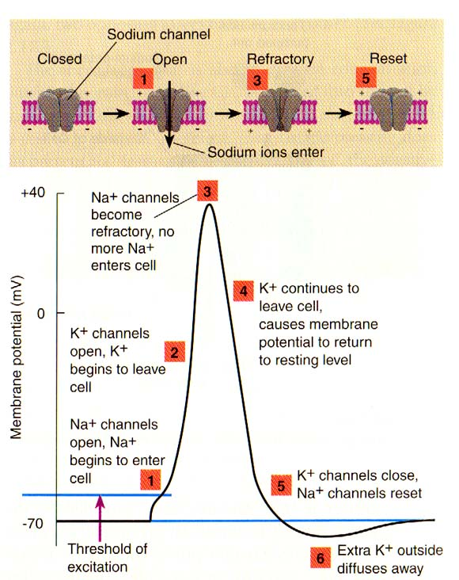

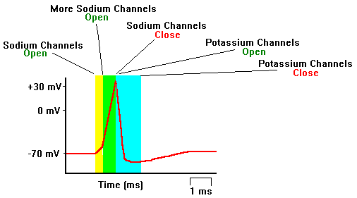

Mechanism of action
- Modulate gating kinetics by slowing the closing of Na+ gates

