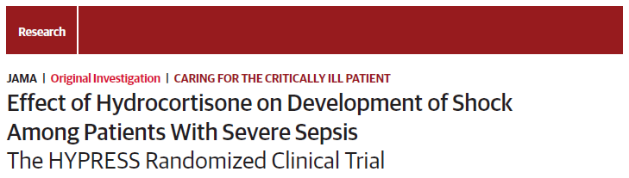
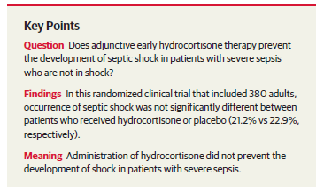
- Hydrocortisone for Prevention of Septic Shock (HYPRESS)
- German multicenter, placebo-controlled double-blinded randomized control trial
- Inclusion criteria: 380 patients
  - Evidence of infection
  - 2/4 SIRS criteria
  - Evidence of organ dysfunction present for not longer than 48h
- Exclusion criteria:
  - Septic shock
  - Hx of glucocorticoid medication
  - Etomidate or glucocorticoid use within 72 h of enrollment were not excluded
- End points:
  - 1ary: Occurrence of septic shock within 14 days
  - 2ary: Time until development of septic shock or death, mortality, organ dysfunction, duration of mechanical ventilation, renal replacement therapy
- CIRCI: defined as increase of cortisol of 9 ug/dL or less 1 hour after 250 ug of corticotropin
- Results:
  - Low-dose hydrocortisone did not prevent evolution of severe sepsis to septic shock
  - No differences in mortality, LOH
  - Hydrocortisone group had higher risk of developing hyperglycemia and lower risk of developing delirium
- Conclusion: No evidence to support use of hydrocortisone in these patients

