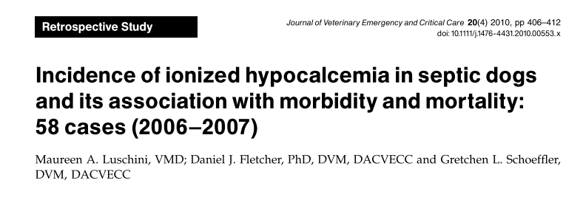
- Objective
  - To determine the incidence rate and prognostic significance of ionized hypocalcemia (iHCa) among septic dogs
- Methods
  - Retrospective study
  - 58 septic dogs
    - 2/4 SIRS criteria AND an infectious foci identified
    - Those with known Ca-altering diseases (such as hyperPTH) were excluded
  - Lowest, mean, highest blood iCa were recorded
    - Lowest: an estimate of the severity of hypocalcemia during hospitalization
    - Mean: reflected the persistence of abnormalities in iCa during hospitalization
    - Highest: revealed whether patients ever achieved normocalcemia during hospitalization
  - Morbidity assessments: duration of hospitalization and the number of transfusions.
    - Longer durations of hospitalization and greater numbers of transfusions administered inferred greater morbidity
  - Outcome:
    - Survival to discharge
    - Cardiac or respiratory arrest during hospitalization with unsuccessful resuscitation
    - Euthanasia
- Results/Discussion
  - 58 cases were included
  - 6 (10.3%) died during hospitalization
    - iHCa was documented in 4 of 6 (67%) of the patients that died
  - 19 (32.8%) were euthanized
    - 5 of 19 (26%) of the euthanized patients
  - 33 (56.9%) survived to discharge
    - 5 of 33 (15%) patients that survived to discharged
  - Overall incidence of 24%
  - Lowest and mean iCa were significantly different between the outcome groups
    - Septic dogs that died during hospitalization from cardiac/respiratory arrest had:
      - More severe iHCa (median lowest ionized calcium 1.09mmol/L,) than those that were discharged (median lowest ionized calcium, 1.24mmol/L) or euthanized (median lowest ionized calcium, 1.21mmol/L)
      - Significantly lower mean ionized calcium concentrations (median, 1.19mmol/L) than patients who were discharged (median, 1.26mmol/L)
    - No statistically significant difference in mean ionized calcium concentrations was found between those patients that died and were euthanized between those that were euthanized and were discharged
    - No difference was found when comparing the highest ionized calcium concentrations and outcome
  - Morbidity assessment:
    - A statistically significant association between the lowest iCa and duration of hospitalization was found
      - Lower iCa during hospitalization was associated with a longer duration of hospitalization
    - No association between mean or highest iCa and duration of hospitalization was found
    - Among patients receiving packed RBCs (3/58):
      - No association between the total dose of packed RBCs received (on a mL/kg basis) and the lowest, mean, or highest iCa
    - Among patients receiving plasma (14/58):
      - No association between dose of plasma received and outcome
      - No association between dose of plasma administered and lowest, mean, or highest iCa
- Conclusion
  - A significant association between iHCa with morbidity (longer duration of hospitalization) and mortality (cardiopulmonary arrest) exists

Questions
- T/F: iHCa occurs infrequently in the septic dog population presenting to an ER.
- In this study, what was associated with increased morbidity?
  - Highest iCa
  - Mean iCa
  - Lowest iCa
- You have to patients present at the same time, and both meet 2/4 SIRS criteria. Additionally, both have evidence of pyelonephritis. Initial bloodwork reveals patient A to have iCa of 1.1mmol/L (rr 1.17-1.37), and patient B to have iCa of 1.2mmol/L. Bloodwork 6 hours later reveals patient A to have iCa of 1.3mmol/L (mean 1.2mmol/L) and patient B to have iCa of 1.0mmol/L (mean 1.1mmol/L). You make which of the following conclusions:
  - Patient A has a worse prognosis due to hypocalcemia on presentation
  - Patient B has a worse prognosis due to lower iCa during hospitalization, and lower mean iCa
  - Patients A and B have the same prognosis

Questions
- T/F: iHCa occurs infrequently in the septic dog population presenting to an ER. 24% incidence found in this study
- In this study, what was associated with increased morbidity?
  - Highest iCa
  - Mean iCa
  - Lowest iCa
- You have to patients present at the same time, and both meet 2/4 SIRS criteria. Additionally, both have evidence of pyelonephritis. Initial bloodwork reveals patient A to have iCa of 1.1mmol/L (rr 1.17-1.37), and patient B to have iCa of 1.2mmol/L. Bloodwork 6 hours later reveals patient A to have iCa of 1.3mmol/L (mean 1.2mmol/L) and patient B to have iCa of 1.0mmol/L (mean 1.1mmol/L). You make which of the following conclusions:
  - Patient A has a worse prognosis due to hypocalcemia on presentation
  - Patient B has a worse prognosis due to lower iCa during hospitalization, and lower mean iCa
**Though it’s probably not possible to stratify patients with the findings from this study, patient B has decrease ‘lowest’ iCa (a measure of severity of hypocalcemia) and mean hypocalcemia during hospitalization.
  - Patients A and B have the same prognosis

