Key Points
- Hypocalcemia is common in sick or septic human patients, but unknown occurance in veterinary medicine (as of 2007)
- Mechanisms are unknown but proposed to be either redistribution, dependent on PTH changes, renal losses or others
- Supplementation should be done via CRI only for clinical patients, severe hypocalcemia, or hypotensive patients not responsive to fluids and vasopressors
- Proposed mechanisms of hypocalcemia include:
  - Intracellular redistribution
  - Hypomagnesemia
  - Alkalosis
  - Paratyhroid gland suppression
  - Vit d deficiency
  - Impaired response to vit d
  - Elevations in calcitonin precursors
  - Cytokine downregulation of PTH

- Hypoparathyroidism
  - Rare as primary disorder
  - Secondary may be seen as part of MODS associated with sepsis
  - Cytokines from sepsis may also downreg Parathyroids
  - PTH in septic patients may be normal or elevated, suggesting other counteregulatory mechanisms at play
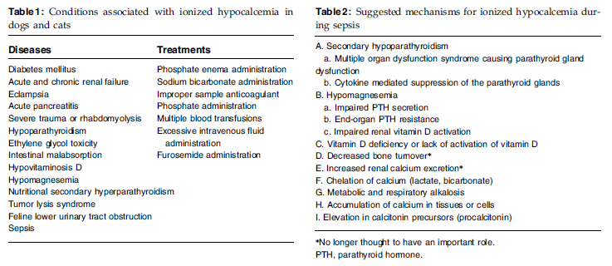
- Hypomagnesemia
  - Impairs PTH secretion
  - Induces end-organ PTH resistance
  - Decreased activated vit D
- Procalcitonin (ProCT)
  - Calcitonin precursor
  - Elevated proCT concentrations have been documented in septic patients
    - Correlate to severity of disease in some populations
    - Body-side upregulation of proCT
- Humans
  - 70% of ICU patients had hypocalcemia
  - 80% of septic patients
  - Higher mortality of hypocalcemic patients
  - ProCT can be used to tract pneumonia and stop antibiotics
- Veterinary medicine
  - Mostly experimental studies
  - Small dog study failed to distinguish sepsis and non-septic SIRS with proCT
  - Treatment:
    - Experimental studies say that calcium administration increases mortality in septic patients
      - Possibly due to already increase intracellular calcium influx worsened by supplementation resulting in cell death
      - Recommends to pursue fluids and vasopressors FIRST prior to administration of calcium
      - Exceptions
        - Clinical signs of hypocalcemia
        - Severely low iCa (<0.75mmol/L)
        - Hypotension unresponsive to fluids and vasopressors
      - CRI preferred over bolus due to possible calcitonin release from bous
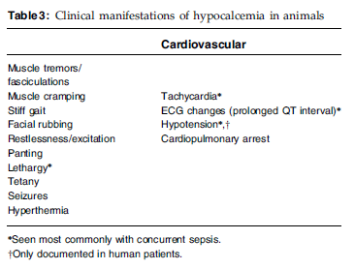

Questions

- You have a patient with hypocalcemia (0.84 mmol/dL), hypotension (MAP 56) and suspected septic abdomen. Patient does not have cardiovascular disease and has not yet received treatments. What the order of steps that you should pursue to correct hypotension.
  - IV fluid bolus, calcium gluconate, vasopressor therapy
  - Calcium gluconate, IV fluid bolus, vasopressor therapy
  - Vasopressor therapy, IV fluid bolus, calcium gluconate
  - IV fluid bolus, Vasopressor therepy, calcium gluconate
- True/False: Supplementation of calcium in a septic patient may worsen outcomes by increasing intracellular calcium influx and cell death
- Which of the following is a proposed mechanism of ionized hypocalcemia in septic patients?
  - Cytokine mediated upregulation of PTH
  - Reduced GFR
  - Hypermagnasemia resulting in reduced parathyroid gland activity
  - Lactate chelation of ionized calcium

Answers

- You have a patient with hypocalcemia (0.84 mmol/dL), hypotension (MAP 56) and suspected septic abdomen. Patient does not have cardiovascular disease and has not yet received treatments. What the order of steps that you should pursue to correct hypotension.
  - IV fluid bolus, calcium gluconate, vasopressor therapy
  - Calcium gluconate, IV fluid bolus, vasopressor therapy
  - Vasopressor therapy, IV fluid bolus, calcium gluconate
  - IV fluid bolus, Vasopressor therepy, calcium gluconate
- True/False: Supplementation of calcium in a septic patient may worsen outcomes by increasing intracellular calcium influx and cell death
- Which of the following is a proposed mechanism of ionized hypocalcemia in septic patients?
  - Cytokine mediated upregulation of PTH
  - Reduced GFR
  - Hypermagnasemia resulting in reduced parathyroid gland activity
  - Lactate chelation of ionized calcium

