Key Points
- Some antigens, when injected into the skin, induce a slowly developing inflammatory response called delayed, or type IV, hypersensitivity
- Delayed hypersensitivity reactions are mediated by T cells and natural killer cells
- A different form of type IV hypersensitivity occurs in allergic contact dermatitis. This is a slowly developing inflammatory response that occurs when reactive chemicals bind to skin cells and trigger a T cell response
12-72h from initial cell recognition to development of tubercle

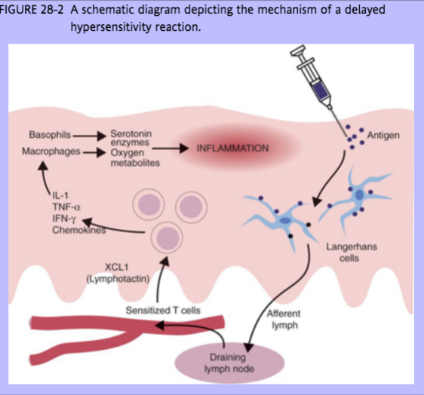
Th1-cell derived chemokines cause inflammation and attract even more T cells (the vast majority of T cells present in lesions are attracted non-specifically)
Ag presented to memory T cells (made from previous exposure to Ag)
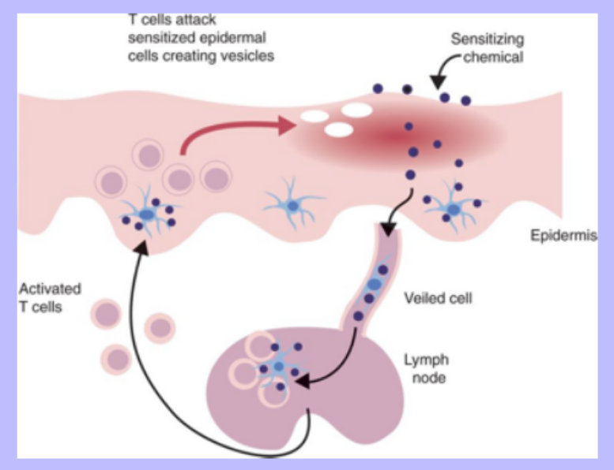
Cytotoxic T cells destroy and remove the altered cells resulting
in the development of intraepithelial vesicles

While presenting the antigen, Langerhans cells secrete large amounts of cytokines…to which cytotoxic T cells, macrophages and neutrophils respond to (infiltrate the region)

Langerhans cells may:
1. Bind the antigen directly to MHC molecules on the cell surface
2. Process the hapten internally into a complete
antigen

- Histologically: mononuclear cell infiltration and vacuolation of skin cells under attack by cytotoxic T cells
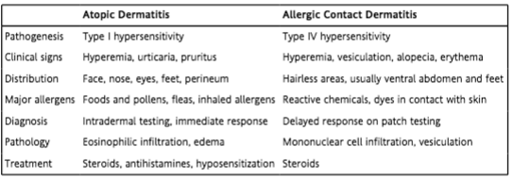
Measurement of cell-mediated immunity
- Serum antibody levels may not truly reflect the degree of immunity possessed by an animal
- In vivo: intradermal skin test
  - Difficult to quantify
  - May cause sensitization

Questions
- Describe the histologic differences between type I and type IV hypersensitivity reactions.
- Describe the pathogenesis of a type IV hypersensitivity reaction.

Answers
- Describe the histologic differences between type I and type IV hypersensitivity reactions.
  - Type IV is characterized by mononuclear cell infiltration and vesicles
  - Type I is characterized by eosinophils and edema
- Describe the pathogenesis of a type IV hypersensitivity reaction.
  - Sensitizing allergen -> Langerhans cells -> lymph nodes -> presented to T memory cells -> generation of cytokines from Th1 cells -> recruitment of macrophages and basophils and eventual degranulation

