Hypernatremia Review – NEJM 2000

- Sodium (and therefore osmolality) closely controlled by water homeostasis – which is mediated by thirst, ADH, kidneys
- Sodium is an effective osmole and therefore contributes to tonicity (induces movement of water across cell membranes)
- Hypernatremia = deficit of water in relation to sodium stores – resulting from net water loss or hypertonic sodium gain
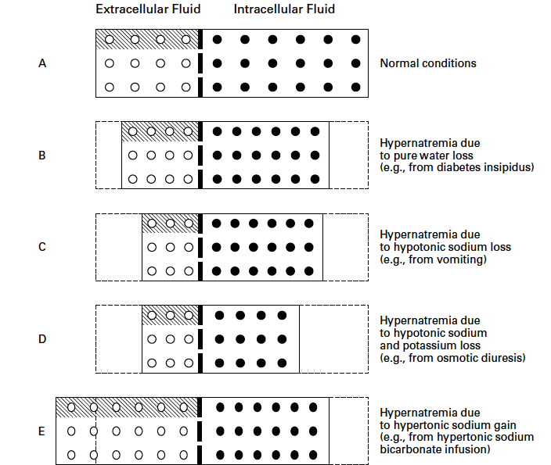
- Sustained hypernatremia can occur only when thirst or access to water is impaired
  - Altered mental status, intubated, no access to water
- Clinical signs
  - CNS dysfunction
  - Depend on severity and rapidity
  - Brain shrinkage can cause vascular rupture cerebral bleeding permanent neuro damages or death
    - Brain shrinkage is countered by adaptive response that is initiated promptly = solute gain (idiogenic osmoles) by the brain to restore lost water normalization of brain volume. BUT this does not correct hyperosmolality in the brain; in patients with prolonged hyperosmolality, aggressive tx with hypotonic fluids may cause cerebral edema coma, convulsions, death

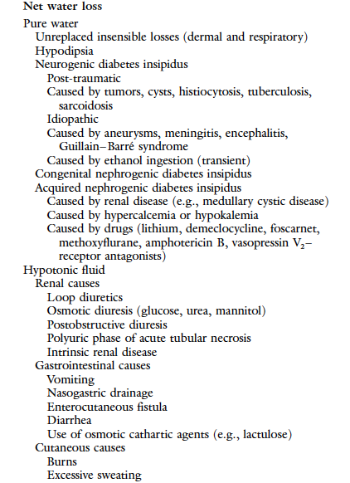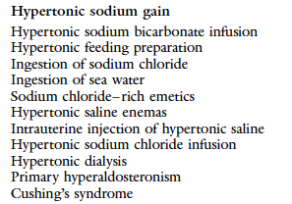

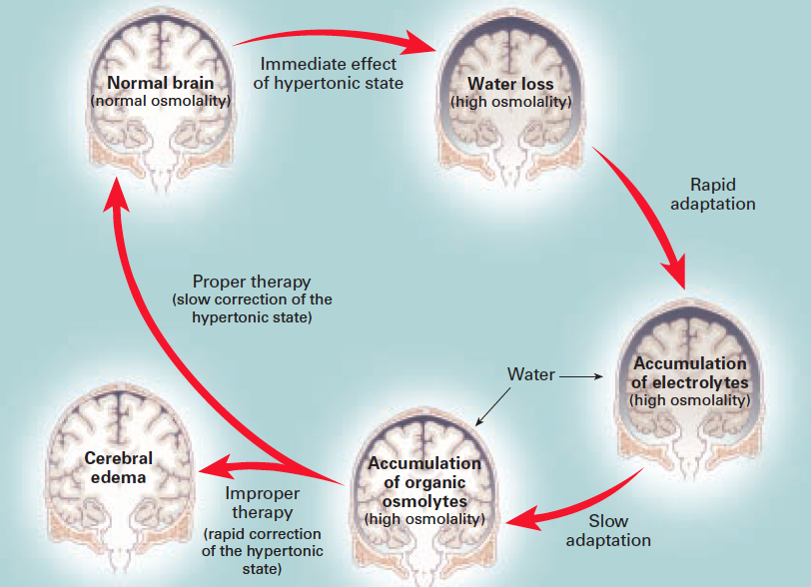

- Tx
  - Address the underlying cause
  - Correct hypertonicity
    - Acute: If hyperNa has developed over period of hours rapid correction improves Px w/out increasing risk of cerebral edema (accumulated electrolytes are rapidly extruded from brain cells)
      - Reduce sodium by 1 mmol/L/h
    - Chronic: If hyperNa of longer (or unknown) duration; full dissipation of accumulated brain solutes occurs over a period of several days maximal rate of 0.5 mmol/L/h to prevent cerebral edema/convulsion (max 10 mmol/L/day)
  - Route for admx fluids – if possible po; otherwise IV
  - ONLY HYPOTONIC FLUIDS ARE APPROPRIATE: pure water, D5W, 0.2% NaCl, 0.45% NaCl
    - The more the hypotonic the lower the infusion rate required
    - Risk of cerebral edema increases with the volume of the infusate volume should be restricted to that required to correct hypertonicity
  - EXCEPT IN CASES OF FRANK CIRCULATORY COMPROMISE, 0.9% NaCl is unsuitable for managing hypernatremia
    - Retention of 1 liter of 0.9% NaCl will decrease the serum sodium concentration by a tiny little amount
      - A 70 kg dog with a [sodium] = 162 mmol/L is given 1L of 0.9% NaCl
        - (154-162)/([0.6 x 70 kg] +1) = -0.186
        - Sodium will only decrease by 0.18 mmol after administration of 1L
        - [sodium] in 0.9% NaCl, despite being lower than that of the patient is NOT LOW ENOUGH to alter hypernatremia substantially
        - AND the ongoing hypotonic losses might OUTPACE the admx of NS aggravating hypernatremia
        - SOLE INDICATION for administering 0.9% NaCl to a patient with hypernatremia correction of substantial hemodynamic compromise
  - This review does not recommend using the conventional formula for water deficit calculation although it provides an adequate estimate of water deficit in patients with hypernatremia caused by pure water loss, it underestimates the deficit in patients with hypotonic loss – use this formula instead:
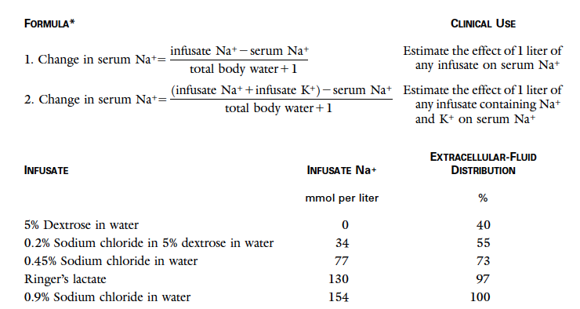
  - And provide extra fluid to correct/replace ongoing losses
Question

Your patient, Pepito Sangria, a 5 kg male neutered domestic short hair cat, spent the day at the Santa Monica beach working on his tan. His owner, a surfer named Carlos, failed to provide him with fresh water because he was too busy rocking the waves. When Carlos, in his wet suit, brings Pepito Sangria to your clinic, you immediately notice Carlos’ perfect Californian tan and then you focus (not fuck us) on Pepito Sangria. You place an IV catheter and draw blood. His serum sodium concentration is 170 mmol/L (normal is 149-157 mmol/L). You decide that Pepito Sangria needs IVFT and you choose D5W. Which volume are you going to administer and how fast? (Let’s assume that Pepito Sangria is a perfectly healthy cat otherwise and that his sodium was normal 24h ago)

Answer

Change in sodium concentration with administration of 1L of D5W to 5 kg cat with a sodium concentration of 170 mmol/L will be: (0-170)/([0.6 x 5.5 kg] +1) = -42.5 mmol
You want to decrease sodium from 170 mmol/L to 153 mmol/L (middle of the normal range) = 17 mmol/L
Acute increase in sodium so you can decrease sodium by 1 mmol/L/h which will take 17 hours
1L of D5W will decrease sodium by 42.5 mmol but you only want to decrease it by 17 mmol so you will not need the entire liter = 400 ml is needed
400 ml over 17 hours = 23 ml/h of D5W

