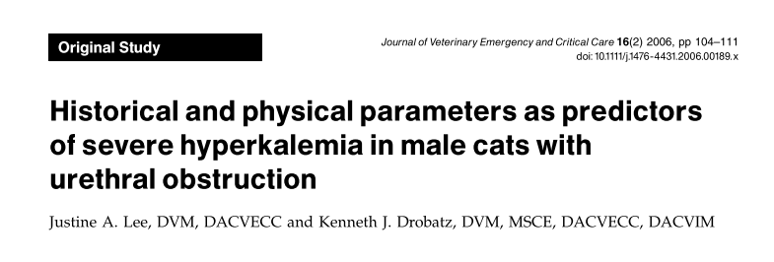
- Objective
  - To evaluate selected historical and physical parameters as predictors of hyperkalemia in male cats with urethral obstruction
- Background
  - Retrospective study
  - 233 male cats
  - Inclusion criteria: any previously untreated male cat presented with clinical signs consistent with a urethral obstruction and that had a large, firm, non-expressible urinary bladder
  - TPR, peripheral pulse strength, presence of arrhythmias assessed
  - On admit:
    - Measured: pH; pCO2; pO2; sodium, potassium, chloride, iCa, glucose, lactate
    - Calculated: bicarbonate and base excess
  - Univariate logistic regression
- Results: in cats with UO
  - Majority were exclusively indoors (173/208 [83%], CI 77–88%)
  - Majority were presented for their first occurrence of urethral obstruction (161/216 [75%], CI 68–80%)
  - Anorexia noted in 115 of 191 (60%, CI 53–67%)
  - Vomiting noted in 104 of 204 (51%, CI 44–58%)
  - 68 (39%, CI 32–47%) were hypothermic (T: <100F)
  - 87 (50%, CI 43–58%) were normothermic (T 100F-102.5F)
  - 19 (11%, CI 7–17%) were hyperthermic (T >102.5F)
  - 22 had a HR< 140 bpm (20%, CI 7–17%) and were considered mildly bradycardic
  - 12 had HR 100-140 (6%, CI 3–11%) and were considered moderately bradycardic
  - 10 cats with UO a HR <100 (5%, CI 2–10%) and were considered severely bradycardic
  - The median respiratory rate was 36bpm
  - 26 of 171 cats (15%, CI 10–21%) had weak pulses
  - 66 of 176 cats (38%, CI 30–45%) were reported to be depressed
  - 64 of 170 cats (38%, CI 30–45%) were considered to be weak
  - 21 of 189 (11%, CI 7–16%) had arrhythmias on presentation to the emergency room
  - 76% (151/199, CI 69–82%) had [K] <6.0mmol/L
  - 12% (24/199, CI 8–17%) had [K] 6.0-8.0mmol/L
  - 12% (23/199, CI 7–17%) had [K] 8.0-10mmol/L
  - 0.5% (1/199, CI 0–3%) had [K]>10.0mmol/L
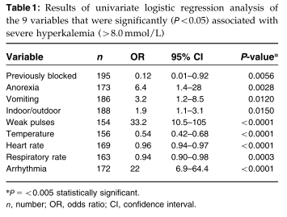
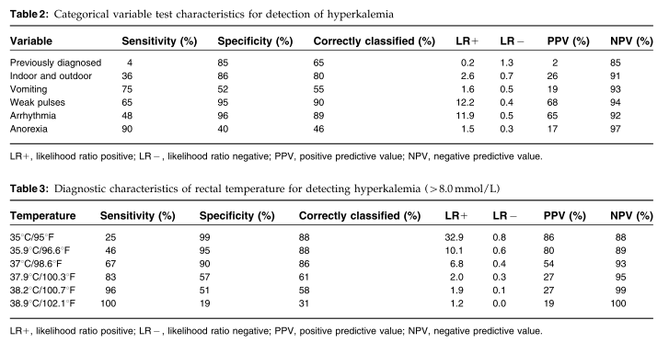

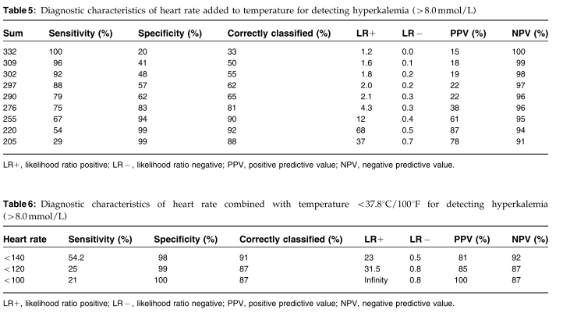
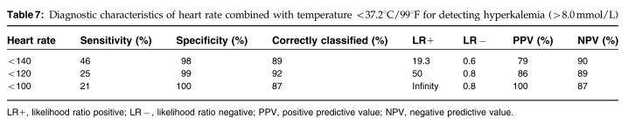
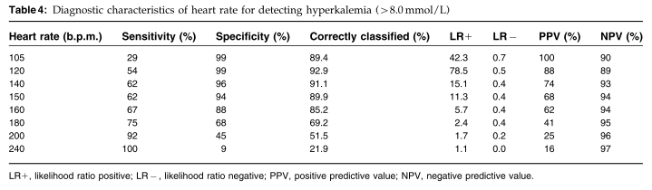
- Discussion
  - Sensitivity: Among the cats that were hyperkalemic, what proportion were test-positive (True positive rate)?
  - Specificity: Among the cats that were not hyperkalemic, what proportion were test-negative (True negative rate)?
  - Positive predictive value: Given a positive test, what is the probability of a cat being hyperkalemic?
  - Negative predictive value: Given a negative test, what is the probability of a cat not being hyperkalemic?
  - Likelihood ratio positive: Given a positive test, what is the chance (likelihood or odds) of the cat being hyperkalemic?
  - Likelihood ratio negative: Given a negative test, what is the chance (likelihood or odds) of a cat being hyperkalemic?
  - Correctly classified: Accuracy of the test. How many true positives and true negatives can a test correctly classify?
  - Positive predictive value: the probability that subjects with a positive screening test truly have the disease
  - Negative predictive value: the probability that subjects with a negative screening test truly don't have the disease

