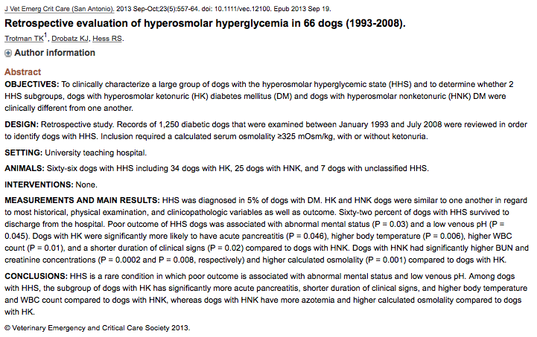

Main Points

- HHS was diagnosed in 5% of dogs with DM
- 62% of dogs with HHS survived to discharge
- Poor Outcome was associated with abnormal mental status and low venous pH
- HK dogs were more likely to have pancreatitis, higher body temperature, higher WBC counts and shorter duration of clinical signs
- HNK dogs had significantly higher BUN and creatinine concentrations and high calculated osmolality.

- Definitions
  - Hyperosmolality
    - Hyperosmolality >310 mOsm/kg
    - Marked hyperosmolality > 300 mOsm/kg
    - Severe hyperosmolality > 330 mOsm/kg
    - This study used >325 mOsm/kg
  - HK vs HNK
    - HNK: hyperosmolar nonketonuric
    - HK: Hyperosmolar ketonuria
- Results
  - 66/1250 (5%) DM dogs had HHS
    - 34/66 (51%) had HK
    - 25/66 (38%) had HNK
    - 7/66 (11%) unclassified (no UA performed)
  - Variables that did NOT differ between HK and HNK
    - Mean age at time of hyperosmolar episode 9.7 +/- 3.1 years
    - Mean age at time of diagnosis of DM 8.7 +/- 3.4 years
    - No difference in sex distribution
      - 53% MC, 36% FS, 6% FI, 4% MI
    - No difference in having received insulin treatment prior to episode
      - 53% newly diagnosed
      - 47% previously diagnosed and treated for median 12 months (0.03-108 months)
    - No difference in presence of moderate to severe dehydration (86% of dogs)
    - Mental status
      - 73% of dogs with HHS had abnormal mentation (64% depressed/dull and 9% coma) AND THIS WAS ASSOICATED WITH A POOR OUTCOME
      - no significant association between abnormal mental status/behavior changes and calculated/effective osmolality, BUN, Na, Glucose concentrations
      - in people, abnormal mental status is associated with osmotic shift of water out of cells > cellular dehydration > neurologic abnormalities. In humans (but not this study) severity of osmolality associated with degree altered mentation
    - Bloodwork
      - Venous pH, lactate, bicarbonate
        - BUT LOWER venous PH in dogs that did not survive to discharge (7.24 +/- 0.13) vs survive to discharge (7.30 +/- 0.09, P= 0.045)
    - Urine cultures
      - 14/58 (24%) showed bacterial growth – E. coli most commonly
    - Diagnosis of hyperadrenocorticism, NOT associated with outcome
    - SURVIVAL NOT DIFFERENT BETWEEN HK AND HNK
      - 38% HHS not discharged from hospital: 22 euthanized and 3 died
      - 48% non-survivors HNK and 44% HK, 2% unclassified
  - Variables that DID differ between HK and HNK
    - Mean duration of clinical signs prior to hyperosmolar episode 0.30 +/- 0.39 months (0.03-3 months)
      - Clinical signs: inappetence (95%), lethargy (92%), vomiting (88%), PU/PD (67%), behavioral changes (44%) and diarrhea (27%).
        - BG > 3.6 mmol/L (65 mg/dL) in all dogs with behavioral changes
      - HK mean duration 0.20 +/- 0.14 months (0.03-0.5 months) significantly shorter than HNK duration 0.38 +/- 0.57 months (0.03-3 months)
    - Body temperature 101.4F (96-105.8 F)
      - HK significantly higher 102.2 F (96-105.8F)
      - HNK 100.8 F (96.5 – 104.2 F)
      - Median body temperature in both groups was within normal range
    - Bloodwork
      - Total WBC count on CBC significantly higher in HK (23.6, 10.4-67.4) vs HNK (14.8, 6.9 – 34.4)
      - Higher BUN, CRE and K concentrations and calculated osmolality in HNK
        - Osmolality HNK: 352.5 (325-390) vs HK 339 (325-382)
          - Takes BUN into account
        - BUN HNK 61.2 (5-109.6) vs HK 27.5 (5-72.8)
        - CRE HNK 4.4 (0.9-10.6) vs HK 2.5 (0.9-7.6)
        - K HNK 5 (3.3-7) vs HK 3.7 (2.4-6.6)
      - Effective osmolality higher in HK (335, 297-381) vs HNK 315 (276-374)
      - Outcome not associated with WBC, BUN, Na, corrected Na, glucose, calculated or effective osmolality
    - Abdominal ultrasound
      - HK (50%) more likely than HNK (24%) to have acute pancreatitis, but this was not associated with outcome (possibly related to shorter duration of clinical signs prior to hospitalization)
- Limitations
  - 13/66 (20%) samples had lipemia (common in diabetes) which can affect reported concentrations of sodium and therefore osmolality
  - 7/66 dogs did not have UA
    - kept so as not to bias study by excluding the most critically ill dogs in which UA could not be collected/performed
  - Degree of dehydration determined subjectively by numerous clinicians
  - Serum beta-hydroxybutyrate not available for review in medical records so could not correlate degree of acidosis with degree of ketosis

