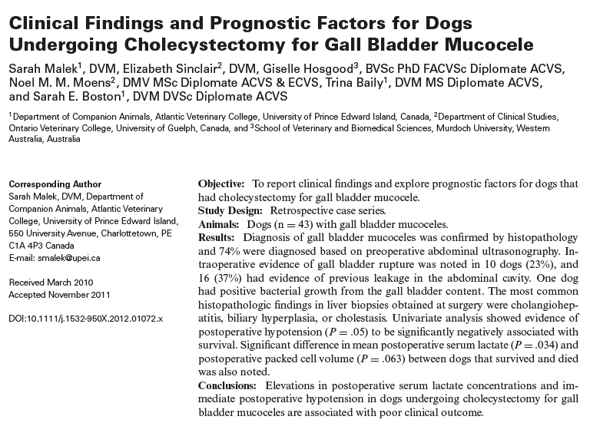

- Gall bladder mucocele: mucus-filled distension of the gall bladder and associated with secretory dysfunction, this accumulation of viscous mucus can cause obstruction of the common bile duct (CBD), resulting in partial or complete obstruction, progressive distention can lead to gall bladder or bile duct rupture
- Histologically: cystic mucinous hyperplasia
- Cholecystectomy involves flushing the CBD before cystic duct ligation to ensure patency, normograde or retrograde through the duodenal papilla after duodenotomy
- Retrospective study, 42 dogs
  - Most frequent clinical signs: Vomiting 90.7%, anorexia 72.1%, lethargy 81.4%
  - Most frequent concurrent problems were hyperadrenocorticism, controlled diabetes with DKA, hypothyroidism
  - 76.7% had a viable, intact gall bladder, necrosis 18.6%
  - 37.2% had evidence of bile leakage
  - Negative culture 97.3%, only positive culture did not have necrosis of GB > 95.4% had been of preoperative antibiotics
  - Postoperative hypotension increased risk of death 20x
  - Increase in lactate by 1 increased risk of death by 30%
  - Decreased postoperative PCV was associated with mortality
  - Immediate postop mortality (2 weeks) 7%
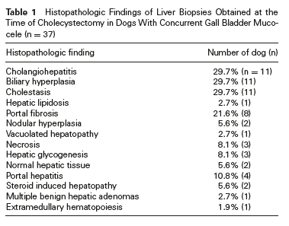

Questions:

- What are the most common breeds associated to gall bladder mucocele?

- What abnormalities do you expect to see in a gall bladder mucocele patient’s chemistry panel?

- The 3 most common histopathologic findings in liver biopsies from gall bladder mucocele patients are:

Answers:

- What are the most common breeds associated to gall bladder mucocele?
Cocker Spaniel, Shetland sheepdog, Miniature Schnauzer

- What abnormalities do you expect to see in a gall bladder mucocele patient’s chemistry panel?
Elevations in Total bilirubin, ALKP, ALT, GGT

- The 3 most common histopathologic findings in liver biopsies from gall bladder mucocele patients are:
Cholangiohepatitis, biliary hyperplasia, cholestasis

