Fluid administration in severe sepsis
and septic shock, patterns and outcomes:
an analysis of a large national database
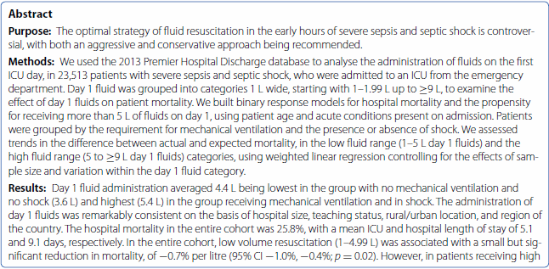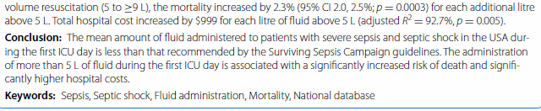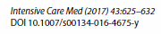
Take-home message: In patients with severe sepsis and septic shock, the administration of more than 5 L of fluid on the first hospital day is associated with a significantly increased risk of death and significantly higher hospital costs. Low-volume resuscitation (1–4.99 L) is associated with a small but significant reduction in mortality.

Background:
- Aggressive fluid therapy has traditionally been advocated in sepsis (including by Rivers goal directed therapy)
- Reason to give fluids is to increase stroke volume and increase cardiac output
  - However, only ~50% of patients will respond and benefits are short lived (<1hr)
Hypothesis: Large volume fluid resuscitation (>5L) during first ICU day would be associated with increased risk of severity-adjusted mortality

Retrospective cohort study. Cohort compaired to ProCESS trial to see if patient populatons were similar
Chose 5L per day as cutoff between groups on basis or prognostic thresholds of previous studies

Results
- Overall mortality was 26.53%
- In patients receieving over 5L on first day, mortality increased by 2.5% for each additional liter
Conclusion
In conclusion, we have demonstrated the average day 1 fluid administration in patients with severe sepsis and septic shock, treated in a broad spectrum of hospitals in the USA, averages about 4.4 L, which is considerably less than that currently recommended. Furthermore, patients receiving more than 5 L of fluid during this time, regardless of illness severity, have an increased risk of death and higher hospital costs.

