Common Lesions in the Female Reproductive Tract of Dogs and Cats

Common Lesions in the Ovary
- Ovarian remnant syndrome
  - Remnant ovarian tissue can develop follicles and corpora lutea, and follicles may become cystic
  - Common clinical signs include periods of vaginal bleeding for several weeks, swelling of the vulva, licking rear region, and attraction to males
  - +/- multifocal areas of erythema on the ventral aspect of the abdomen, mammary gland enlargement due to progesterone activity, pollakiuria and stranguria, dermal hyperpigmentation and alopecia, polyuria and polydyspsia, poor coat, weight loss, and recurrent urinary tract infections
  - Vaginal cytologic examination: 80%–90% superficial cells will indicate an increasing circulating levels of estradiol
  - Estradiol and progesterone levels
  - AUS is limited due to the small size of the remnant tissue
    - May be useful in medium-sized to large dogs
- Cystic Ovaries
  - Anovulatory ovarian functional follicular cysts are common incidental findings in older bitches and queens
    - Originate due to failure to ovulate
  - Clinical signs:
    - Persistent or irregular proestrus/estrus manifestations due to hyperestrogenism, anestrus, and infertility
    - Chronic cases: symmetrical bilateral alopecia and bone marrow suppression may occur
  - Predisposes both species to cystic endometrial hyperplasia (CEH)-pyometra complex
  - AUS: 1+ large follicles
Common Lesions in the Uterus
- Cystic Endometrial Hyperplasia-Pyometra Complex
  - Hormone mediated
  - Cystic dilatation of
endometrial glands
    - Accumulation of noninflammatory, watery to viscid, aseptic fluid within the uterine lumen with posterior bacterial contamination, endometrial inflammation, and presence of blood and pus
  - Not all cases of CEH will end in
Pyometra
- Metritis/endometritis
  - Metritis is an inflammation of the uterus involving the mucosa and myometrium layers during the first week postpartum
    - Consequence of bacterial invasion through a dilated cervix to a susceptible uterus
  - Common isolated bacteria:
    - E. coli and Proteus
    - Streptococcus and Staphylococcus
- Endometritis
  - Inflammation of the endometrium
  - Present in many cases of infertile
bitches and queens
  - Generally chronic and subclinical
  - Histology: infiltration of PMNs in the endometrium
- Uterine Neoplasia
  - Occurs infrequently
  - Majority are of mesenchymal origin
    - Lack a glandular component and are benign
- Endometrial polyps
  - Old bitches and queens
  - Normally only one develops
    - Frequently small and of little consequence unless their growth compromise the uterine lumen
Common Lesions in the Vagina
- Vaginal Prolapse
  - Several forms of vaginal prolapse
  - ‘True’ vaginal prolapse occurs when the entire vaginal wall extends through the vulvar opening
    - Rare in the bitch and queen
    - Occurs around parturition, when concentration of serum progesterone declines and the concentration of serum estrogen increases
  - The urethra may be displaced and twisted and dysuria may occur
  - The prolapsed vagina is very vulnerable to trauma, ulceration, necrosis, and self-mutilation and may interfere with normal mating
  - Treatment is removal of the estrogen stimulus
  - Condition resolves spontaneously as the bitch enters diestrus
  - OHE
- Vaginal neoplasia
  - Majority are benign
    - Vaginal leiomyomas, fibromas and fibroleiomyomas
  - Complete surgical resection is usually curative
  - Canine transmissible venereal tumor
    - Most common tumor in the vagina in tropical developing countries
    - Chemoresponsive tumor most commonly treated with weekly intravenous vincristine
    - Chemotherapy treatments are continued until 1-2 treatments beyond full clinical remission of the tumor
    - Reports of surgical management of TVTs but recurrence is more likely with surgery

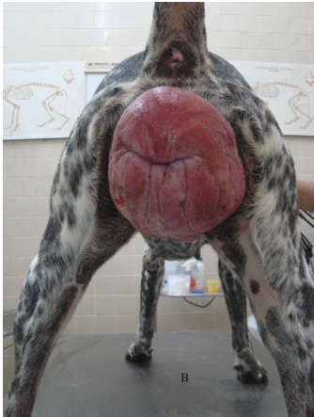
Questions

- You have a patient presented for evaluation of episodic vulvar bleeding. Among other differentials, you are concerned for ovarian remnant syndrome. What diagnostics could you perform to further evaluate the possibility of this condition?

Answers
- Vaginal prolapse
- Vaginal cytology, progesterone, estrogen, +/-AUS

