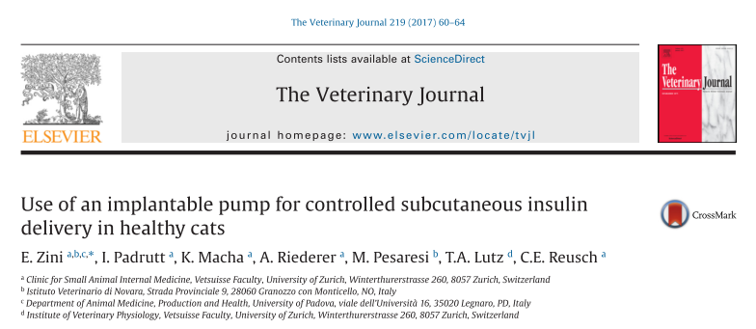

Study Design
- 10 healthy cats
  - 2y MC DSH
  - PE, CBC, chem
- Novel feline-specific insulin pump surgically implanted in the SC of the neck
- Assessed for function pre-implantation, and 1d, 3w, 5w, 8w
- Reservoir emptied and refilled at 4w
- Via human insulin glargine ELISA assay, assess the ability to measure insulin glargine and potential for cross reactivity with feline insulin
- Following programmed insulin delivery, insulin and glucose measured at 1h, 3h, 5h, 7h and 9h
- Pump removed at 90d
- Stability of insulin glargine not stored according to recommendation (to mimic being in the body rather than stored in the fridge) was assessed using mass spectrometry

Results
- Structural stability of insulin glargine is maintained at 37oC x 8w
- The insulin glargine ELISA was suitable for measuring insulin
glargine in cat plasma
  - No evidence of cross-reactivity between the insulin glargine ELISA and feline insulin
- Pump implantation:
  - Pump implantation took 25–30 min
  - 9/10 cats, the
pumps were removed after 90 days
  - One cat developed severe hypoglycemia (blood glucose 20 mg/dL) within 6 h of implantation: the pump was removed immediately
    - Leakage of insulin from the convex septum of the reservoir was identified
    - This cat was withdrawn from the study and the pump immediately removed
  - The remaining nine cats did not have detectable signs of discomfort or inflammation
- Pump boluses and refill, SC injections of insulin glargine
  - Prior to implantation the pumps recognition by the computer and bolus generation was assessed….functional in 10/10 pumps
  - Delivery of the bolus was accompanied by a faint buzzing noise from the pump: the noise lasted 5s and no cat reacted to it
  - After implantation, the computer did not recognize 1/9 pumps
    - This cat was withdrawn from the study and pump removed at 90d
  - First bolus (1w)
    - 8/8 cats: no problems were encountered
    - 6/8 cats had increased plasma
insulin glargine peaks AND decreased capillary blood glucose
    - 2/6 cats did not have increased plasma insulin glargine
      - 1/2 cats had a decrease in capillary blood glucose
  - Second bolus (3w)
    - 2/8 cats: the computer command was not received or processed by the pump
      - These cats were withdrawn from the study and the pumps removed at 90d
    - 1/6 cats had increased plasma insulin glargine
    - 1/6 cats had decreased capillary blood glucose
    - Second bolus did not significantly increase plasma insulin glargine or decrease capillary blood glucose
  - Pump filling (4w)
      - 6/6 cats: the procedure took 1 min, required only brief sedation and was straightforward without any complications
  - Third bolus (5w)
    - 1/6 cats: the computer command was not received or processed by the pump
      - This cat was withdrawn from the study and the pump removed at 90d
    - Did not significantly affect plasma insulin glargine and capillary blood glucose
  - Fourth bolus (8w)
    - 5/5 cats successfully received the bolus
    - Did not significantly affect plasma insulin glargine and capillary blood glucose
  - 50% (5/10 cats) successfully completed the study
  - 90d pump removal
    - The computer and pumps appeared to be functional and intact

Key Points
- The administration of insulin glargine via the pump increased
plasma insulin glargine to a noticeable degree in 75% of the first boluses, in only 17% of the second boluses, and in none of the remaining boluses
- Because the computer and pumps appeared to be functional until the end of the study, it is possible that failure was related to insulin glargine degredation over time
  - Mass spectrometry demonstrated structural stability of insulin glargine though it is possible that changes in the three-dimensional conformation of the protein were responsible for the malfunction, because conformational changes might not be detected by mass spectrometry
  - None of the 3rd/4th boluses produced an increase in plasma insulin glargine or a decrease in capillary blood glucose even though the reservoir was emptied before refill with fresh insulin glargine (after the second bolus)
  - This suggests that insulin glargine was rapidly inactivated in the pump
- The insulin delivery pump did not cause discomfort in cats, but
caused life-threatening hypoglycemia in one cat
- Frequent device problems indicate that technical improvements are necessary prior to the initiation of subsequent studies
- As successive boluses did not increase plasma insulin glargine, this insulin type may not be appropriate for use with the insulin pump

