Effects of neuromuscular blockers on transpulmonary pressures in moderate to severe acute respiratory distress syndrome
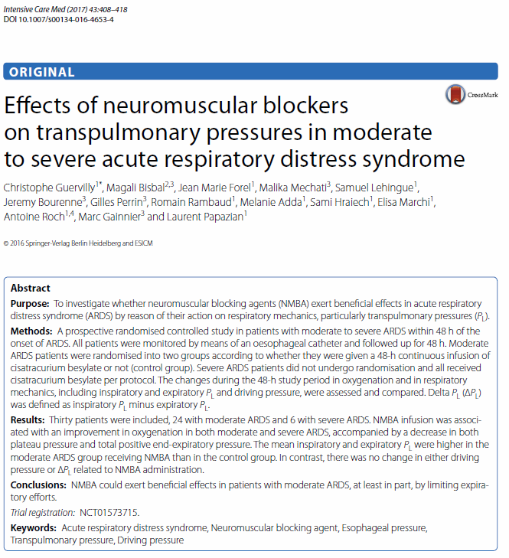
- Background:
  - Cisatricarium has anti-inflammatory effects through nicotinic acetylcholine pathway
  - Could possibly also improve synchronism and distribute pressure better during tidal ventilation
- Cons:
  - Using paralytics may decrease risk of diaphragmatic dysfunction (in dogs too?)
- Pros:
  - Spontaneous breathing could lead to increased transpulmonary pressures despite normal Pplat
- Patients:
  - Moderate to severe ARDS patients
    - All severe ARDS patients got cisatricarium (no control group for this pop)
  - Had to have P:F ratio <150 despite 5cmH2O PEEP
    - If < 100 on PEEP of 10 then severe ARDS
- Ventilation
  - Volume-Control, Assist Control
    - Goals were SpO2 of 88-95 or PaO2 of 55-80
  - Esophageal balloon used for measurement of Transpulmonary pressures
  - Sedation with Sufentanil, midazolam, +/- ketamine
Results
- Some improvement of transpulmonary pressures and of PaO2 in cisatricarium groups
- Cisatricarium group had lower PEEPS
  - Possibly due to better PaO2s, so clinicians could turn down PEEPs

