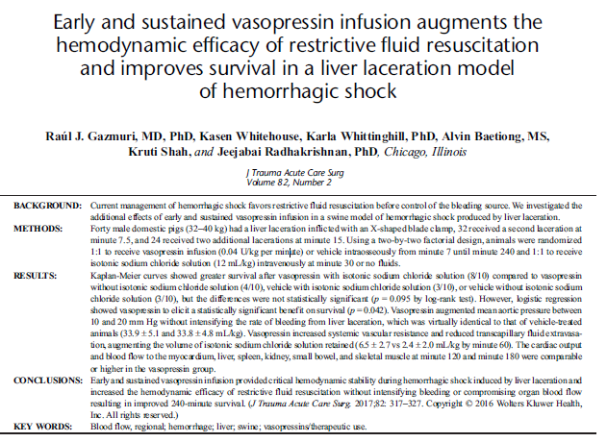
Purpose: To see if vasopressin infusion during hemorrhagic shock allows for more restrictive fluid resuscitation prior to surgical treatment

Background: Restrictive fluid administration (maintaining therapeutic hypotension) is recommended in humans, as aggressive fluids may worsen coagulopathy is via dilution and hypothermia, and dislodge clots

Methods - Pigs, controlled liver lacerations under anesthesia.
4 groups:
Vasopressin and fluids, vasopressin alone, fluids alone and nothing
Vasopressin rate was 0.04U/kg/min
Restrictive fluids were 12ml/kg over 30 min

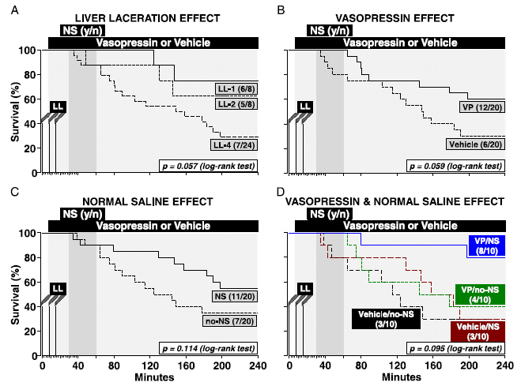

No statistical difference in groups:
V+F = 8/10 survived
V = 4/10
F = 3/10
Nothing = 3/10

However, logistic regression showed survival benefit to vasopressin (when comparing both no vasopressin groups to both vasopressin groups)

Vasopressin did not increase bleeding

