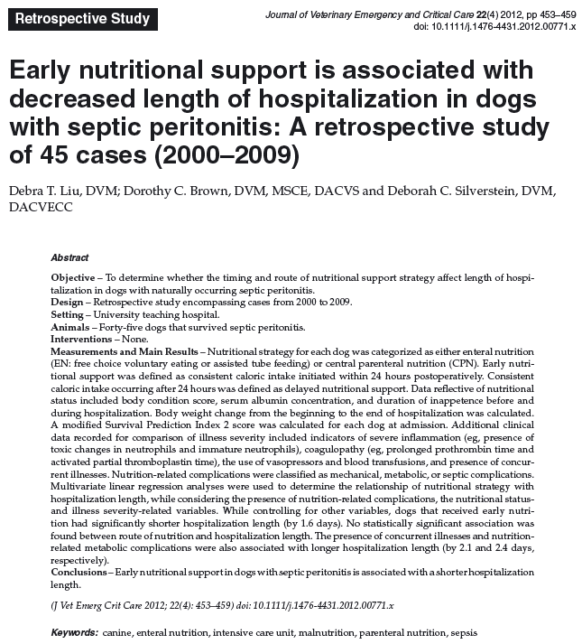
- Nutritional status was evaluated with albumin concentrations, BCS, days of inappetence pre hosp, days of anorexia during hosp, BW at admission and discharge.
- Complications were divided into mechanical, metabolic and septic categories
- Early nutritional support > appropriate caloric intake CPN or EN within 24h of surgery> 27%
- Late nutritional support > appropriate caloric intake CPN or EN 24h post-surgery >73%
- 71% received EN, 29% received CPN
- Mean serum Alb 2.5 +/- 0.8 g/dL, median wt change -2 to +4.8 kg, median inappetence duration 3 days, median no caloric intake in hosp 2 days, median of minimal to no caloric intake since onset illness 6 days
- 42% developed nutrition-related metabolic complications > HypoMg (33%) and HypoK (20%) most common, HypoP only occurred in CPN and stayed 2.4 days more in hosp
- 7% septic related complications > purulent discharge of jug cath or around feeding tube
- Early feeding in septic peritonitis dogs had a shorter hosp stay by 1.6 days
  - Hormonal modulation attenuating hypermetabolic state
  - Preservation of hepatic antioxidant defense
  - Prevention of protein-caloric malnutrition
  - Maintains GI barrier function

Questions
- What is refeeding syndrome?

- T or F: If a patient develops refeeding syndrome, nutrition should be stopped immediately

- Early feeding in septic peritonitis dogs can reduce hospitalization days due to :

a.
b.
c.
d.

Answers:
- What is refeeding syndrome?

Usually occurs after several days of inanition when they are re-fed. It is a life threatening syndrome characterized by electrolyte disorders such as hypophosphatemia, hypomagnesemia and hypokalemia.

- T or F: If a patient develops refeeding syndrome, nutrition should be stopped immediately
Electrolytes disturbances should be managed, nutrition should not be stopped

- Early feeding in septic peritonitis dogs can reduce hospitalization days due to :

a. Hormonal modulation attenuating hypermetabolic state
b. Preservation of hepatic antioxidant defense
c. Prevention of protein-caloric malnutrition
d. Maintains GI barrier function

