Disorders of Sodium and Water: Hypernatremia and Hyponatremia
Summary

- Volume and tonicity of body fluids is maintained by regulation of Na and water balance
- ECF is determined by the total body Na content
  - Osmolality and [Na] are determined by water balance
  - Kidneys balance excretion and conservation of Na

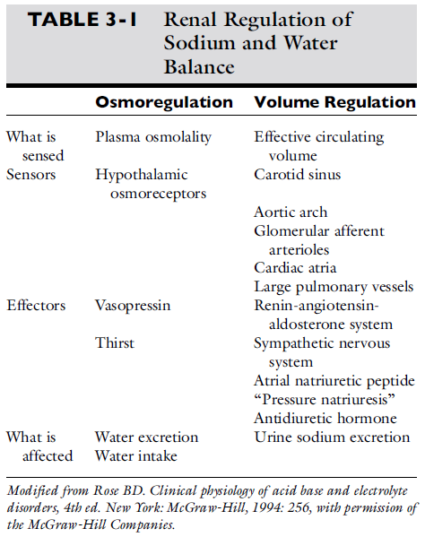

Osmolality: concentration of osmotically active particles in a solution
- Osmolarity: Osm/L
- Osmolality: Osm/Kg, term used in clinical medicine
- Measured by freezing-point depression osmometry
- Dogs: 290-310 mOsm/kg
- Cats: 290-330 mOsm/kg
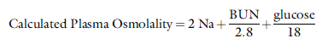
(Denominators are to convert BUN and glucose from mg/dL to mmol/L)

- Measured osmolality should not exceed > 10 mOsm/kg → abnormal osmolal gap is present
  - Due to unmeasured solute is present in large quantities (mannitol, E glycol metabolites)
  - Due to hyperlipidemia or hyperproteinemia

Specific Gravity: ratio of the weight of a vol of liquid to the weight of an equal vol of distilled water
- Depends on # of particles present in solution and on their mol. Weight
- Refractometer
- Last 2 digits of USG multiplied by 36 gives rough estimate of urine osmolality
  - Normal Urine Osmolality 68-244 mOsm/kg
  - USG can be affected by high mol. weight solutes
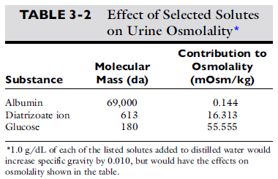
Tonicity of Effective Osmolality:
- BUN does not cause movement of water because they are distributed equally throughout total body water
- Na and glucose do cause movement of water, because they do not readily cross cell mb
- Tonicity is the ability of a solution to initiate movement and is dependent on the presence of impermeant solutes in the solution
  - Tonicity = Effective Osmolality
  - Effective Osmolality is calculated without BUN
Diuresis:
- UOP >1-2 ml/kg/hr
- Solute or osmotic diuresis: increased diuresis due to excessive amount of non-reabsorbable solutes (Diabetes mellitus, mannitol)
  - Urine osmolality approaches plasma osmolality
- Water diuresis: increased diuresis due to decreased reabsorption of solute-free water in collecting ducts (psychogenic PD or DI)
  - Urine osmolality is < than plasma osmolality

Types of Dehydration:
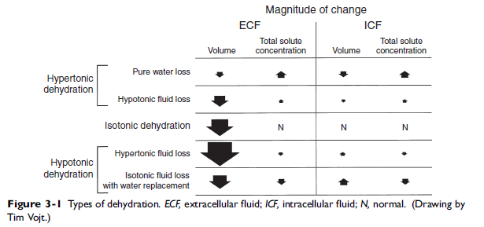

Renal Regulation of Na Balance
- Na is filtered through glomeruli, 67% is reabsorbed with H2O in the proximal tubule
- Na crosses luminal mb by cotransport with glucose, aa, P and in exchange for H+ via luminal Na/H antiporter
- Once intracellular it is actively reabsorbed in the Na/K/ATPase pump on the basolateral mb of tubular cells, maintaining a low intracell [Na] promoting entry of Na at the luminal surface
- 25% is reabsorbed in the loop of henle (mostly thick ascending limb)
- 5% is reabsorbed in the distal convoluted tubule
- 3% is reabsorbed in the collecting ducts
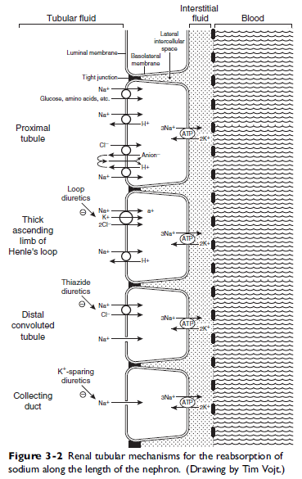
- Glomerulotubular Balance
  - Slight changes in GFR affect Na reabsorption/excretion
  - Primary GFR increase leads to increased Na reabsorption
  - Secondary or compensatory GFR increase (ingestion of Na – thirst -water consumption – expanded ECF – increased Hydro pressure – atrial stretch – ANP - natriuresis) dooes not produce glomerulotubular balance, Na reabsorption is not increased

- Aldosterone
  - Made in zona glomerulosa in adrenal cortex
  - Mediates changes in renal reabsorption of dietary Na – Increases Na reabsorption by increasing open Na channels in the luminal mb of principal cells in the collecting ducts
  - Production and release of aldosterone is stimulated by:
    - Angiotensin II
    - Hyperkalemia
    - ACTH
  - Inhibited by:
    - Dopamine
    - Atrial natriuretic peptide

- Peritubullar Capillary Factors (Starling forces)
  - Increased hydros pressure, reduced Na and water reabsorption
  - Decreased hydros pressure, increased Na and water reabsorption

- Catecholamines
  - Catecholamine induced vasoconstriction affects efferent > than afferent arterioles
  - Increase in filtration fraction leads to increased Na and water reabsorption
  - Directly stimulate α1-adrenergic effects and stimulate renin release from granular cells of JGA through β1- adrenergic effects – produce more Ang II
  - Catecholamines offset the tendency to produce pressure natriuresis from increase in systemic arterial pressure

- Angiotensin II
  - Induces efferent vasoconstriction, increasing filtration fraction – changes in peritubular capillary starling forces – increasing Na and water reabsorption
  - Directly stimulates Na/H antiporter in proximal tubules

- Atrial Natriuretic Peptide
  - Synthesized by atrial myocytes, released in response to atrial distention caused by volume expansion
  - Causes dilation of afferent arterioles and constriction of efferent arterioles (increasing GFR)
  - Relaxes mesangial cells, increasing glomerular surface available for filtration
  - Inhibits Na reabsorption in the cortical and inner medullary collecting ducts and inhibits renin secretion – decreasing production of Ang II
  - Inhibits aldosterone secretion

- Pressure Natriuresis
  - Na and water excretion increase when renal arterial pressure increases, even without changes in GFR

Regulation of Water Balance
- Vasopressin (Antidiuretic Hormone)
  - Synthesized in supraoptic and paraventricular nuclei in hypothalamus, released into neurohypophysis
  - Increases reabsorption of water in collecting ducts
  - Increases permeability of the medullary collecting ducts to urea
  - V2 receptor in basolateral mb of principal cells of cortical and medullary collecting ducts
  - Aquaporin 2 water channels are inserted into the luminal mb of principal cells
  - Aquaporin 3 and 4 channels are on the basolateral mb to evacuate the intracell water coming in from Aquaporin 2 channels
  - Chronic diuresis can lead to depletion of urea from medullary interstitium by suppression of vasopressin release and impaired urea reabsorption leading to medullary washout

- Stimuli for Vasopressin Release
  - Hypertonic plasma reaching osmoreceptors of the hypothalamus
    - Threshold for vasopressin release is plasma osmolality 280 mOsm/kg (slightly higher in dogs)
    - Below this vasopressin is suppressed and urine is maximally diluted
    - 1-2% increases in osmolality lead to a maximal vasopressin release
  - Volume depletion
    - Sensed by carotid bodies, aortic sinus and LA
    - < 5-10% lowers the threshold for release and increases the sensitivity of the osmoregulatory mechanisms
  - Nausea, Pain, Emotional Anxiety

- Role of Kidneys in Water Balance
  - 3 conditions to excrete water normally:
    - Adequate delivery of tubular fluid to distal diluting sites (ascending loop of henle), requires normal RPF, normal GFR, normal isosmotic reabsorption
    - Loop of henle must function normally (furosemide affects it)
    - In absence of vasopression, collecting ducts must remain impermeable to water

- Defense against Hypotonicity
  - Brain water content > 10% = incompatible with life
  - Acute hypotonicity
    - Water moves into the brain – increase hydrostatic pressure in interstitium
    - Forces Na containing ECF into CSF within minutes
    - 1st 24hr, K moves out of cells
    - 24-48 hr, reduction of intracell organic solutes; aminoacids (taurine, glutamate, glutamine), methylamines (phosphocreatine), polyols (myoinositol)
    - When hyponatremia is corrected, these solutes need to be recovered, this takes several days
    - If correcting is too fast, osmotic demyelination syndrome (myelinolysis) occurs.
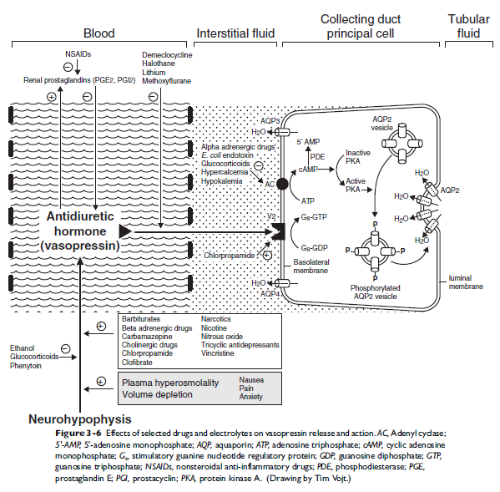
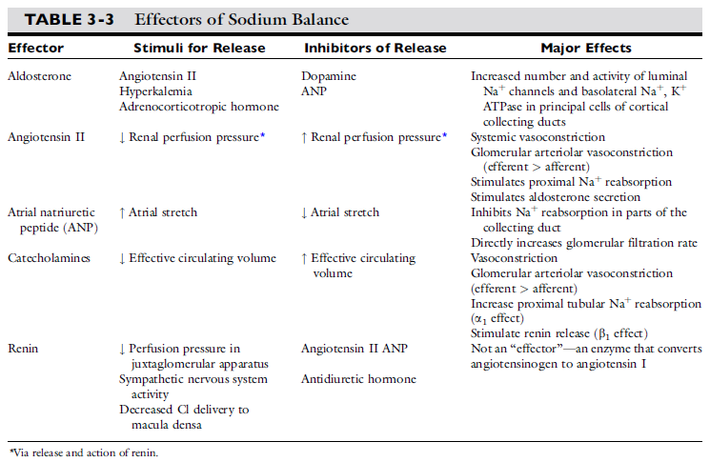

Clinical Approach to the Patient with Hypernatremia
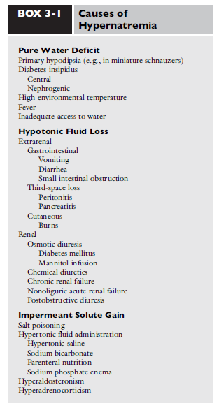
- Pure Water Loss
  - ECF becomes hypertonic, water shifts from intracell to extracell
  - Oncotic pressure favors retention in vessels, hence volume depletion is not a clinical feature
  - Almost impossible for a conscious animal with intact thirst mechanism to develop hypertonicity from pure water loss

- Hypotonic Fluid Loss
  - Hypotonic losses cause less shifts of water from intracell to extracell, causing a greater reduction in ECF volume, producing volume depletion
  - Most common
  - Classified as:
    - Extrarenal: GI, 3rd spacing, cutaneous
    - Renal

- Gain of Impermeant Solute
  - Na
  - Mannitol and glucose: initially cause hyponatremia because water is pulled into vasculature, but then lost through diuresis
  - Paintballs (contain sorbitol, polyethylene glycol, glycerol)
  - This volume overload can lead to pulmonary edema in <3 patients

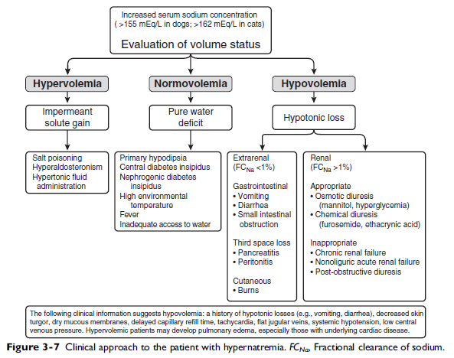

Clinical Signs of Hypernatremia
- Primarily neurologic, related to water moving out of brain cells
- Rapid decrease in brain volume may cause rupture of cerebral vessels and focal hemorrhage
- Clinical signs occur > 170 mEq/L
- If hypernatremia is chronic osmolytes or idiogenic osmoles are produced as intracell solutes (inositol and aminoacids), preventing dehydration of brain cells
- Anorexia and lethargy
- Vomiting
- Muscular weakness
- Behavioral changes
- Disorientation
- Ataxia
- Seizures
- Coma
- Death
- If hypotonic losses are the cause, signs of volume depletion and shock may also be present
- If due to solute gain, pulmonary edema may be present
Questions:
- How much Na is reabsorbed in each segment?
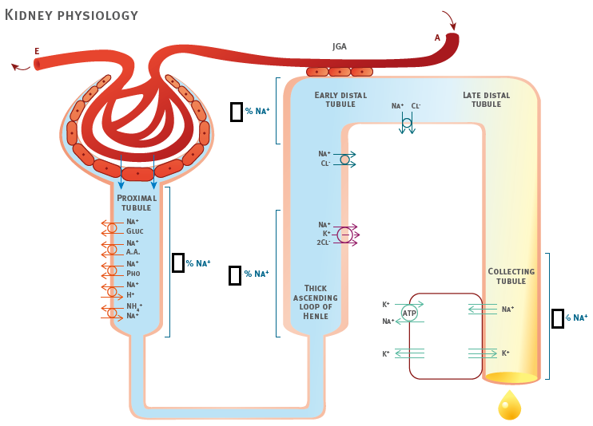

- T or F: Pure water loss leads to a severe volume depletion

- Indicate if the following increase, decrease or do not affect Na reabsorption

  - Aldosterone
  - Angiotensin II
  - Atrial natriuretic peptide
  - Catecholamine
  - Renal hypertension
  - Renin
  - Vasopressin

Answers:

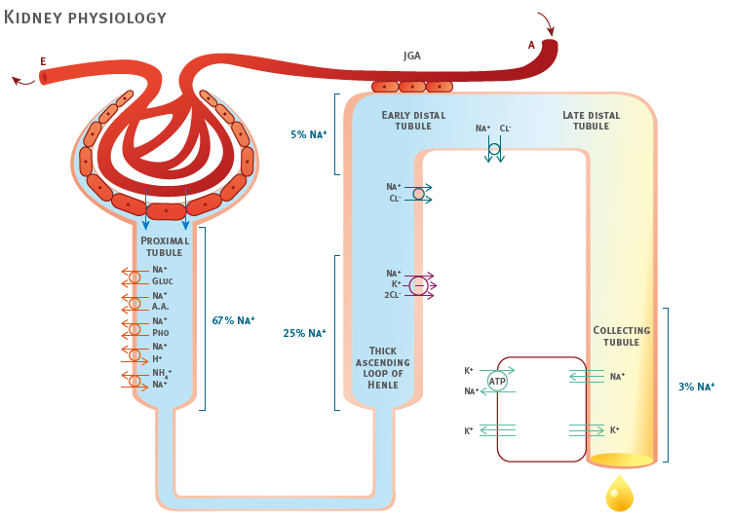

- T or F: Pure water loss leads to a severe volume depletion

Due to oncotic pressure exerted by plasma proteins, fluid remains in vasculature and rarely produces volume depletion from pure water losses

- Indicate if the following increase, decrease or do not affect Na reabsorption

  - Aldosterone Increase
  - Angiotensin II Increase
  - Atrial natriuretic peptide Decrease
  - Catecholamine Increase
  - Renal hypertension Decrease
  - Renin No effect – indirectly increase from Ang II
  - Vasopressin No effect

