Disorders of Potassium – Hypokalemia and Hyperkalemia – Dibartola chapter 5

The basics
- > or = 95% of potassium IN the cells – muscle cells containing 60-75% of this K
  - Important for: normal cell volume, cell growth (enzymatic function)
- 5% of potassium OUTSIDE the cells – maintaining ECF [K+] important to avoid detrimental effects on cardiac conduction
- ONE OF THE MOST IMPORTANT FUNCTIONS of potassium = normal resting cell membrane potential
  - Na+/K+ ATPase pump: 3:2 Na/K ratio; [IC potassium] >> [EC potassium] potassium wants to flow OUT (down concentration gradient) and sodium IN. Inside is negative because the cell membrane is IMPERMEABLE to most IC anions (PT and organic phosphate). **Permeability of cell membrane to potassium is 100x >>> permeability to sodium
    - [K+ in]/[K+ out] is a MAJOR determinant of resting cell membrane potential
- Threshold cell membrane potential
  - WTF is that? = the critical level to which a membrane potential must be depolarized to initiate an action potential.
  - It is reached when sodium permeability increases TO THE POINT THAT SODIUM ENTRY EXCEEDS potassium exit then depolarization becomes self-perpetuating and AP develops
  - Excitability of a cell: determined by difference between resting and threshold (the smaller the greater the excitability…)
  - See p.93
  - HYPOkalemia: increases resting mp (MORE negative)
  - HYPERkalemia: decreases resting mp (LESS negative)
  - If resting mp is less and less negative and less negative and threshold mp depolarization and can’t repolarize no longer excitable
  - Membrane excitability is also affected by iCa
    - iHOCa: MORE excitable – threshold MORE negative (closer to resting mp)
    - iHCa: LESS excitable – threshold LESS negative (away from resting mp)
  - Membrane excitability is also affected by acid-base
    - MORE excitable with ALKALEMIA

Potassium balance – balance between INTAKE, DISTRIBUTION, EXCRETION
- Entry in the body: From diet :GI tract – small intestine = passive transport; colon = active transport (aldosterone); also endogenous cellular breakdown; from parenteral fluid
- Exit: urine (90%) >> feces (10%)
- Translocation ECF ICF (insulin, Beta2)
- Response to acute potassium load: increased renal and colonic excretion, more uptake by liver and muscle (insulin and catecholamines)
- Response to deprivation: decreased aldo, increased reabsorption in inner medullary collecting duct; suppression of secretion by distal nephron; less colonic secretion

Acid-base and Potassium
- In GENERAL: acidosis associated with K+ moving out of cells into ECF
  - MINERAL acidosis (not organic)
  - VARIABLE
  - Hyperkalemia with ACUTE mineral acidosis (transient); eventually increased urinary potassium excretion and mild HYPOkalemia
    - Decreased urinary EXCRETION of potassium when ACUTE; increased when chronic (probably by stimulation of secretion of aldosterone by acidosis)
    - Mineral acidosis: H+ ions enter cells to be buffered by IC proteins; K+ moves out into ECF. When this ion exchange occurs across basolateral membranes in connecting tubule, cortical collecting ducts: DECREASED [IC potassium] LESS tubular secretion (less favorable concentration gradient)
    - With ORGANIC acidosis (lactate, ketoacids): permeable and they can FOLLOW H+ inside the cell so K+ DO NOT NEED TO BE EXCHANGED
  - Alkalosis: H+ out into ECF, K+ INSIDE the cell; increased concentration of K+ inside distal tubular cells favors increased SECRETION (concentration gradient); alkalosis also stimulates Na+/K+/ATPase in principal cells

Kidneys and Potassium
- 70% of filtered potassium is reabsorbed in PT
  - ISOsmotically
  - With water and sodium
  - Early lumen is NEGATIVE (but reabsorption of water favors gradient concentration) then becomes positive
  - Paracellular; also transcellular (K+ channels and K+/Cl- cotransporters)
  - Na+/K+ATPase pump
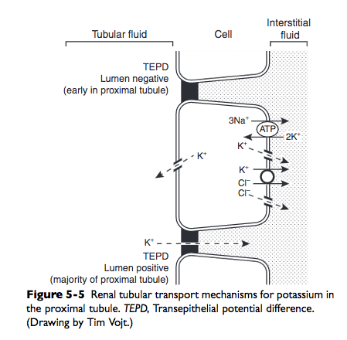
- 10-20% is reabsorbed in ascending LH
  - Lumen is POSITIVE – most reabsorption paracellular* route
  - NKCC cotransport
  - K+ and K+/Cl- cotransporters
  - Na+/K+ATPase pump
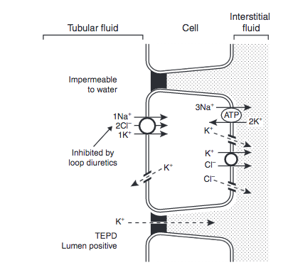
- 10-20 % is delivered to distal nephron FINAL ADJUSTMENTS: reabsorption/secretion
  - In distal convoluted tubule
    - Na+/Cl- cotransporters
    - K+/Cl- cotransporters *SECRETION*
    - Na+/K+ATPase pump
    - K+ channels
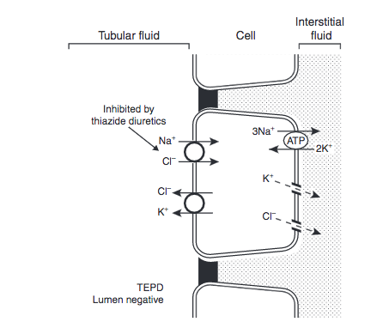
  - Principal cells: connecting tubule and collecting duct
    - Aldosterone responsive
    - ENaC – electrogenic sodium channel (mvt of sodium through renders the lumen MORE negative facilitates K+ secretion
    - K+ channels
    - Na+/K+ ATPase
    - Paracellular
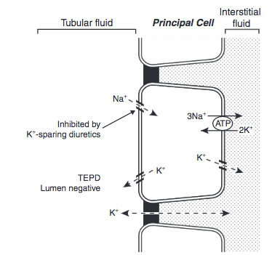
  - Type A intercalated cells – H+ secretion in connecting tubule, cortical collecting duct and outer medullary collectin duct
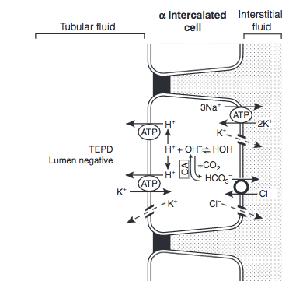
Remember Type B intercalated cells: HCO3- secretion
- Some reabsorption in the last portion of outer medullary and inner medullary collecting duct
  - Paracellular route despite lumen being negative (water reabsorption favor concentration gradient)
- Determinants of urinary potassium excretion (secretion in distal nephron)
  - Chemical concentration gradient (tubular cells vs lumen)
    - More GI absorption of potassium increased [ECF potassium] more uptake of K+ by Na+/K+ATPase increased [ICF potassium] increased gradient lumen-cell diffusion of K+ out of the cells
    - Aldosterone**
  - Tubular flow rate
    - Increased flow rate distally rapidly moves secreted K+ downstream providing new tubular fluid from upstream in the nephron therefore maintain a high chemical concentration gradient
  - Transmembrane potential difference
    - Lumen electronegativity created by Na+ reabsorption in principal cells through ENaC
    - Some of this negativity is dissipated by Cl- reabsorption
    - If large [ ] of non absorbable anion (SO₄²⁻, HCO₃⁻, penicillin) is present, less dissipation of electronegativity occurs K+ must be secreted
    - So metabolic alkalosis promotes K+ excretion
    - **Na+ and Cl- concentrations of distal fluid usually have little effect on K+ secretion
      - But when Na+ is very low (lumen), diffusion of Na+ into cells may be impaired sufficiently to produce an increase in tubular cell membrane potential (interior more negative)
      - But when Cl- is very low (lumen) increased K+ secretion (because some K+ reabsorption or secretion may be accomplished by K+/Cl-?)
- Factors influencing renal potassium excretion
  - Sodium intake
    - More sodium delivered to distal nephron more Na+ crossing luminal membranes of distal tubular cells; increased Na+/K+/ATPase actibity; favorable electrochemical gradient; more sodium = increased distal tubular fluid flow rate more potassium excretion
    - Low sodium intake the reverse; also recycling of potassium into medullary interstitium; increased reabsorption by type A intercalated cells in medullary collecting duct
  - Potassium intake
    - More intake, more secretion – aldosterone and more uptake by Na+/K+/ATPase and increased activity (tyrosine phosphorylation in ROMK protein) of luminal potassium channels in principal cells
    - Less intake, less secretion by principal cells (less uptake by Na+/K+/ATPase) and increased reabsorption by type A intercalated cells in medullary collecting duct
  - Aldosterone
  - Hydrogen ion balance – see potassium and acid-base above
  - Diuretics
    - Increased excretion of potassium, increased tubular fluid flow rate and distal tubular delivery of sodium

Questions

- Explain how potassium accomplishes its role of generation resting membrane potential

- T or F – Acute lactic acidosis will cause hyperkalemia; explain

- Which part of the nephron reabsorbs 15% of filtered potassium
  - Proximal tubule
  - Descending LH
  - Ascending LH
  - Distal nephron

- Where do you find this cell

- And this cell?

- Name 3 determinants of urinary potassium excretion

- Name 5 factors influencing urinary potassium excretion

Questions & Answers

- Explain how potassium accomplishes its role of generation resting membrane potential

- T or F – Acute lactic acidosis will cause hyperkalemia; explain
False - ACUTE - MINERAL acidosis --> hyperkalemia
Transcellular shift (H+ in to be buffered by PT and K+ out)
Eventually increased EXCRETION so mild hypokalemia possibly by acidosis stimulating aldosterone secretion
Only mineral not organic because organic anion are more permeable and can follow H+ in the cells, so K+ do not have to be exchanged to preserve electroneutrality

- Which part of the nephron reabsorbs 15% of filtered potassium
  - Proximal tubule 70%
  - Descending LH nope
  - Ascending LH
  - Distal nephron 10-20% delivered to it: absorption or secretion depending on tubular fluid flow rate, chemical concentration gradient, transmembrane potential difference; final adjustment

- Distal tubule

- Thick ascending LH

- Chemical concentration gradient (tubular cells vs lumen), Tubular flow rate, Transmembrane potential difference

- Sodium intake, potassium intake, diuretics, acid-base, aldosterone

