Disorders of Phosphorus – Dibartola chapter 7

Introduction
- Structural: phospholipids, hydroxyapatite, nucleic acids, phsophoPT
- E°: ATP
- 2,3 DPG – affinity of Hb for O2
- 2nd messenger: cAMP
- Buffer
- Metabolism
- Regulation of enzymatic activity (glutaminase for ammoniagenesis and 1a-hydroxylase for calcitriol synthesis)
- Organic (phospholipids, phosphate esters) or inorganic – orthophosphate ***
- Orthophosphate:
  - 2 prevailing ionic species are HPO₄²⁻ and H₂PO₄⁻ in a ratio of 4:1 (at pH = 7.4)
    - HPO₄²⁻ + H⁺ H₂PO₄⁻ (pKA = 6.8) * weird equation in Dibartola*
- Serum phosphorus reported as elemental phosphorus in mg/dl
- 1 mmol/L = 3.1 mg/dL = 1.8 mEq/L
- MAJOR IC ANION***
- 80-85% is INORGANIC in bone; 15% is in ST, < 1% in ECF
- In serum: 10-20% is PT bound, remainder is free or complexed to Na, Mg, Ca
- Normal concentration maintained by balance between: reabsorption/excretion in kidneys, intake/intestinal absorption
- Growth: increased phosphorus; increased renal tubular reabsorption mediated by GH
- Effect of finding: CH translocation in the cells/glycolysis decreased phosphorus; PT contain phosphorus increased phosphorus
- Variation throughout the day
- Hemolysis increased phosphorus
- Hyperlipidemia, hyperPT, thrombocytosis may affect result: overestimation
- Intestinal absorption
  - Ingested inorganic phosphate hydrolyzed in GI tract inorganic P for absorption
  - Absorption of about 60-70% of ingested load
    - Passive diffusion*, paracellular*, duodenum, jejunum, ileum
    - Active mucosal transport, sodium dependent, saturable – calcitriol increases active transport during dietary phosphate deficiency; duodenum
  - No evidence of a direct effect of PTH
  - High Ca in diet suppression of P absorption (binding of P&Ca)
- Renal handling
  - 80-90% of filtered load is reabsorbed
  - PT: Na-P cotransporters (3Na: 1P) - PTH decreases reabsorption of P phosphaturia; volume expansion less Na reabsorbed less P reabsorbed; GH,(young animals), insulin, thyroxine, respiratory alkalosis increase reabsorption, calcitonin, ANP, ACTH, GC, chronic metabolic acidosis, respiratory acidosis, phosphatonins (FGF-23, FGF-7, MEPE) inhibit reabsorption
  - Possible reabsorption in distal nephron – PTH sensitive

Hypophosphatemia
- Can occur even when total body phosphorus is normal
- Causes:
  - Maldistribution/translocation
  - Loss – renal (can calcite fraction urinary phosphorus excretion)
  - Decreased intake/malabsorption
  - 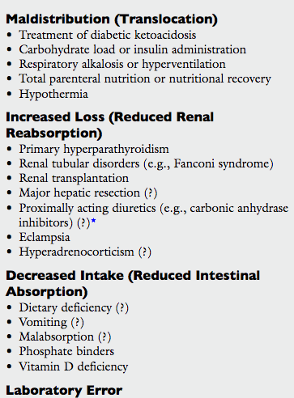
  - Respiratory alkalosis: by stimulating glycolysis by activating PFK (more if glucose given at the same time)
  - Loop diuretics and thiazides have little effect on renal excretion; CA inhibitors may increase renal excretion 2nd to effect on PT Na reabsorption
  - Eclampsia: because of low Ca PTH phosphaturia
  - Healing, regeneration?
- Consequences
  - Hemolysis – decreased ATP more fragile hemolysis (< 1.0 mg/dL)
  - Reduction 2,3 DPG impaired O2 delivery to tissues
  - Impaired chemotaxis, phagocytosis, bacterial killing
  - Plt: shorter life, impaired clot retraction, megakaryocytosis, thrombocytopenia
  - Weakness, pain
  - A-, V+, nausea (ileus)
  - Metabolic encephalopathy: from impaired CNS glucose use and ATP prod
  - Decreased contractility
  - PT tubular bicarbonate wasting, reduction in titratable acidity, impaired ammoniagenesis
  - Demineralization (via PTH and calcitriol); release of carbonate from bone may prevent serious metabolic acidosis
- Tx
  - PREVENTION!
  - Monitoring
  - Depends on magnitude and CS, at risk of development of hypoP (DKA…)
  - Oral is ideal if possible
  - Careful because tx can mineralization, hypocalcemia, renal failure, hyperphosphatemia
  - Sodium or potassium phosphate
  - DKA: you could give ¼-1/2 of supplemental potassium as potassium phosphate and the rest as potassium chloride…

Hyperphosphatemia
- Causes:
  - ***Decreased renal excretion
  - Increased intake
  - Translocation
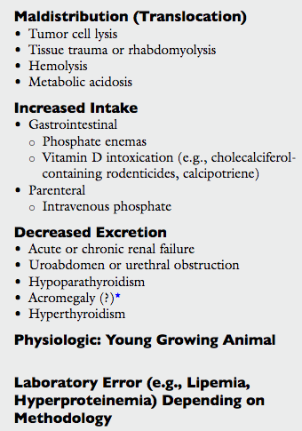
  - Rhabdomyolysis/trauma hyperphosphatemia; can also cause kidney injury which will also contribute to hyperphosphatemia
  - ATE
  - Metabolic acidosis: by organic acids; results in breakdown of ATP to AMP and Pi
  - CS associated with phosphate enema in cats: lethargy, Aatxia, V+, bloody diarrhea, pallor, stupor
  - CKD**** and AKI, uroabdomen, UTO
    - Sustained hyperphosphatemia does not usually develop in early disease (compensation by remnant nephrons) – PTH mediates increase in renal excretion of phosphate and prevent hyperphosphatemia
    - When GFR decreases to 20% of normal or less (late CKD): compensatory mechanisms are exhausted hyperphosphatemia
    - Renal 2nd hyperPTH is consistent finding in progressive renal disease
    - Hyperphosphatemia inhibits 1a-hydroxylase impaired conversion of 25D to calcitriol less intestinal absorption of calcium (and phosphorus but that’s ok)
    - Hyperphosphatemia hypocalcemia by mass law effect
    - Hypocalcemia and low calcitriol PTH secretion
    - PTH secretion renal excretion of phosphate and release of Ca & P from bone and stimulate calcitriol synthesis by kidneys normalization of Ca & P (so electrolytes maintained by progressive increase in PTH)
    - As disease progresses less and less functional tubules and decrease in 1a-hydroxylase harder for increased PTH to increase calcium (because less calcitriol)
    - And less calcitriol no inhibition of PTH…
    - As phosphate persistently remains high increased # and size of PTH cells
    - High PTH bone demineralization
    - Uremia decreased responsiveness of PTH glands to inhibitory effect of calcitriol
    - So less calcitriol and decreased responsiveness to it and less receptors for it more PTH
      - Renal 2nd hyperPTH can be prevented/reverses by limiting P in diet (and calcitriol intake)
      - Phosphorus restriction less mineralization of kidneys and less progression of kidney disease
  - HypoPTH – because no/low PTH renal reabsorption of P is increased
  - Acromegaly GH increased renal reabsorption
- Consequences:
  - Mass law effect deceased calcium (so that Ca X Pi remains constant)
  - *Hypocalcemia and mineralization aka calciphylaxis (acute calcification of organs)*
  - AKI (direct toxicity of phosphate on renal tubular cells); may increased CV mortality in people
  - Depositon of Ca and P in bone and ST may contribute to hypocalcemia (magnitude of hypocalcemia depends on the rate at which serum phosphor sincreases – unpredictable)
  - More risk of mineralization if Ca x P = > 60-70
- Tx
  - Volume expansion to dilute and promote natriuresis and consequently renal excretion of P
  - Glucose/insulin – from IC translocation though rarely necessary
  - Restriction of intake
  - Avoid calcium salts mineralization
  - Dialysis is unpredictable: poorly diffusible ion
  - Oral phosphate binders
    - Cation in the binder combines with P insoluble, non absorbable compound
    - Aluminum or calcium + hydroxide, carbonate or acetate
    - Not with magnesium diarrhea
    - Aluminum constipation; toxicity (bone, encephalopathy)?
    - If contains calcium risk of hypercalcemia
    - Give with meals: decreased absorption of calcium from calcium acetate phosphate binders, decreased absorption of dietary phosphorus
    - The endogenous phosphate removed originates probably from basal intestinal secretions or passive diffusion into intestine
    - Take time… Pool of accumulated phosphate is large and persistent osteolytic effects of PTH provide a large endogenous phosphate load

