Dibartola chapter 19 p.472-478
Key Points
- As liver function deteriorates and portal hypertension worsens, several maladaptive responses threaten renal function.
- Hepatorenal syndrome is a state of functional renal failure characterized by a low GFR, preserved tubular function, and normal renal histology. It occurs in some patients with cirrhosis and ascites; rare in med vet.
- Cats and dogs with severe liver disease accumulate “unmeasured” anions – lactate – leading to metabolic acidosis. They can also develop metabolic alkalosis from hypoabuminemia and hypochloremia.
- All cells except RBCs can extract lactate for metabolism.
  - Removal of lactic acids by liver (TCA, Cori cycle) or renal excretion
  - Hepatic use of lactate depends on substrate uptake, hepatic gluconeogenic capacity, and hepatic BF
  - In the absence of metabolic acidosis or tissue hypoperfusion, hyperlactatemia usually is associated with conditions that favor glycolysis (high catecholamines, alkalosis) and increased conversion of pyruvate to lactate
    - Respiratory alkalosis increases lactate production by increasing PFK activity
    - Symptomatic hypoglycemia increases catecholamine release
    - High blood ammonia concentrations inhibit PDH and cause preferential conversion of pyruvate to lactate
    - Acidosis inhibits pyruvate carboxylase and impairs hepatic gluconeogenesis from lactate

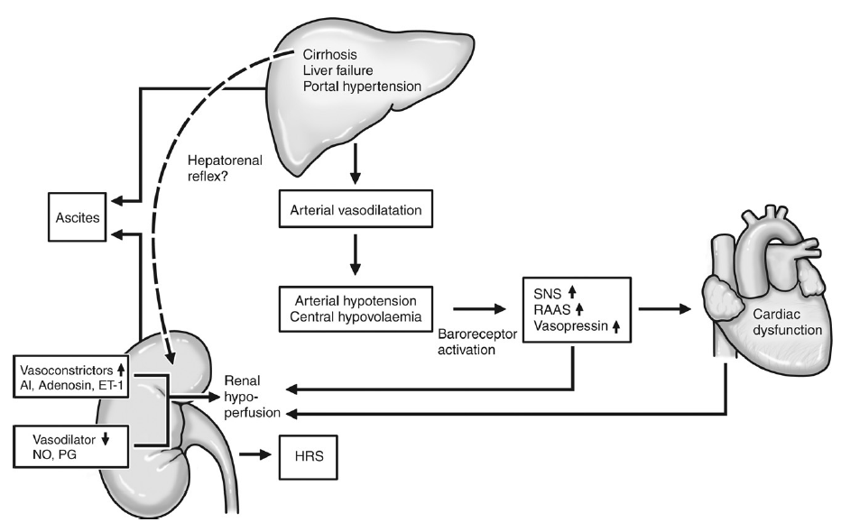

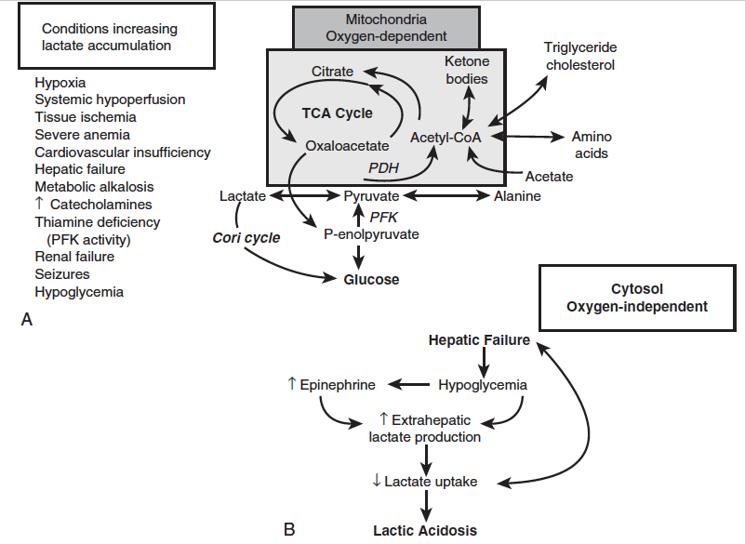

Abnormal renal function in liver disease
- As liver function deteriorates and portal hypertension worsens, several maladaptive responses threaten renal function
- Decreased GFR reduces delivery of glomerular filtrate to distal diluting segments and increased resorption in PT this increases renal sodium and water retention, impairs renal escape from abnormally increased aldosterone, and favors resistance to ANP.
  - Aldosterone escape in primary hyperaldosteronism is the escape from the salt and water retaining effect of excessive levels of aldosterone.¹ This phenomenon is considered to be an important homeostatic mechanism and thought to be dependent on nitric oxide.² Natriuresis produced by elevated levels of atrial natriuretic peptides is another proposed mechanism for escape from the salt retention in this situation.³ Pressure natriuresis is another proposed mechanism for aldosterone escape, with increased renal arterial pressure induced natriuresis.⁴ Aldosterone escape in the setting of primary hyperaldosteronism may have an important role in reducing the severity of hypertension in the condition. Aldosterone escape is the reason for edema not being a prominent manifestation of primary hyperaldosteronism.This mechanism of aldosterone escape does not work in the aldosterone excess of edematous conditions like congestive heart failure and cirrhosis liver, possibly due to the renal hypoperfusion, which is not a feature of primary aldosteronism
- Systemic counter-regulatory responses that normally preserve filtration fraction increase production of ATII vasoC of efferent; this maintains glomerular capillary pressure, increases FF and alters peritubulat Starling’s forces favoring fluid reabsorption BUT do at the expense of decreased renal BF
- Increased water turnover and GFR
- PU/PD
  - Psychogenic from HE
  - Sensory input signaling splanchnic vasoD
  - Decreased hepatic portal perfusion
  - Altered osmolality
  - Renal medullay washout (low urea concentration)
  - Renal tubular dysfunction
  - Increased concentrations of endogenous steroids
- Altered intrarenal hemodynamics
  - Normally renal BG is distributed to cortex (90%) and outer (9%) and inner (1%) medulla
  - Autoregulation of renal BG maintains proper balance between afferent and efferent arteriolar tone to regulate GFR and FF
  - Redistribution of BF from outer cortical to JM nephrons occurs in about 60% of people with ascites
  - Redistribution of RBF and increased intrarenal arterial resistance are correlated with increased plasma renin activity
  - Changes in systemic and splanchnic hemodynamics associated with hyperdynamic circulatory state of cirrhosis initiate renal vasoC further compromises renal perfusion
  - Arterial vasoD expands vascular capacity and makes effective circulating blood volume difficult or impossible to maintain
  - High SNS activity further reduces renal cortical BF; low BP and increased renal ITS pressure compromise renal BF, GFR, sodium excretion, water diuretics
- Hepatorenal syndrome
  - State of functional renal failure
  - Low GFR, preserved tubular function, normal renal histology
  - In some patients with cirrhosis and ascites; rare in med vet
  - Reduced cortical perfusion from increased renal vascular resistance precedes renal failure
    - Cause of intrarenal vasoC is complex; poorly understood
  - Factors associated with development of HRS in people
    - Constant associations
      - Ascites
      - IV volume disturbances
    - Variable associations
      - GI bleeding
      - Large-volume paracentesis
      - Overzealous use of diuretics
      - Progressive jaundice
      - Sepsis
      - Nephrotoxic drugs
      - NSAIDS
      - Radiographic contrast media
  - Essential diagnostic criteria
    - Spontaneously acquired acute decline in GFR
    - Impaired urinary sodium excretion
    - Urine osmolality > plasma osmolality
    - Absence of other causes of renal failure
  - Tx: plasma expanders, long-acting alpha-adrenergic agonist midodrine to improve systemic BP and renal perfusion, somatostatin analog octreotide and AVP analog terlipressin to attenuate splanchnic vasoD

Acid-base disturbances in liver disease
- Respiratory Alkalosis – from:
  - Reduced arterial oxygen saturation 2ndary to acquired venoarterial shunting
  - VQ mismatch (from ascites-induced restriction of ventilatory efforts or changes in pulmonary capillaries)
  - Shift to right in oxyhemoglobin dissociation curve
  - Direct stimulation of respiratory center by encephalopathic toxins (NH₃)
  - CNS acidosis
  - Compensation for metabolic acidosis
- Metabolic Alkalosis – from:
  - Hypoalbuminemia (dogs)
  - Hypochloremia (cats with HL)
  - Excessive diuretic therapy
  - Vomiting of GI content
  - Alkali loading from transfusion (CPD – immediately after blood collection, CPD blood has low bicarbonate and high citrate; during storage, red cell metabolism consumes bicarbonate as a result of glycolysis and lactic acid production; after infusion CPD-preserved blood products favor development of metabolic alkalosis because both lactate and citrate can be metabolized to HCO3-); transfused blood is transiently acidifying because of free citric acid but this effect is quickly counteracted by the metabolism of citrate to CO2 and water
  - Persistent 2ndary hyperaldosteronism
  - Loss of effective extracellular volume (concentration alkalosis)
- Metabolic Acidosis
  - Terminal stages of cirrhosis – hypoxia, hypotension, lactic acidosis, renal dysfunction
  - Cats with severe HL appear to be at greater risk for acidemia, metabolic acidosis, accumulation of UA, dilutional acidosis
- Lactate metabolism
  - All cells produce lactate
  - All cells (except RBCs) cab extract lactate for metabolism
  - Production primarily in skin, RBCs, brain, muscle
  - Kidney and liver: primary sites of lactate removal; liver predominating at rest
  - Normal dog liver can extract at least 19% of physiologic lactate load per hour
  - Lactate is governed by conversion to pyruvate via LDH; and the pyruvate formed is either metabolized to glucose or oxidized in Krebs cycle to CO₂ and water.
  - Lactate generation by brain, RBCs, skin with subsequent gluconeogenesis by liver and kidneys = Cori cycle
  - Pyruvate = immediate precursor of lactic acid
  - Glucose and alanine = physiologically important pyruvate precursors
  - Pathologic conditions stimulating conversion of glucose or alanine to pyruvate predispose to lactic acidosis
  - PDH plays integral role in lactate metabolism; catalyzing intramitochondrial conversion of pyruvate to acetylCoA which enters the Krebs cycle
  - Removal of lactic acids:
    - Cori cycle glucose
    - TCA
      - Generation of bicarbonate with both mechanisms
      - Hepatic use of lactate depends on substrate uptake, hepatic gluconeogenic capacity, hepatic BF
      - In the absence of metabolic acidosis or tissue hypoperfusion, hyperlactatemia usually is associated with conditions that favor glycolysis (high cathecolamines, alkalosis) and increased conversion of pyruvate to lactate.
    - Renal excretion
  - Respiratory alkalosis is thought to increase lactate production by enhancing PFK activity
  - Lactate accumulation also favored when symptomatic hypoglycemia increases catecholamine release, when high blood ammonia concentrations inhibit PDH and cause preferential conversion of pyruvate to lactate, and when acidosis inhibits pyruvate carboxylase and impairs hepatic gluconeogenesis from lactate
  - Reduction in systemic pH compromises hepatic uptake of lactate, and decreased hepatic arising from lactic acidosis directly disables hepatic lactate metabolism
  - Lactic acidosis from decreased use of lactate or increased production
  - Lactate production is a late sign of inadequate oxygen supply and therefore is neither a Sn nor early indicator of impending hepatic insufficiency
  - Can also develop with DM, renal failure, fulminant hepatic failure, sepsis – condition not associated with perfusion deficits or hypoxic injury
- Acid-base disturbances in dogs and cats with cirrhosis
  - Met. alkalosis (hypoalbuminemia, hypochloremia), met. acidosis (UA)
Hepatic encephalopathy
- Complex neurophysiologic syndrome involving the CNS that implies a critical loss of functional hepatic mass (65-70%) or extensive PSS.
- Multifactorial
- Rarely associated with acute hepatic failure in cats/dogs; onset of clinical signs can be acute or chronic and episodic or progressive
- Signs: lethargy, somnolence, stupor, coma

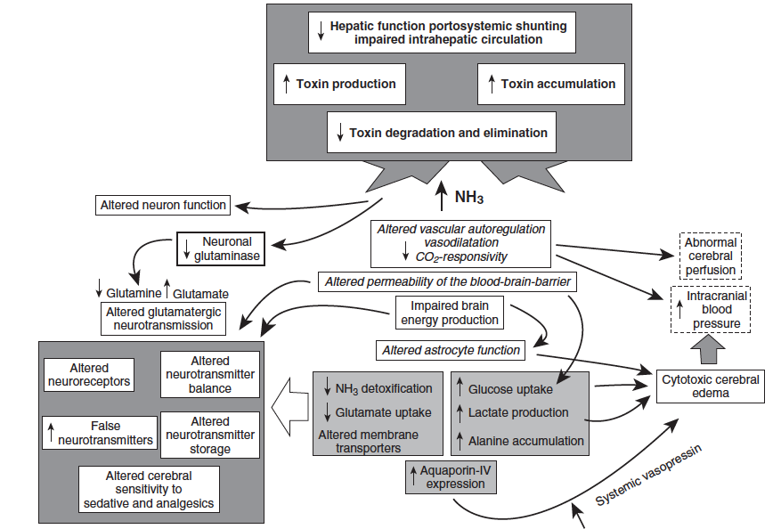

QUESTIONS
- Hepatorenal syndrome, a form of __________________ (reversible or irrerversible) renal failure, occurs as a consequence of profound renal __________________ (vasoconstriction or vasodilation) secondary to the release of _______________, norepinephrine, and _____________ in response to splanchnic ___________________ (vasoconstriction or vasodilation).

- Hepatorenal syndrome is characterized by
  - Low GFR
  - Abnormal tubular function
  - Increased urinary sodium excretion
  - Necrosis and infiltration of inflammatory cells

- At rest, the liver metabolizes _______________ of endogenously produced lactate.
  - 90%
  - 70%
  - 50%
  - 30%

- Name the 2 mechanisms by which the liver metabolized lactate and where this mechanism occurs.

- Name 3 causes of metabolic alkalosis in cats and dogs with severe liver disease

QUESTIONS & ANSWERS
- Hepatorenal syndrome, a form of reversible renal failure, occurs as a consequence of profound renal vasoconstriction secondary to the release of angiotensin, norepinephrine, and ADH in response to splanchnic vasodilatation.

- Hepatorenal syndrome is characterized by
  - Low GFR
  - Abnormal tubular function
  - Increased urinary sodium excretion
  - Necrosis and infiltration of inflammatory cells

- At rest, the liver metabolizes _______________ of endogenously produced lactate.
  - 90%
  - 70%
  - 50% (40-60%)
  - 30%

- Name the 2 mechanisms by which the liver metabolized lactate and where this mechanism occurs.
Cori cycle (cytosol) glucose
TCA (mitochondria)

- Name 3 causes of metabolic alkalosis in cats and dogs with severe liver disease
Hypoalbuminemia and hypochloremia

