Dibartola Ch 10 pp254-258

Disorders Associated with a Normal AG
- Diarrhea
  - Intestinal fluid normally has higher HCO₃⁻ and lower Cl⁻ as compared with plasma
  - With diarrhea, absorptive capacity may be overwhelmed resulting in hyperchloremic metabolic acidosis OR mixed metabolic acidosis (if lactic acidosis also present)
- Renal Tubular Acidosis (RTA)
  - Hyperchloremic metabolic acidosis (with normal GFR) caused by:
    - Decreased HCO₃⁻ resorption (proximal RTA)
    - Defective acid excretion (distal RTA)
  - Uncommonly recognized in small animals
  - Distal RTA (classic/type 1)
    - Impaired H⁺ secretion in the collecting ducts
    - Urine pH >6 despite markedly decreased HCO₃⁻
    - r/o UTI prior to diagnosis
    - Common features (human)
      - Nephrolithiasis
      - Nephrocalcinosis
      - Bone demineralization (loss of bone buffer stores from chronic acidosis)
      - Urine potassium wasting and hypokalemia
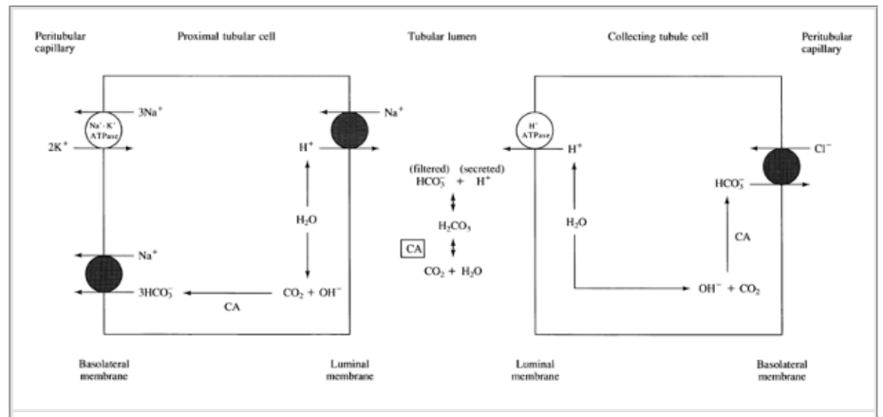
    - Inherited forms of distal RTA:
    - Diagnosis
      - NH₄Cl tolerance test
        - Admin 0.2g/kg NH₄Cl PO
        - Monitor of urine pH hourly (x5h)
        - Normal dogs: urine pH decreases to a minimum of 5.16 4h post admin
  - Proximal RTA (type II)
    - Renal reabsorption of HCO₃⁻ is decreased, urinary fractional excretion of HCO₃⁻ is increased (>15%)
    - Due to failure of the proximal tubular cells to reabsorb filtered HCO₃⁻ from the urine
    - Leads to urinary bicarbonate wasting and subsequent academia
    - Distal intercalated cells function normally, so the acidemia is less severe than dRTA
    - Typically also have other abnormalities of proximal tubular function
      - Defects in glucose, phosphate, sodium, potassium, uric acid and amino acid secretion
        - Fanconi’s syndrome
    - Diagnosis
      - Acid urine pH (<5.5 to 6) in the presence of hyperchloremic metabolic acidosis and normal GFR
      - Then, following normalization of academia with alkali admin, increased urine pH (>6) and increased urinary excretion of HCO₃⁻
- Carbonic Anhydrase (CA) Inhibitors
  - Decrease proximal tubular reabsorption of HCO₃⁻ by noncompetitive inhibition of luminal and cellular CA
  - Hypokalemia due to increased sodium delivery to distal nephron, and exchange with potassium via the NaK exchanger
- Ammonium Chloride
  - Equivalent to admin of HCl due to hepatic conversion of NH₄⁺ to urea and H⁺
- Infusion of Cationic Amino Acids
  - Lysine, arginine, histidine
  - NH₄⁺ produced….then hepatic metabolism to urea and H⁺
- Posthypocapnic Metabolic Acidosis
  - Chronic respiratory alkalosis -> renal acid excretion decreases -> decreased plasma HCO₃⁻ and increased plasma Cl⁻
  - When hypocapnia resolves (and P_{CO2} increases), it takes several days for the kidneys to adjust back though during this time a metabolic acidosis will be present
- Dilutional Acidosis
  - Decreased HCO₃⁻ due to extracellular volume expansion with an alkali-free chloride-containing solution
- Hypoadrenocorticism
  - Aldosterone stimulates activity of the luminal H⁺-ATPase

