Key Points
- Vasopressin secretion regulated by small changes in osmolality (~1%) or larger changes in blood volume (~10%)
- Vasopressin acts on V2 receptors in collecting ducts, causing insertion of AP2 channels to allow free-water reabsorption
- Treatment of diabetes insipidus can be with medication or constant free access to water

Vasopressin synthesis and release
- Nuclei of cells starting in hypothalamus with axonal transport to neurohypophysis for release
- Release stimulated by osmoreceptors in hypothalamus (~1% changes in osmolality) or by baroreceptors in atria or carotid bodies (~10% changes in blood volume)
- Angiotensin II also stimulates release via ATII receptors in hypothalamus

Central
- Partial or complete lack of secretion of ADH/Vasopressin
  - Causes include
    - Neoplasia
    - Trauma
    - Inflammatory
    - Congenital
    - Idiopathic
  - Human causes most commonly associated
    - Brain surgery/trauma
    - Immune mediated diseases
Nephrogenic
- Failure of kidney to respond to ADH/Vasopressin
  - Secondary much more common than primary
    - Hypercalcemia
    - Hypokalemia
    - Pyelonephritis
    - Pyometra
    - Gram-negative sepsis
    - Portal-systemic shunts
    - Liver insufficiency
    - Hypoadrenocorticism
    - Hyperthyroidism
Diagnosis
- DDX whenever dog/cat has a hyposthenuric PU/PD
  - Although can be isosthenuric (or even slightly concentrated)
- Chem rules out most common causes of secondary nephrogenic DI
- Modified water deprivation test
  - Causing mild dehydration to confirm continued hyposthenuria, followed by administration of desmopressin
  - Not recommended for routine use
    - If there is medullary washout, then you can get false positives
    - Partial or relative lack of vasopressin can be difficult to interpret
    - Cushing's disease can cause false positive
  - Risks
    - Overdehydration
    - Hypernatremia
    - Death
- Desmopressin Acetate trial
  - A few days of limited water followed by beginning desmopressin therapy
  - Collect urine each morning during trial for measurements of USG
  - If positive for acquired CDI, pursue brain imaging
    - Radiation therapy for intracranial tumors
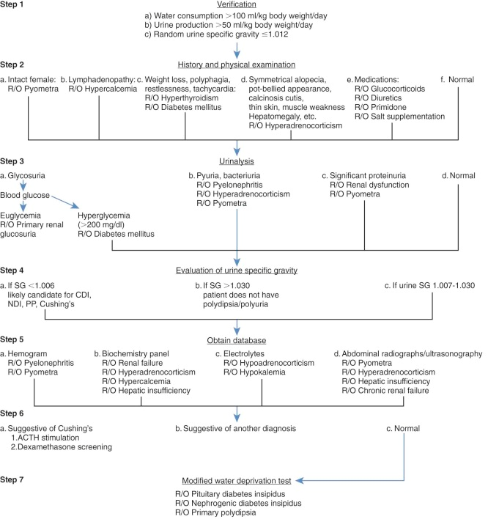
Treatment
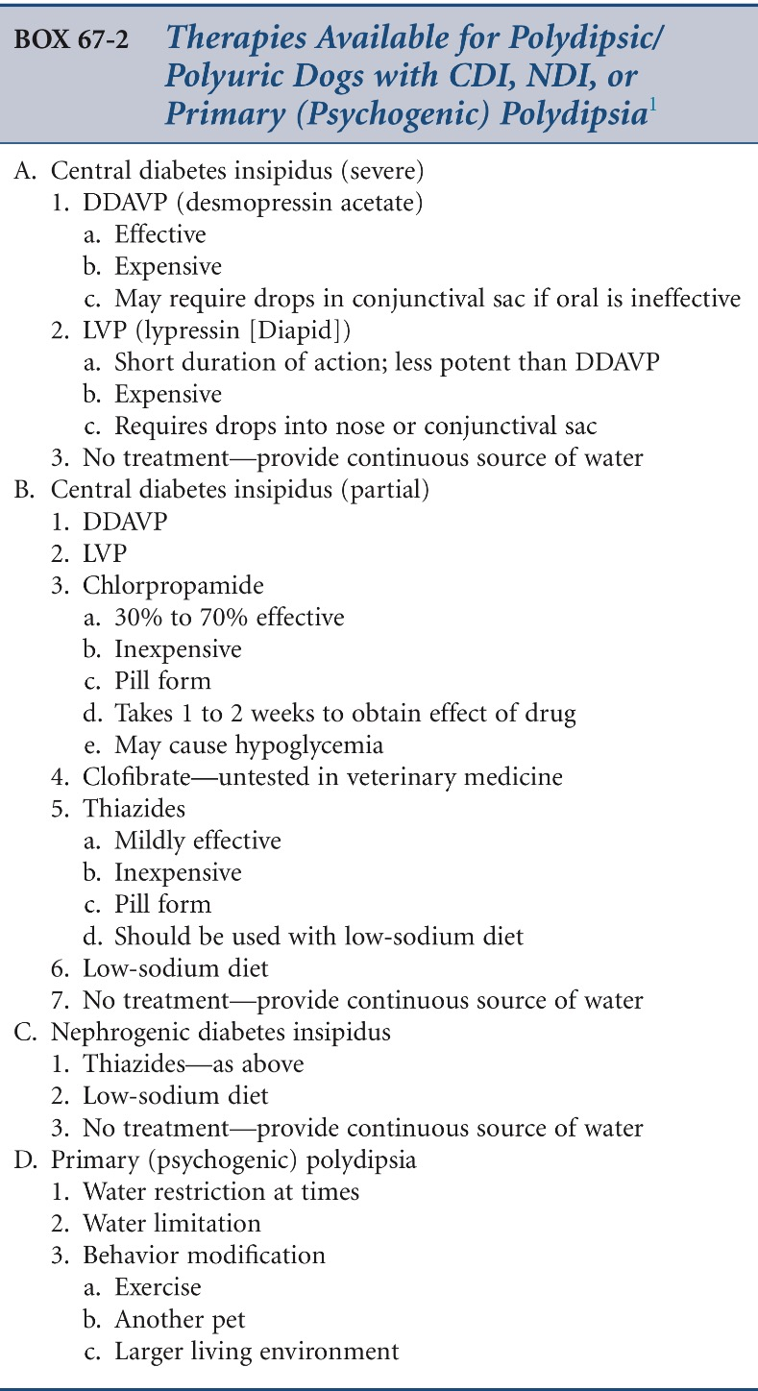

Questions
Which is more likely to induce release of vasopressin from the neurohypophysis?
- Increase serum osmolality of 2%
- Increase in blood volume by 8%
- Decrease in serum osmolality by 2%
- Increase in blood volume by 8%

Name 2 risks of a modified water deprivation test?

Answers
Increase serum osmolality

Hypernatremia
Dehydration death

