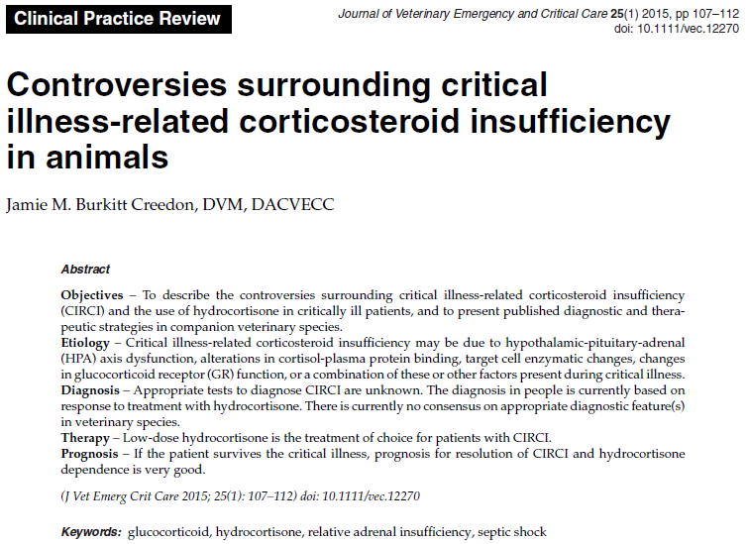
- “Relative Adrenal Insufficiency (RAI)” is use to describe septic patients with either unexpectedly low basal plasma cortisol concentrations or those whose response to exogenous ACTH (termed “delta cortisol”: serum cortisol concentration hour after exogenous ACTH administration minus baseline serum cortisol concentration) was deemed inadequate regardless of basal cortisol concentration

- “The French Study” , Annane et al showed improved survival in septic shock patients with low delta cortisol who were treated with hydrocortisone and fludrocortisone, but had limitations
  - Small sample size
  - Etomidate used before being included in study
  - Fludrocortisone use?
  - No adverse effects declared

- CORTICUS study (Corticosteroid therapy of septic shock) was a multicenter, international, randomized, double-blinded, placebo-controlled trial
  - 499 people, evaluated SCTH stim test and hydrocortisone in septic shock
  - Low-dose hydrocortisone group more rapid pressor weaning regardless of ACTH results
  - Hydrocortisone had no survival benefit despite rapid pressor weaning
  - Hydrocortisone was associated with more incidents of superinfection than placebo
  - Limitations: initial target study was 800, underpowered to detect mortality, less ill population than French study, etomidate use

- RAI was changed for Critical Illness-related Corticosteroid Insufficiency (CIRCI)

Etiology
- Unknown
- Hypothalamus, pituitary or adrenal glands may be inhibited or damaged by cytokines, ROS, hemorrhage or others during septic shock, leading to inadequate cortisol production or inadequate response to administered ACTH

Diagnosis
- Human critical care community does not advocate for any method of diagnosis for CIRCI
- Diagnosis is made by evaluating response to treatment with low-dose hydrocortisone, because current guidelines recommend treating pressor-resistant septic shock patients with hydrocortisone without or with no regard to HPA axis assessment
- Surviving sepsis 2012 recommend against ACTH stim, 2008 recommend against baseline cortisol as normal reference range for critically ill patients is not established
- Delta cortisol of < 9 ug/dL or a random total cortisol concentration of < 10 ug/dL may diagnose CIRCI, but should not be used to decide which patient gets treated (Marik et al)
- In dogs, a delta cortisol ≤ 3 ug/dL following an ACTH stimulation test are more likely to be hypotensive, be pressor dependent and have decreased survival – CIRCI?
- In cats, no proper diagnostic criteria has been found

Treatment
- Hydrocortisone approx. 4.3 mg/kg/day – appropriate dose???
- 1–4.3 mg/kg/day, either divided into 4 equal IV doses q6h or CRI; or 0.5 mg/kg IV q6h or 0.08 mg/kg/hr CRI
- Over several days in a tapering regimen

