Conjunctivitis and Blepharitis
Summary
- Steroids!

Auto-Immune Blepharoconjunctival Diseases
- Medial Canthal Ulcerative Blepharitis
  - GSD, long haired Dachshund, Toy and miniature Poodle
  - In GSD can be associated with pannus and immune-mediated plasma cell infiltration of the 3rd eyelid
  - In Dachshund can appear concurrently with superficial punctate keratitis
  - Usually bilateral
  - Lymphocytic and plasma infiltrates
  - Treatment: topical antibiotics and steroids
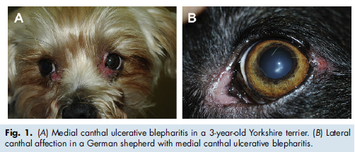

- Vogt-Koyanagi-Harada-Like Syndrome (VKH) or Uveodermatologic syndrome
  - Melanocytes are targeted
  - Anterioir uveitis, chorioretinitis, exudative retinal detachment, poliosis (decreased melanin in hair), vitiligo, dysacusis (hearing impairment by difficulty processing sound), meningitis – in people
  - Akita, Siberian Husky, Golden Retriever, Beagle, Chow Chow, Old English Sheepdog, St Bernard, Australian Shepard, Dachshund, Brazilian fila, Shetland sheepdog, Irish setter, Samoyed
  - Usually adults, ocular lesions precede dermatological lesions in mucocutaneous junctions
  - Eyelid are ulcerated, hypopigmented, crusting
  - Treatment: Immunosuppresive prednisone, azathioprine, cyclophosphamide, topical steroids and immunosuppresives
  - Poor prognosis
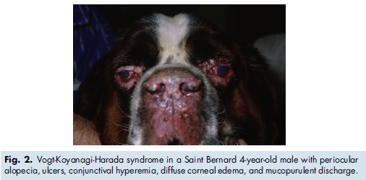

- Pemphigus Complex
  - Pemphigus foliaceus, vulgaris and erythematosus
  - Pustules or vesicles that erupt and leave erosions, ulcers, crusting and hypopigmentation on eyelids
  - Pemphigus antibodies through immunofluorescence or immunohistochemistry
  - Treatment: topical and systemic steroids, with additional cyclophosphamide, azathioprine
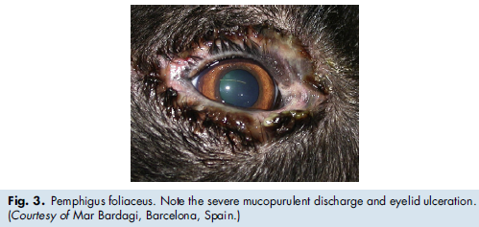

- Lupus Erythematous
  - Has polyclonal lymphocytic involvement
  - Sun exposure aggravates the disease in 50% of cases
  - Facial dermatitis, crusting, depigmentation, erosions, ulcers on nasal planum, muzzle and eyelids
  - Treatments: topical or systemic immunosuppresives

Immune-Mediated Blepharoconjunctival Diseases
- Canine Juvenile Cellulitis
  - Lymphocutaneous disease seen in puppies < 8 months
  - Dachshund, Labrador retriever, Golden Setter, Lhasa apso
  - Uncommon granulomatous and pustular disorder of the face, pinnae and submandibular LN
  - Acute swollen face, 24-48 hr papules and pustules develop around lips, muzzle, chin, bridge of nose, periocular area, then fistulate, drain and crust
  - Diagnosis: clinical signs bilaterally, cytology and histopath
  - Treatment: Immunosuppresive tapered 3-4 weeks after resolution of clinical signs
  - Excellent prognosis
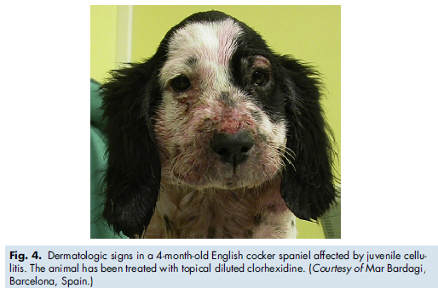

- Acute Allergic Blepharitis and Conjunctivitis
  - Any age in atopic or non-atopic dogs
  - Hypersensitivity reaction
  - Clinical signs: pruritus, eye redness, ocular swelling
  - Treatment: self-limiting, wash eye
- Necrotizing Marginal Blepharitis or Meibomitis
  - Meibomitis secondary to Staphylococcus toxin
  - Swollen lids, pruritus, tear film abnormalities
  - Treatment: Topical and systemic antibiotics, topical steroids

Chronic Allergic Blepharitis and Conjunctivitis
- Canine Atopic Disease
  - Redness, blepharospasm, erythema, crusting, excoriation and ulceration
  - 2ary bacterial infection from rubbing
  - Chronic Meibomian inflammation > more polar lipid secretion inducing surface corneal disease due to early preocular tear film evaporation
  - Diagnosis: allergy testing
  - Treatment: cold topical steroids, systemic and topical antihistamine

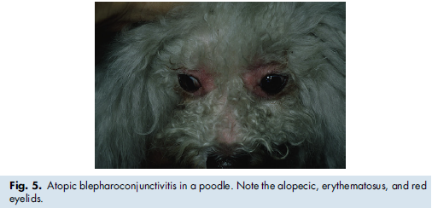

- Canine Food Hypersensitivity
  - Non seasonal pruritic skin disorder
  - Treatment: allergen detection and elimination, topical antibiotics and steroids

- Allergic Conjunctivitis without Systemic Clinical Signs
  - Chronic epiphora, ocular redness
  - Treatment: Topical antihistamines

- Follicular Conjunctivitis
  - Proliferation of the conjunctival-associated lymphoid tissue of the palpebral and bulbar conjunctiva
  - Follicle appear at the palpebral and bulbar conjunctiva
  - Mucous or serous discharged and redness, presence of conjunctival giant papillae, cornela inflammation
  - Dogs < 18 months
  - Secondary to chronic antigenic stimulation
  - Treatment: topical steroids, saline irrigation, +/- debridement of follicle
