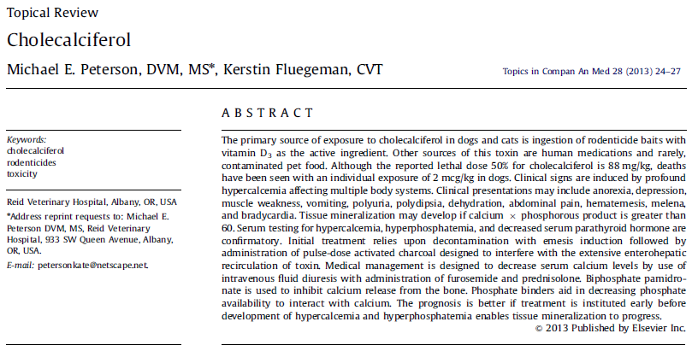
Summary

Primary sources of cholecalciferol are rodenticides and dietary supplements
Dietary supplements are labeled in International Units and 1 IU = 0.025 ug of cholecalciferol
Rodenticides contain 0.075% or 0.75 mg cholecalciferol per kg of bait

Toxic Dose:
- LD50: 88 mg/kg dogs, clinical signs may be seen at low as 0.5 mg/kg, cats are more resistant
- 50-100 ug/kg daily manifest clinical toxicosis within 2-3 weeks
- Puppies are more susceptible than adults

Toxicokinetics:
- Rapidly absorbed from GI tract
- Hepatic cytochrome P-450 with mixed function oxidase enzyme 25-hydroxylase rapidly metabolizes cholecalciferol to the metabolite 25- hydrocholecalciferol (calcifediol)
- Calcifediol reach concentrations up to 20 x normal within 24 hr
- Calcifediol converted in proximal convoluted tubule of the kidney by a mixed function oxidase enzyme1-a-hydroxylase to 1,25-dihydroxycholeciferol (calcitriol > 1ary active metabolite)
- Peak concentration of calcitriol is achieved approximately 48-96 hours post–oral exposure
- Highly lipophilic, can concentrate in milk
- Half-life 15 days, due to ongoing metabolism functional half-life is 29 days

Mechanism of Toxicity:
- Calcitriol:
  - increases renal tubular reabsorption of Ca
  - increases Ca resorption from bone
  - increases intestinal reabsorption of Ca
  - decreases parathyroid hormone synthesis
- Once hyperCa and hyperP reach a Ca x P product exceeding 60 (units must be in mg/dL), then metastatic mineralization of soft tissues will occur in kidneys, intima of the large vessels, myocardium, and gastrointestinal tract **young animals have high Ca x P product
- Hypercalcemia directly affects cells by:
  - changing membrane permeability
  - decreasing cellular energy production
  - altering calcium pumps
  - inducing cellular necrosis

Clinical Signs:
- Signs are associated to hypercalcemia and hyperphosphatemia
- Signs may be delayed 8-12 hrs post ingestion as the production of active metabolites progresses
- Acute renal tubular necrosis, gastrointestinal stasis, increased gastric acid secretion > ulcers, decreased skeletal muscle responses, and decreased neural tissue responses
- Often polyuric, polydipsic, and dehydrated
- Elevations of gastric acid secretion and smooth muscle intestinal atony predispose to gastrointestinal hemorrhage.
- Anorexia, lethargy, abdominal pain, hematemesis, melena, vomiting, and diarrhea
- Bradycardia
- Seizures
Diagnostic Tests:
- Chemistry: hypercalcemia, hyperphosphatemia, azotemia
  - Ca and P should be monitored for 5-7 days after they are normalized, then 3 times a week for 2 weeks
- USG: isosthenuria
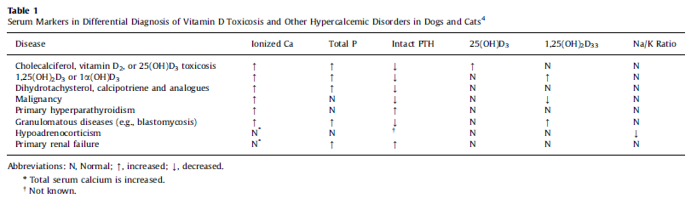
Confirmatory Tests:
- Serum 25-hydroxycholecalciferol and 1,25 dihydroxycholecalciferol levels are elevated
- Necropsy: mineralized soft tissue (may also be seen on rads)

Treatment:
- All patients receiving > 0.1 mg/kg should be decontaminated
- Emesis
- Enterohepatic recirculation > activated charcoal
- Cholestyramine 0.5-1 g/kg q8h for 4 days
- Control Ca levels:
  - Goal is to keep Ca x P product < 60
  - NaCl 0.9%
  - Furosemide: inhibits Ca reuptake in the ascending loop of henle, loading dose 0.66 mg/kg then 0.66 mg/kg/hr CRI
  - Prednisolone 1-3 mg/kg q 8-12h: decreases bone resorption, increases Ca excretion and decrease intestinal Ca uptake (takes 7 days to max effect)
  - Calcitonin 4-6 IU SQ q8-12h, transient effect only for a few days
  - Pamidronate disodium: inhibits osteoclastic Ca release from bone 1.5-2 mg/kg IV in 150-250 ml 0.9% saline over 24h
- Decrease P levels:
  - Aluminum hydroxide 10-30 mg/kg every 8h until levels stabilize

Prognosis:
- Fair if before soft tissue calcification occurs
- Once mineralization progresses, prognosis is guarded

Differential Diagnosis:
- Malignancy (lymphoma, perianal adenocarcinoma, multiple myeloma)
- Primary hyperparathyroidism
- Acute kidney injury
- Hypoadrenocorticism
- Granulomatous disease
- Osteolytic disease

Questions:
- Which patient is at higher risk of metastatic mineralization of soft tissues?
Patient A: Patient B:
Ca: 10.2 mg/dL Ca: 11.4 mg/dL
P: 6.0 mg/dL P: 5.2 mg/dL

- What is the effect of calcitriol?

Answers:
- Which patient is at higher risk of metastatic mineralization of soft tissues?
Patient A: Patient B:
Ca: 10.2 mg/dL Ca: 11.4 mg/dL
P: 6.0 mg/dL P: 5.2 mg/dL
61.2 59.28

- What is the effect of calcitriol?
  - increases renal tubular reabsorption of Ca
  - increases Ca resorption from bone
  - increases intestinal reabsorption of Ca
  - decreases parathyroid hormone synthesis

