Canine and Feline Endocrinology

Chapter 1 – Water Metabolism and Diabetes Insipidus
Key Points
- Important players in the regulation of water balance (water intake and urine production)
  - Plasma osmolality - Hypothalamus and osmoreceptors
  - Intravascular volume – baroreceptors
  - Thirst
  - Kidneys
  - Pituitary glands – release of ADH
- Vasopressin has 2 major receptors
  - V_{1A}: Phosphatidylinositol – vasoC
  - V₂: cAMP – antidiuretic – aquaporin-2 water channels
- DDX for PU/PD - mechanisms
  - Osmotic diuresis
  - DI- central
  - DI – nephrogenic; primary or 2nd
  - Psychogenic polydipsia
  - Drug induced
  - Renal medullary washout
- 3 types of dehydration
  - Isotonic – loss of isotonic fluid
  - Hypotonic – loss of hyperosmolar fluid
  - Hypertonic loss of free water
- Treaments for diabetes insipidus
  - DDAVP
  - Thiazide
  - Chlorpropamide
  - No treatment

- Water consumption and urine production controlled by:
  - Plasma osmolality
  - IV volume
  - Thirst
  - Kidneys
  - Pituitary gland
  - Hypothalamus
- Urine osmolality can vary from 20 mOsm/kg to 3200 msOsm/kg!
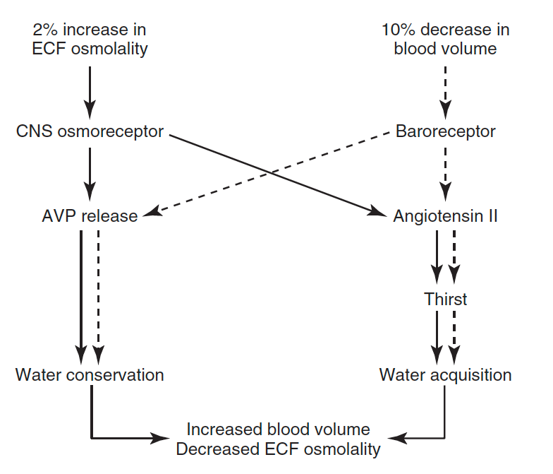
- Water balance
  - Controlled by regulation of water intake (thirst) and urine volume (ADH)
  - ADH regulated by ECF osmolality (sodium)** and blood pressure and volume
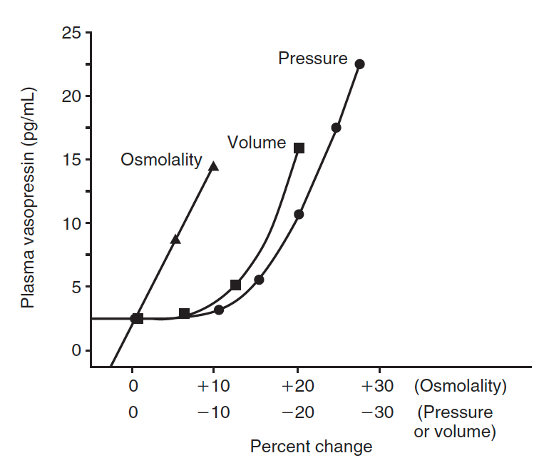
  - Vasopressin is main hormone in regulation of water homeostasis and osmolality
  - RAAS is mainly responsible for regulation of blood pressure and volume
- Neurohypophysis
  - Set of hypothalamic nuclei (supraoptic and paraventricular) containing magnocellular neurons (synthesis of oxytocin and ADH); axonal processes (form the supraopticohypophysial tract); termini w/in posterior lobe of pituitary
  - Production of vasopressin associated with specific binding proteins = neurophysins II (I is for oxytocin) – one molecule of neurophysin II binds 1 molecule of vasopressin (the comobo is called neurosecretory material)
  - Neurosecretory material transported along the axons of the hypothalamo-neurohypophyseal nerve tract; stored in granules in nerve terminals located in posterior pituitary
  - Release of ADH in bloodstream following electrical activation of magnocellular neurons containing AVP
  - Secretion by exocytosis
  - Neurophysin and vasopressin dissociate – free vasopressin
  - Elimination of ADH: through binding of ADH to specific receptors which subsequent proteolytic cleavage of peptide AND renal excretion (1/4)
  - Input to magnocellular cells: high-pressure arterial baroR (carotid sinus and aortic arch), low pressure volume receptors (atria and pulmonary venous system) – they normally inhibit magnocellular cells
    - When ADH is released action on V_{1A} receptors vasoC detection by baroR negative feed back to inhibit vasopressin secretion
    - ADH at the kidney: retain water increase in IV volume; though major system for BV regulation is RAAS
- Vasopressin:
  - DDAVP is synthetic vasopressin – formed by removal of amino terminal (NH2) and replacement of L-arginine by D-arginine, which increases and prolongs antidiuretic effect; STRONG affinity for V2 with MINIMAL pressor (V1) activity
  - 3 receptors
    - V_{1A}: vasoC – phosphatidylinositol dependent receptors
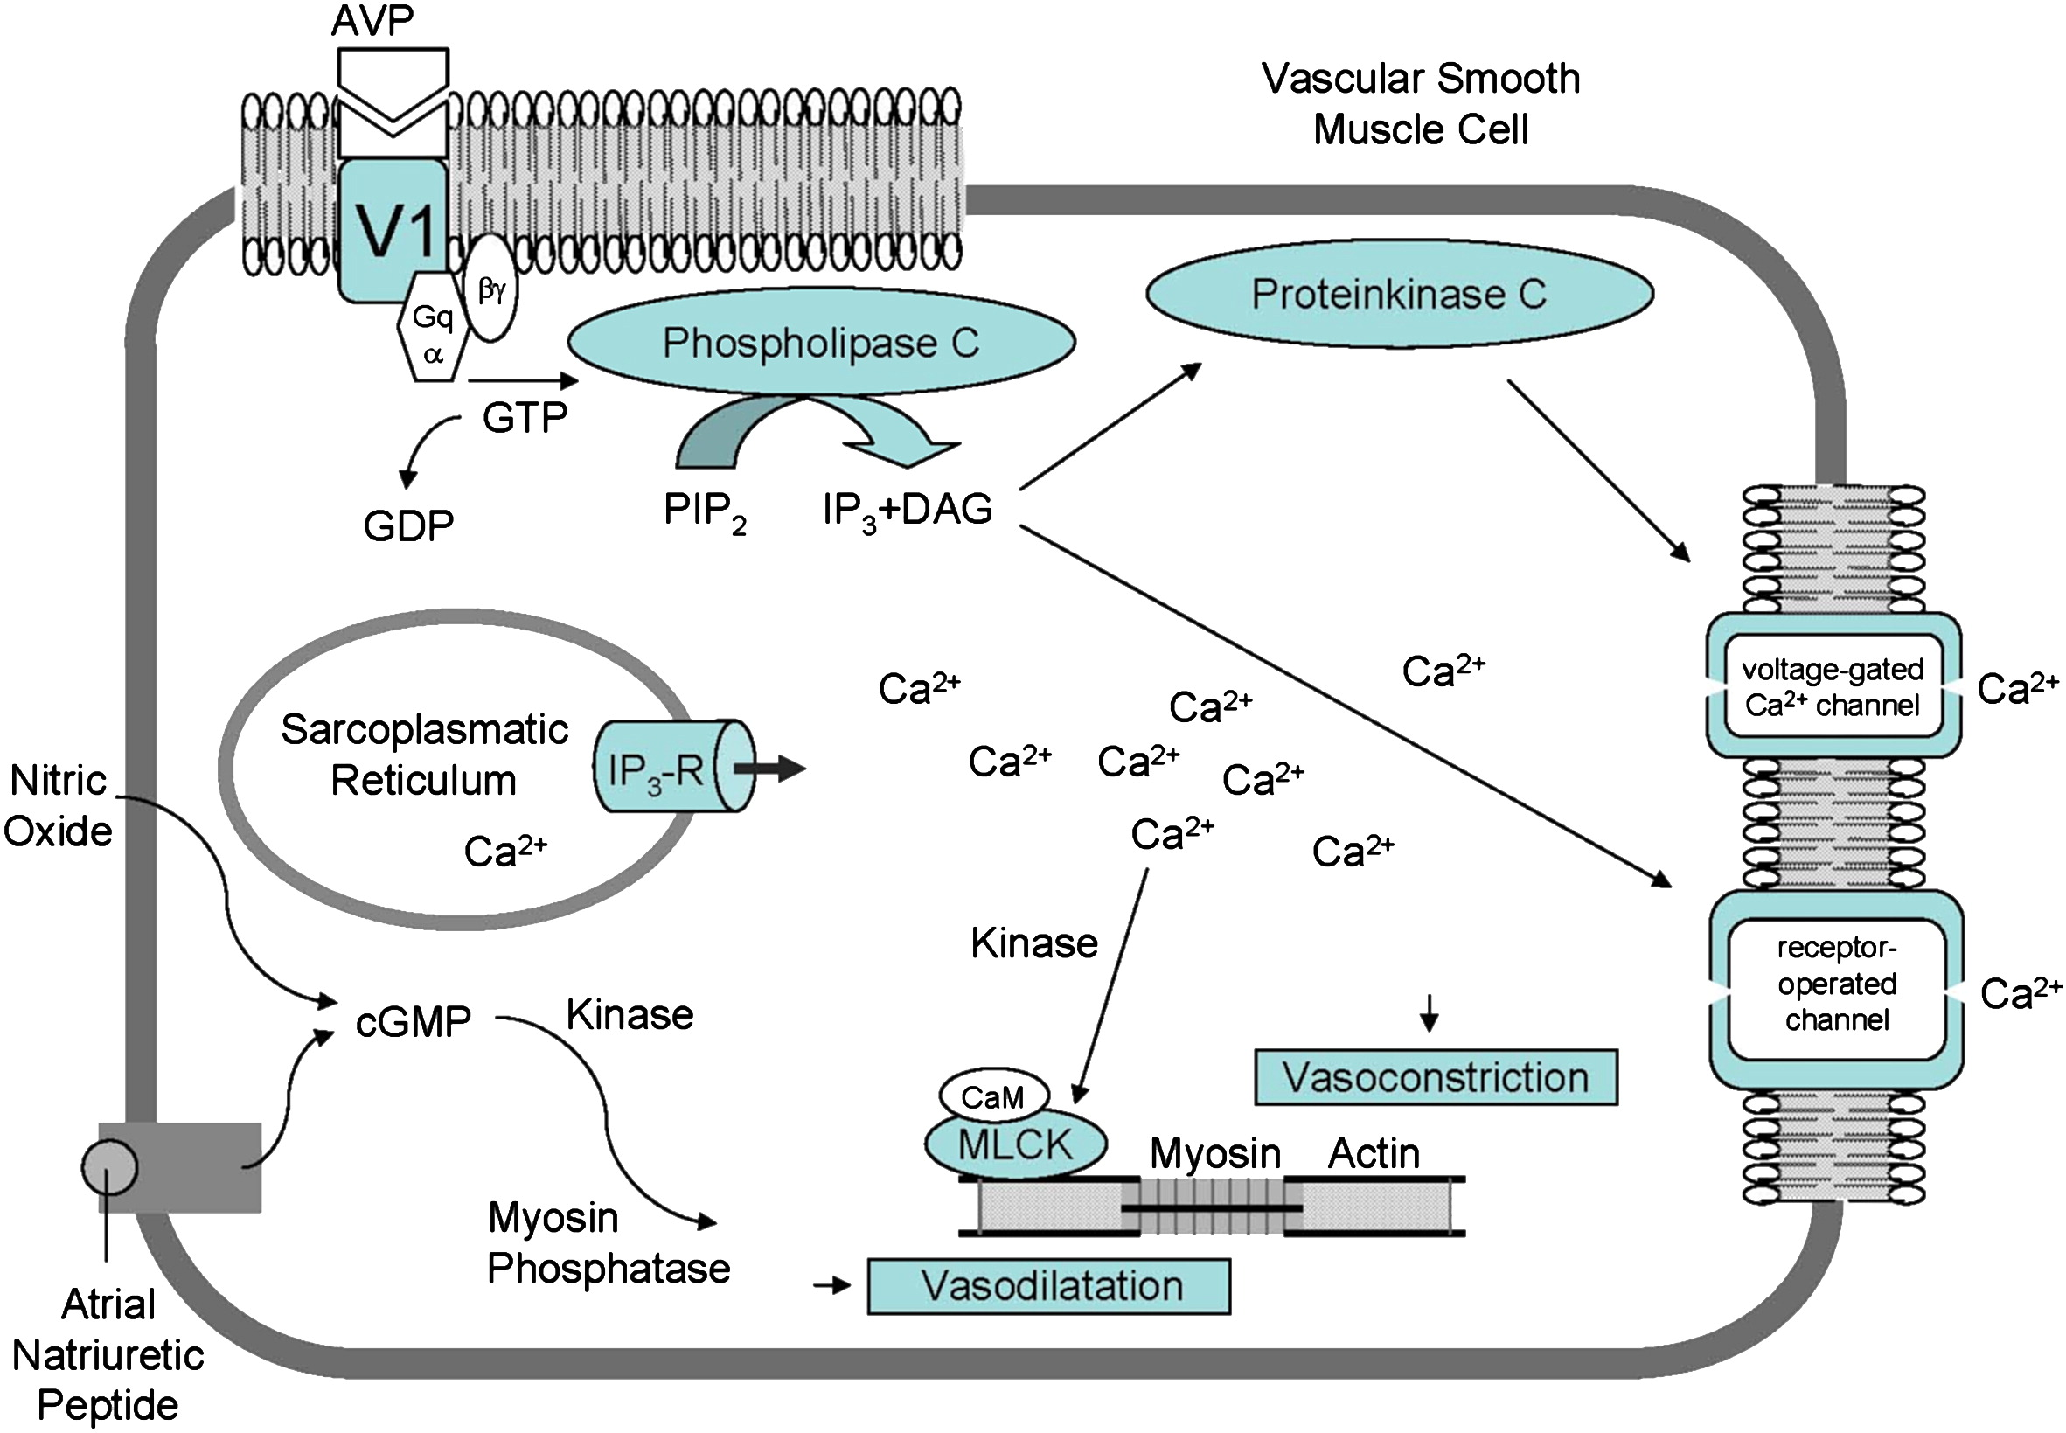
    - V₂: antidiuretic – cAMP dependent receptors on renal collect ducts; also production of FVIII and vWf
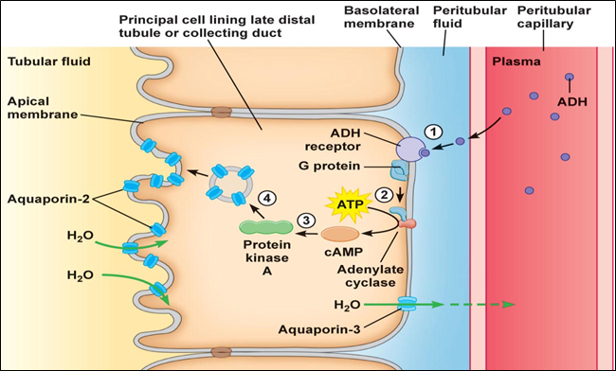
    - V₃ or V_{1B}: nontraditional biologic action of vasopressin to simulate ACTH secretion from anterior pituitary
  - Receptors to sense changes in osmolality
    - In the brain – cells in organum vasculosum of the lamina terminalis and in areas close to anterior hypothalamus (near third ventricle)
      - Fenestrated capillaries – BBB is deficient
      - Influenced by PLASMA osmolality (not that of CSF)
      - RAPID action, fine-tuning (1% change in osmolality can lead to increase or decrease vasopressin secretion) – rapid metabolism of ADH (1/2 life of 15 min) quick adjustment
  - Water conservation in the kidneys
    - LH: generates high osmolality in medulla (countercurrent multiplier); 85-90% of fluid filtered by glomerulus is reabsorbed isomostically with sodium and glucose in proximal portion of nephron – then sodium selectively reabsorbed in LH (without water) hypotonic urine when reaches distal nephron
    - DT: additional 90% of fluid can be reabsorbed under influence of ADH
      - ADH acts to increase water permeability of the collecting duct to allow osmotic equilibration between urine and hypertonic medulla
      - Insertion of aquaporin-2 water channels – transmembrane water movement through those channels (not by diffusion); microtubule dependent insertion of AP-2. Water flow from tubular lumen (hypo) into hypertonic medulla; blood vessels of vasa recta distribute absorbed water into systemic circulation, maintain hypertonicity of medulla (urine becomes more concentrated, less amount of urine)
      - Dissociation of ADH from V2 receptor allows IC cAMP levels to decrease; water channels are reinternalized
      - **No ADH – DT are resistant to diffusion of water AND solutes
      - Amount of water reabsorbed depends on:
        - Plasma ADH concentration
        - Existence of significant OSMOTIC GRADIENT in renal interstitium
          - If has been lost (chronic water diuresis, reduced medullar BF) – not able to reabsorb water
            - (though lot of water can be reabsorbed in distal convoluted tubule and proximal collecting duct, loss of hypertonic medullar concentration gradient alone rarely results in marked PU)
      - Vasopressin does not cause active (energy requiring) reabsorption of solute-free water – its along osmotic gradient
- Actions of ADH
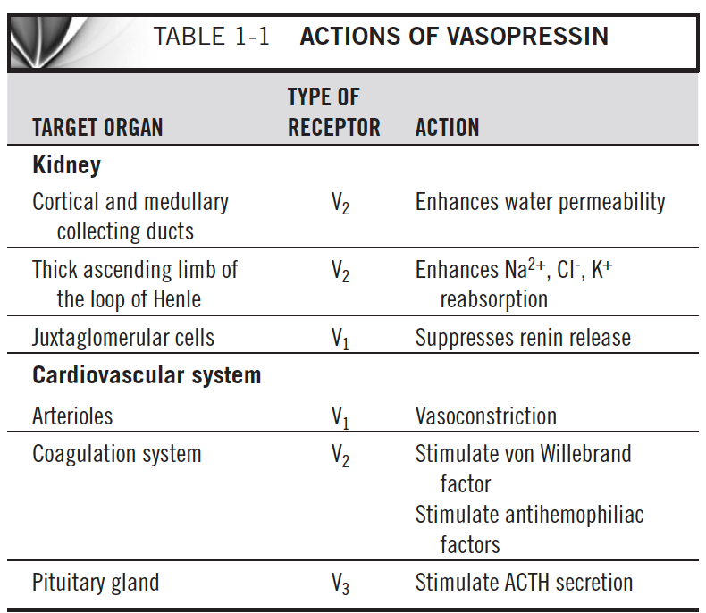
- Thirst
  - Thirst stimulated if increase in ECF osmolality or decrease in IV volume
  - OsmoR in AH and low- and high- baroR mediate thirst
  - ATII may also stimulate thirst (severe hypoV and hypoT)
  - Increase in plasma osmolality of 2-3% necessary to produce thirst sensation (so ADH is better)
- PU/PD
  - Normal water intake: < 80 ml/kg/day (dogs); > 100 = PD (similar for cats)
  - Norma UOP: 20-45 ml/kg/day (1-2 ml/kg/h); > 50 ml/kg/day = PU
  - PD or PU started first?!
  - See p.7
  - Primary PU disorders: primary pituitary and nephrogenic DI, 2nd DI, osmotic diuresis induced PU, interference with ADH secretion
    - Most common form of DI is acquired 2nd NDI – variety of renal and metabolic disorders in which renal tubules lose the ability to respond adequately to AVP (most are reversible)
      - Interference with generation of cAMP, problems with renal tubular cell function, loss of renal medullary concentration gradient
  - Osmotic diuresis
    - DM: when BG exceeds renal tubular capacity for glucose reabsorption glucose in urine increased water loss in urine
    - Primary renal glycosuria: Basenji and Norwegian Elkhound – congenital – tubular disorder – inability to reabsorb glucose from UF – in some patients may be part of Fanconi like syndrome (inadq reabsorption of P, K, uric acid, a.a, Na, and/or bicarbonate)
      - Suspect if: PU/PD, glycosuria, normal BG and fructosamine
    - CKD – decreased # of functional nephrons = compensatory increase in GFR in surviving nephron though amount of fluid presented to distal renal tubules is increased increased tubular flow rates causes less urea, sodium, other substances to be reabsorbed osmotic diuresis further complicated by reduce medullary concentration gradient
    - Postobstructive diuresis
  - Central DI (primary pituitary)
    - Partial or complete lack of ADH
  - Primary NDI
    - Partial or complete lack of RESPONSE to ADH
    - From congenital defect involving cellular mechanisms responsible for opening water channels
  - Acquired (2nd) NDI
    - AVP, AVP receptor sites, postreceptor mechanisms responsible for water absortion are present; though interference between AVP and receptors, disturbance of generation of cAMP, loss of hypertonic medullary gradient…
    - Bacterial endotoxins (pyometra)
      - E.coli
      - Compete with ADH receptors on renal tubular membrane
      - Not only with pyometra – also prostatitis, PN, sepsis
    - Hypercalcemia
      - Downregulation of aquaporin-2 channels and decreased function of ADH by inhibiting binding of ADH to its receptor, damage to ADH receptors, inactivation of AC, decreased transport of Na/Cl into renal medulla
    - Hepatic insufficiency and PSS
      - Loss of medullary hypertonicity due to impaired urea production, altered renal BF, increased GFR and UF volume, hypoK, impaired metabolism of cortisol, primary PD
      - Urea = major constituent in establishment/maintenance of medullar hypertonicity
    - HAC
      - GC inhibits ADH release by direct effect w/in hypothalamus and/or neurohypophysis – characterized by increase in osmotic threshold and decrease in sensitivity of ADH response to increasing osmolality
      - GC increases GFR, PT sodium transport, free water clearance
      - GC causes resistance to effect of ADH through intergerence with ADH action at the renal collecting tubules or direct depression of renal tubular permeability to water
    - Primary hyperaldosteronism
      - Mineralocorticoid-induced renal resistance to action of ADH; disturbed osmoregulation of ADH release
      - Similar to HAC for PU/PD
      - HypoK may downregulation of AP-2 and urea transporters (interference with ability to concentrate urine)
    - Pyelonephritis
    - Hypokalemia
      - Terminal portion of nephron less responsive to ADH by causing downregulation of AP-2
      - Downregulation of urea transporters
      - Interference with solute accumulation and release of ADH from pituitary
      - PU/PD = not common sign of hypoK (more weakness…)
    - HOAC
      - Lack of aldosterone chronic sodium wasting, renal medullary solute washout and loss of its gradient
      - Impairment in the coupling between ADH receptor complex and AC
      - Hypercalcemia may also contribute
    - HyperT4
      - Why?
      - Increased renal medullary BF may decrease hypertonicity
      - Psychogenic PD
      - Concurrent renal disease
    - Acromegaly
      - From hyperglycemia
      - Renal disease from diabetic or GH-induced glomerulonephropathy may also play a role
    - Polycythemia
      - Increase in osmotic threshold for ADH release delayed ADH response to increasing osmolality
        - From increased BV and hyperviscosity? Stimulation of ANP and atrial and carotid baroR
        - ANP inhibits release of ADH and renal responsiveness to ADH
  - Primary and psychogenic PD
    - Not to compensate for excessive fluid loss..
    - People: problem in the thirst center or mental illness
    - Not been reported in cats
    - May be induced by other diseases: hepatic, hyperT4
    - PU to prevent overhydration
  - Iatrogenic (drug-induced) PU/PD
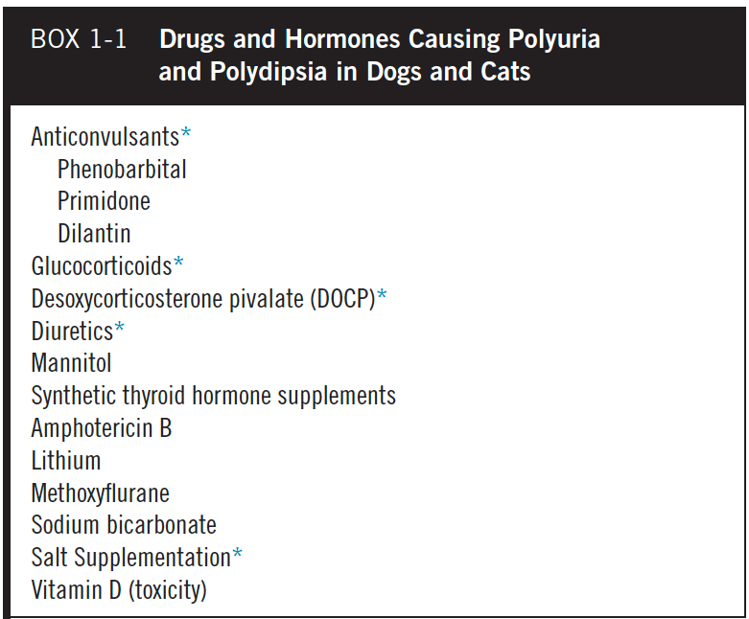
  - Renal medullary washout
    - Mostly sodium and urea loss of hypertonicity impaired ability of nephron to concentrate urine
    - Causes: chronic diuretic therapy, abnormalities in circulation (polycythemia, hyperPT), renal lymphatic obstruction (lymphoS, lymphangiectasia), systemic vasculitis, all previously described causes of PU/PD
- Diagnostic of PU/PD
  - First confirm PU/PD (and not PK)
  - USG – multiple urine samples collected at home (< 1.020)
  - If at least one urine with USG > 1.030 – normal pituitary vasopressin renal tubular cell axis; may still be PU/PD: osmotic diuresis, psycho, disorders in regulation of ADH secretion
  - Most common causes in dogs: HAC, DM, CKD, liver disease, hypercalcemia
  - Most common causes in cats: CKD, DM, hyperT4
  - See p. 11
  - Tests to consider: CBC, chem UA, T4, AUS, dexamethasone screening, UCCR, trial DDAVP, MWDT
  - Neuro signs, sodium at high end of normal, hyposthenuria, rapid onset of dehydration with water restriction – CDI or primary NDI
  - Behavioral signs, sodium at lower end, USG below and above isosthenuric range, relatively prolonged time until dehydration with water restriction – psychogenic PD
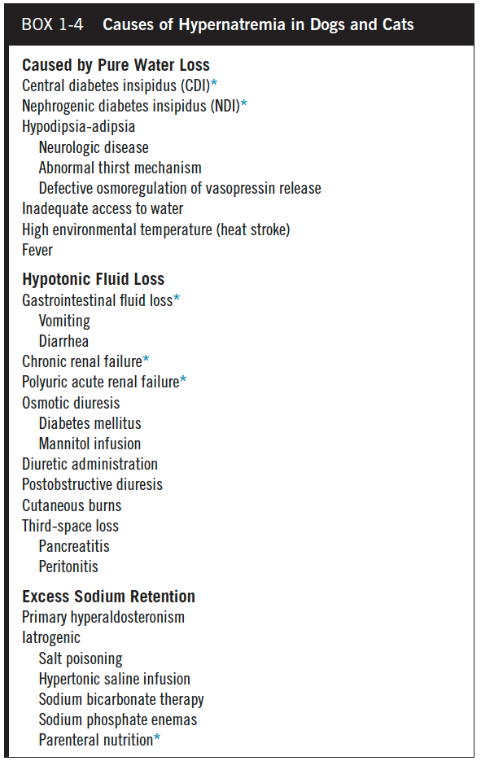
Central Diabetes Insipidus
- Absolute deficiency – hyposthenuria (even with water restriction), severe diuresis
- Partial – hyposthenuria, diuresis as long as unlimited access to water – if restriction: can increase USG into iso range but cant > 1.015-1.020 with severe dehydration
- Destruction of production sites for ADH – supraoptic and paraventricular nuclei of hypothalamus and/or loss of axons that carry ADH to storage and release depots in posterior pituitary
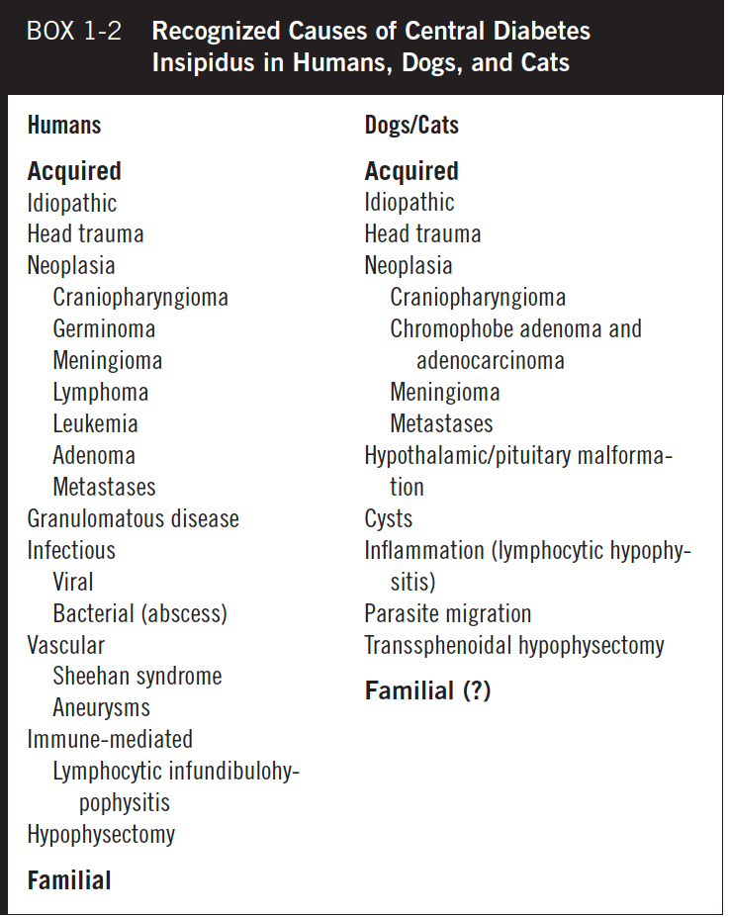
- Idiopathic is the most common
- Polyendocrine autoimmunity?
- Head trauma*, neoplasia, hypothalamic/pituitary malformations (cystic structures)
  - Trauma induced transection of pituitary stalk often results in transient CDI – 1-3 weeks; duration depends on the location of the transection relative to hypothalamus: more proximal = longer (more time for regeneration of axons)
  - Suspect if PU/PD w/in 48h of trauma; or when hypernatremia, hyposthenurica, hypertonic dehydration develops in a patient treated with IVFT
- Transient post hypophysectomy for tx of PDHAC; can be permanent
- 90% of magnocellular cells must be destroyed for symptomatic DI
  - Mass lesion would have to destroy LARGE area of the hypothalamus or be located where the tracks of the nuclei converge at the base of the hypothalamus and the top of the pituitary stalk
- No breed, gender, age predilection for CDI

Primary nephrogenic DI
- Impaired responsiveness of nephrons to actions of AVP
- ADH concentrations normal to increased
- Primary or 2nd (acquired)
- Primary is rare – usually PU/PD starts when 8-12 weeks (may be congenital)
- 2 types of congenital NDI in people
  - Mutations in V₂ receptors
  - Mutations in AP-2 channels
- More than 90% of congenital NDI in people are x-linked recessive; males; V₂ receptors
- Dx: high ADH, hypotonic PU, no response to DDAVP
- Familial NDI in Huskies described – males puppies, normal # of receptors though low affinity for ADH
- If PU/PD occurs later in life – suggestive of acquired NDI
- Rare in dogs and cats; not reported in cats
Primary and psychogenic PD
- Dogs – often hyperactive dogs, placed in exercise-restrictive environments, changes to their routine, unusual stress – sometimes learned behavior to gain attention
- They can concentrate their urine > 1.030 with water restriction
- May have problem with AVP secretion (abnormal response to hypertonic saline infusion)
- Any breed, gender, age; not reported in cats

Diabetes insipidus and Psychogenic polydipsia
- CS
  - PU/PD, sometimes describe as incontinence (because large volume of urine produced…)
  - Sometimes weight loss because they prefer to drink than eat
  - Sometimes neuro signs (CDI from growing mass – A-, stupor, disorientation, pacing, ataxia, seizures, tremors; or 2nd to hypertonic dehydration and hypernatremia)
- PE
  - Usually normal – if access to water euhydrated…
- CBC/chem/UA
  - CBC- normal
  - UA: hyposthenuria; urine osmolality < 300 (isosthenuria does not r/o DI or PP)
  - CHEM: sometimes low BUN (loss through kidneys), prerenal azotemia, hypernatremia (sometimes hypo), hyperK, intact RAAS succeeds in maintaining e- homeostasis
- To confirm DX of DI
  - MWDT, random osmolality determination, response to trial DDAVP
  - CDI, primary NDI, PP are uncommon to rare – partial CDI and PP are the most common
  - Trial tx with desmopressin acetate (DDAVP)
    - Q12h for 7 d (oral tablet or conjunctival drops of nasal spray) –wait 5-7 d to evaluate response due to medullary washout – improvement in USG by 50% or more – minimal improvement if primary NDI (though could respond with very high dose of DDAVP) – dogs with PP: mild decline in UOP and eater intake
  - MWDT – see p. 17-24
    - !!! Can develop severe hypertonic dehydration and hypernatremia
    - Normal (will dehydrate quite slowly) or PP: concentrate urine to > 1.030 (1.035 in cats) if dehydrated- DDAVP injection – less than 10% change in urine osmolality (because AVP already maximal response)
    - Partial or complete CDI and primary NDI: impaired ability to concentrate urine/increase urine osmolality in face of dehydration – then you do phase II = trial with DDAVP
      - Complete CDI – cannot concentrate urine to levels greater than 280-310 even when dehydrated +++ with MWDT
        - If DDAVP injected: increase in osmolality from 50% to 600% greater than baseline!
      - Partial CDI – can increase urine osmolality to above 300 with dehydration but they also experience a further 10-50% increase in urine osmolality following DDAVP injection (takes longer to dehydrate than dogs with complete CDI)
      - Primary NDI – cannot increase urine osmolality to levels greater than 280-300; NO response to DDAVP; dehydrate quickly with no water
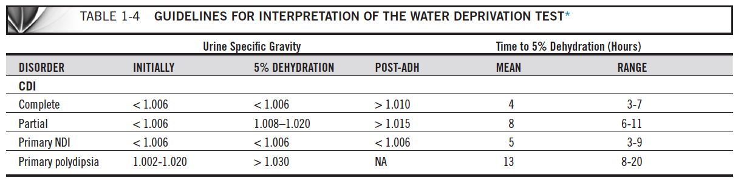

- Water in the body
  - 60% of body weight
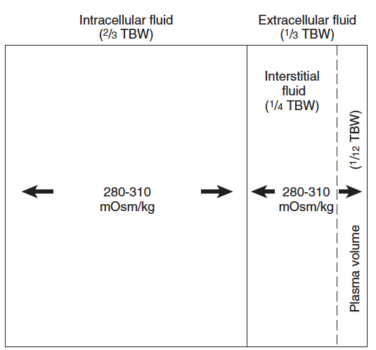
  - Solutes that are less permeable across cell membranes by virtue of size, electrical charge, active membrane pumps effective osmotic force
- Types of dehydration
  - Isotonic –proportional loss of water and electrolytes
    - Vomiting and diarrhea
    - Lost of ECF
    - Sodium generally normal
    - 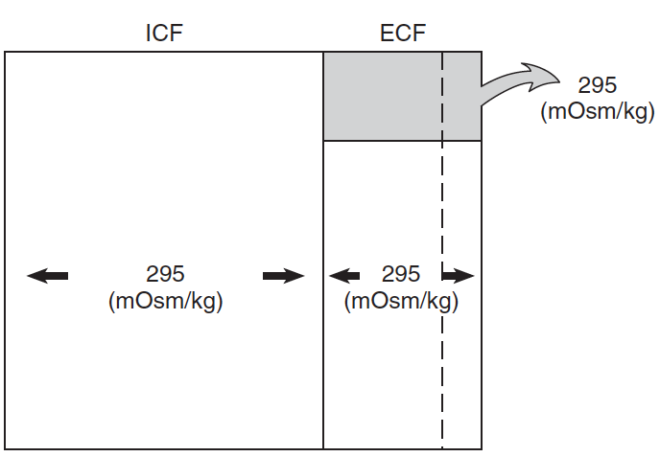
  - Hypotonic
    - Loss of e- in excess of water (hyperosmotic losses)
    - HOAC
    - ECF loses water to environment but also to ICF
    - Generally more hypovolemic
    - Low sodium
    - 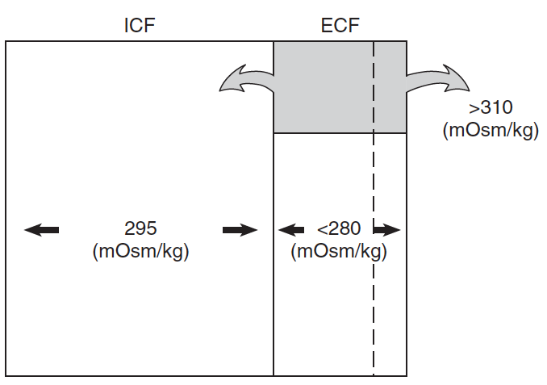
  - Hypertonic
    - Hypotonic losses – no access to water in CDI, NDI, PP
    - Minimal loss of fluid from IVS because lost in proportion to their water content – dehydration of IC +++ (because 2/3 of water is there)
    - Severe hypernatremia
    - Less signs of hypovolemia and dehydration; hyposthenuria
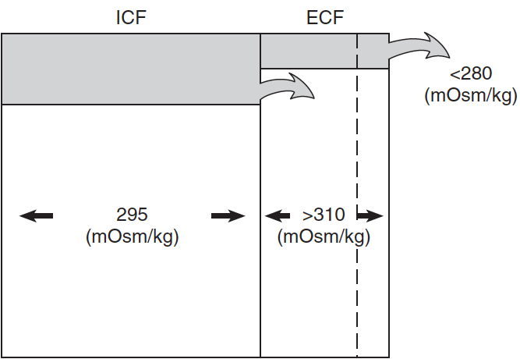
    - More signs of CNS dysfunction - irritability, weakness, ataxia, stupor, coma, seizures (depending on onset, degree, duration)
    - Sodium has limited access to brain cells and is slow to equilibrate with CSF – rapidly developing hypernatremia results in a shift of water from IC to EC spaces shrinkage of the brain (tearing of veins, subdural hemorrhage, venous thrombosis)
    - Brain synthesizes IC cerebral osmolar active subtances – produced w/in 1 hour after induction of persistent hyperosmolality of ECF
    - Goal of tx is to replete ECF volume and to correct water deficits at a fluid rate that avoids complications – rapid repletion of water with ECF dilution causes translocation of water into cells, causing cerebral edema, due to the presence of idiogenic osmoles. If slower repletion is undertaken, cells lose the accumulated IC solutes and osmotic equilibration can occur w/out cell swelling
    - Initial priority is to restore ECF volume to normal – choice of fluid depends on whether circulatory collapse is present, the rate at which hypernatremia developed, and the magnitude of hypernatremia
      - With modest volume contraction (tachyC, dry MM, slow skin turgor) – consider NS (CI to bolus unless significant signs of hypovolemia)
      - Fluid deficit: [(current Na /normal Na) -1] x0.6 x BW
      - Do not change sodium by more than 1 mEq/L/h
- Plasma vasopressin determinations
  - Patients should severe or partial CDI should have AVP deficiencies
  - Patients with primary NDI or PP should have normal or excessive AVP in the face of dehydration
- Random plasma osmolality as a diagnostic tool
  - When unrestricted access to water
  - Normal is 280-300
  - The stimulation for water intake in CDI and NDI is loss of free water through the kidneys decreased BV and increased serum osmolality thirst!
    - Patients should have high normal or increased plasma osmolality
  - Dogs with PP drink water w/out needing it, they urinate because they drink too much; uncontrollable water intake raises blood volume and decreases plasma osmolality decreased AVP and decreased renal medullary concentration gradient urine +++
    - Low end of normal or low plasma osmolality
- CT/MRI
  - On T1 – bright spot in the sella caused by stored hormones in the neurosecretory granules in posterior pituitary
    - 80% of normal people have this spoit – absent in CDI (though not always absent)
    - Also seen in dogs

TX for CDI (complete or partial) - DDAVP
- Synthetic analogue of vasopressin – DDAVP
  - 3x antidiuretic action of AVP
  - Minimal to no vasopressor or oxytocic activity
  - Also: release of FVIII, vWF; decrease in blood pressure and peripheral resistance; increase in plasma renin activity
  - Intranasal DDAVP give as conjunctival drops (rare ocular irritation); 1-2 drops q12-24h; or tablets q8h-12h; or SC (more risk of develop hyponatremia with parenteral admx)
  - In people with CDI, a decrease in urine volume usually occurs w/in 2 hours after admx of DDAVP – regardless of route of admx – total duration of action 6-18h
  - HAC is primary DDX when PU/PD recur despite DDAVP tx in a dog with (presumptive) CDI
  - Not for NDI
- Chlorpropamide
  - Oral sulfonylurea drug used for tx of hyperglycemia in people
  - rise in urine osmolality, correction of dehydration, reduction in fluid consumption similar to what observed with small doses vasopressin
  - MOA - ? May enhance AVP stimulation of renal medullary cAMP by augmenting AC sensitivity to AVP; by inhibiting phosphodiesterase, inhibition of PGE₂ synthesis (which is an antagonist of AVP), augmentation of AVP dependent NaCl absorption by the thick LH increased driving force for water absorption in collecting ducts
  - Not for NDI
- Thiazide diuretics
  - NDI and CDI
  - Inhibition of sodium reabsorption in distal convoluted tubules reduction of total body sodium concentration contraction of ECF volume and increased salt and water reabsorption in the PT lower sodium concentrations in the distal renal tubule and less osmotic effect to maintain tubular volume reduction of urine volume
    - Slight rise in urine osmolality and proportionate reduction in urine volume
    - Possible hypokalemia
    - Depending on sodium intake, PU can be reduced by 30-50% in people with NDI or CDI
- Salt restriction
  - Reduction in UOP by increasing volume of filtrate absorbed isosmotically in the proximal nephron
  - CDI or NDI
- No treatment
  - As long as they have enough water
  - Careful!! Dehydration (and hypernatremia) can occur quickly!!!! Illnesses causing vomiting and diarrhea or reducing water intake can be very dangerous
- Behavior medication – PP
Prognosis
- Dogs with idiopathic or congenital CDI usually become aSC with adq Tx and proper care = normal life expectancy
- Growing mass - grave; RT, chemo… usually PU/PD persist despite RT because CS of CDI do not develop until 90% of the magnocellular neurons are destroyed
- Primary NDI = guarded to poor because of limited therapeutic options, poor response to tx, risk for developing severe dehydration and hypernatremia
- 2nd NDI = depends on underlying cause
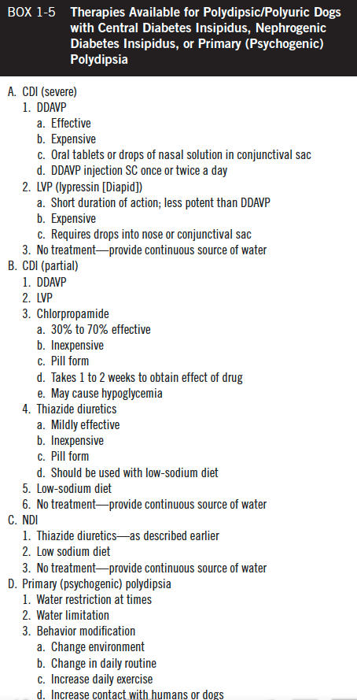

Questions
- Vasopressin is the main hormone for the regulation of water homeostasis and ______.
RAAS is mainly responsible for the regulation of ________.

- What happens when vasopressin binds to its V₂ receptors? Where are those receptors?

- You suspect your patient to have CDI – what would be the expected response to mild dehydration? To administration of DDAVP?

- Which of the following is most likely to cause severe hypovolemia?
  - Hypotonic dehydration
  - Hypertonic dehydration
  - Isotonic dehydration
  - Oncotic dehydration

- Explained how thiazide diuretic could help in the treatment of DI

Questions & Answers
- Vasopressin is the main hormone for the regulation of water homeostasis and osmolality.
RAAS is mainly responsible for the regulation of blood pressure and IV volume.

- What happens when vasopressin binds to its V₂ receptors? Where are those receptors?
V2 receptors are located in the membrane of cells of distal convoluted tubules and collecting ducts (principal cells – basolateral). Vasopressin binds to V2 activation of protein Gs activation of AC augmentation of cAMP activation of PKA insertion of AP-2 water channels on apical surface absorption of water from luminal tubule (hypotonic) – water can exist cells through constitutive AP-3 and AP-4

- You suspect your patient to have CDI – what would be the expected response to mild dehydration? To administration of DDAVP?
Dehydrate quickly – no change in urine osmolality (if partial very mild increase)
Increase in urine osmolality with DDAVP

- Which of the following is most likely to cause severe hypovolemia?
  - Hypotonic dehydration
  - Hypertonic dehydration
  - Isotonic dehydration
  - Oncotic dehydration

- Explained how thiazide diuretic could help in the treatment of DI
Decreased reabsorption of sodium at DCT (Na+/Cl- cotransporters) volume contraction increased reabsorption of Na+ at PT lower sodium concentrations in the distal renal tubule and less osmotic effect to maintain tubular volume reduction of urine volume

