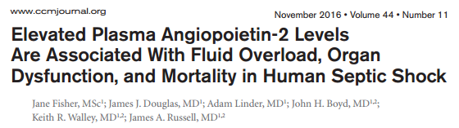
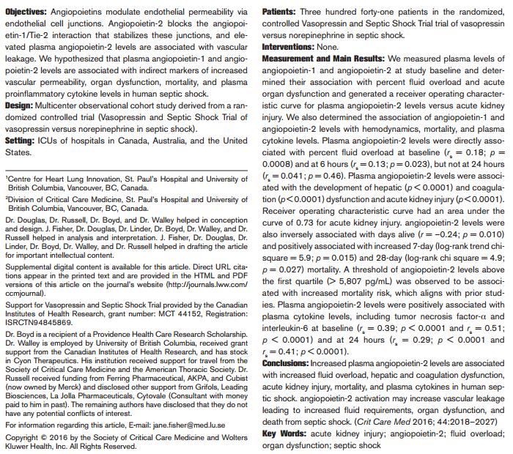
- Angiopoietins (Ang) are secreted endothelial growth factors that bind to Tie-2 receptors to control endothelial permeability and to regulate angiogenesis
- The actions of angiopoietin Ang-1 and Ang-2 oppose each other
- Ang-1 (produced primarily by pericytes) protects against vascular leakage by constitutively maintaining interendothelial junctions and has anti-inflammatory properties Ang-2 (stored in Weibel-Palade bodies of endothelial cells with vWF, tissue-type plasminogen activator, and P-selectin) increases vascular leakage by competing with Ang-1 for binding to Tie-2 by inhibiting autophosphorylation
- If Tie-2 is deficient, then Ang-2 binds to integrins that regulate angiogenesis, vascular permeability, and levels of multiple cytokines, indirectly modulating vascular permeability and leakage
- Ang-2
  - Elevated levels direct correlation with increased vascular permeability
  - Associated with severity, development of shock, and mortality in sepsis
  - Elevated levels predict development of ALI
- Percent FO (%FO) is used commonly in the renal replacement therapy literature to define and compare efficacy of various dialysis regimens, %FO is an indirect marker of vascular leakage
  - %FO = (fluid intake – output)/body weight × 100

Hypothesis: plasma Ang-1 and Ang-2 levels are associated with indirect markers of increased vascular permeability, organ dysfunction, mortality, and plasma proinflammatory cytokine levels in human septic shock.
Population: post hoc analysis of the Vasopressin and Septic Shock Trial (VASST – norepi vs vasopress), age over 16 years and presence of septic shock, plasma taken at admission
Methods: Ang-1 and Ang-2 Enzyme-Linked Immunosorbent Assay and plasma cytokines
Results:
- Ang-2 correlated directly with %FO at baseline, 6 hours, but not at 24hr
- Ang-2 was higher in patients that developed hepatic dysfunction within 28 days
- Ang-2 was higher in patients that developed coagulopathy within 28 days
- Ang-2 was negatively correlated with platelet count on days 1-5
- Ang-2 was NOT associated with development of ARDS and CNS dysfunction
- Higher Ang-2 was associated with increased severity of AKI
- Ang-2 was directly and significantly associated with arterial lactate
- Ang-2 positively correlated with CVP
- Ang-2 significantly associated with 7-day mortality (> 5,807 pg/mL)
- Ang-2 positively correlated with most proinflammatory cytokines

Take Home Message:
- Increased Ang-2 is associated with vascular permeability and leakage
- Increased leakage leads to organ dysfunction (hepatic dysfunction, coagulopathy, AKI)
- Ang-2 antagonism could be beneficial in sepsis – still in investigation

