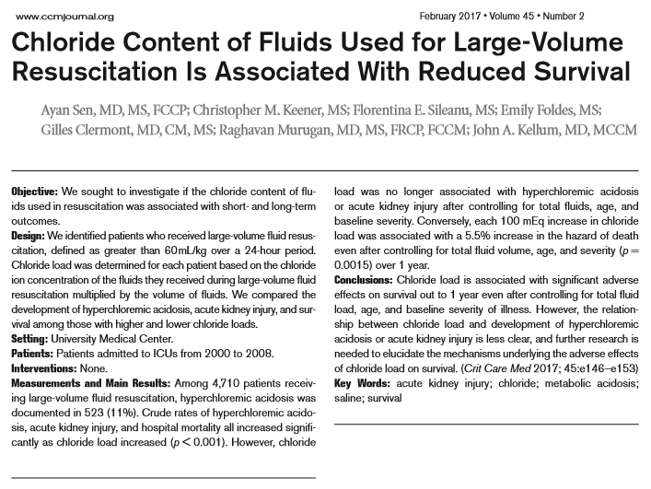
- Use of crystalloids containing supraphysiologic chloride concentrations has been associated with hyperchloremia, acidosis, and more frequent complications when compared to resuscitation with balanced crystalloids
- Hyperchloremia independently associated with increased mortality in ICU and post-surgical patients
- Cl restriction was associated with a significant reduction in the occurrence of AKI and the use of renal replacement therapy

- Large volume resuscitation defined as 60 mL/kg in 24hr, kidney disease patients were excluded

- Total Cl load was determined for each patient as follows: (C1 xV1) + (C2 xV2) + (C3xV3) + (CnxVn) = Cl load (mEq), where Cn indicates chloride concentration (mEq) per liter of fluid n, and Vn is the volume of that fluid administered in the 24 hours beginning with the start of LVR. For example, if a patient received 3 L of 0.9% saline and 2 L of lactated Ringer’s solution, total chloride load would be (154 × 3 = 462) + (109 × 2 = 218) = 680 mEq

- Each 100 mEq increase in Cl load was associated with 5.5% increase in mortality over 1 year

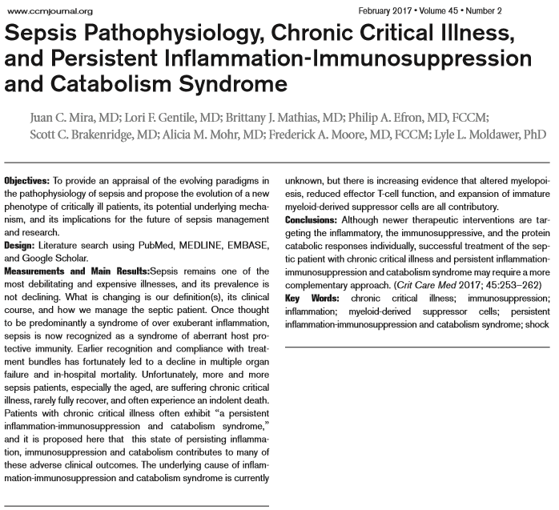
- Chronic critical illness (CCI): patients remaining in the ICU > 8 days suffering from one or more of five eligible conditions (prolonged mechanical ventilation [> 96 continuous hours], tracheostomy, sepsis/severe infections, severe wounds, and multiple organ dysfunction)

- Persistent inflammation-immunosuppression and catabolism syndrome (PICS): ongoing inflammation, manageable organ failure, ongoing protein catabolism, and poor nutrition, leading to cachexia, poor wound healing, and immunosuppression with increased susceptibility to secondary infections
  - explains the immunologic dyscrasia that now defines sepsis and pervades CCI
  - granulocytes in the bone marrow rapidly demarginate and follow chemokine gradients to the site of infection/injury creating niches in the bone marrow for the expansion of hematopoietic stem cells (HSCs)
  - HSCs preferentially differentiate down myeloid pathways toward mature granulocytes, macrophages, and dendritic cells > Emergency granulopoiesis/myelopoiesis
  - this process occurs at the expense of both lymphopoiesis and erythropoiesis that are suppressed
  - these immature myeloid cells are predominantly granulocytic, have profound suppressive properties, and at the transcriptional level, are proinflammatory and poor antigen presenters
  - patients who had the greatest elevation in MDSCs had either early mortality or prolonged hospitalizations; rapid resolution of MDSC numbers was associated with early discharge from the ICU

- Anergy, reductions in absolute lymphocyte counts, and reactivation of latent viral infections
are all indicative of this suppressed protective immunity. With this suppression of protective immunity and protein malnutrition, changes in the microbiota and increased loss of barrier
functions, increased incidence of nosocomial infections, and reactivation of latent viral and bacterial infections all lead to reinfection and frequently readmission

- Pharmacologic interventions meant to interrupt the cycle of inflammation, immunosuppression, and protein catabolism leading to reinfection, induced frailty, and indolent outcomes become critically important

