Calcium channel blocker toxicity in dogs and cats – VCNA
Calcium channel blocker toxicity – JVECC
Key Points
- 3 main classes of CCBs
  - Dihydropyridines – amlodipine: marked effects on vasculature; hypotension
  - Phenylalkylamines – verapamil : marked effects on nodal conduction and myocardial contractility – bradycardia, arrhythmias
  - Benzothiazepines – diltiazem: marked effects on nodal conduction and myocardiac contractility – bradycardia, arrhythmias
- Pharmacology
  - Good oral absorption
  - Reduced bioavailability due to first-pass effect
  - Metabolism liver, elimination kidneys
  - Highly PT-bound
  - Immediate release and extended release formulations
- CCBs only affect L-type calcium channels
  - Important for depolarization of SAN and AVN and maintenance of AP in Purkinje cells and cardiomyocytes
  - Also L-type calcium channels in pancreatic beta cells CCBs can cause hyperglycemia
- Clinical signs: bradycardia, bradyarrhythmias (AVB, junctional escape rhythms, AIVR, asystole), hypotension, reflex tachycardia, pulmonary edema
- Treatment:
  - Decontamination – emesis, activated charcoal, gastric lavage, ILE
  - No antidote
    - Calcium
    - Insulin + dextrose
    - Glucagon
    - ILE
    - Temporary cardiac pacemaker
    - Calcium channel agonists

- CCBs block the slow (long-lasting – L-type) calcium channel
- This channel is found primarily in atria, blood vessels, skeletal muscles
- Use in vet med: hypertension, HCM, arrhythmias, AKI (? – inhibition of cytosolic and MT accumulation of calcium; prevention of free radicals production associated with accumulation of calcium; inhibition of vasoC mediated by endothelin better blood flow; in a study evaluating diltiazem in dogs with AKI 2nd to leptospirosis: the rate of reduction in creatinine in the diltiazem group was 1.76 times faster than the standard group)
- Normal role of calcium
  - Critical role in SAN & AVN conduction and electrical depolarization; contraction of cardiomyocytes and vascular smooth muscle
  - Different types of calcium channels
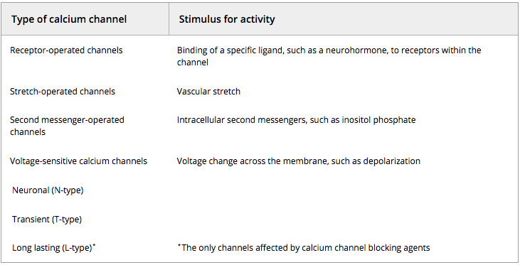
    - L-type: heart, vessels, skeletal muscle > pancreas, lung, brain, other
    - T-type: cardiac nodal and conducting cells, sm, sk, neurons
    - P-type, Q-type, R-type: Purkinje cells of cerebellum and cerebellar granule cells
    - N-type: neurons
    - L-type are the ONLY channels affected by CCBs
  - In the normal physiologic state, there is a large concentration gradient of calcium across the cellular membrane (high extracellular)
    - Calcium is unable to diffuse freely across the cellular membrane
    - The large gradient is maintained by limiting calcium influx into cell through specific calcium channels, sequestration of IC calcium in the SR of myocytes, maintaining an ATP-driven calcium export pump

  - Calcium channels in the SAN, AVN, conduction pathway and cardiomyocytes
    - Calcium is important for depolarization (phase 4)
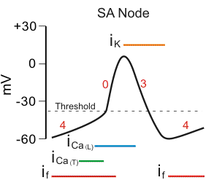
    - Propagation of electrical impulse trough the AVN, Purkinje fibers, cardiac myocytes is also maintained by the influx through L-type channels, which open during phase 2 (N.B.: W/in Purkinje fibers and cardiomyocytes, the depolarization is dependent upon sodium, but the maintenance of the AP is provided by opening of L-type channels)
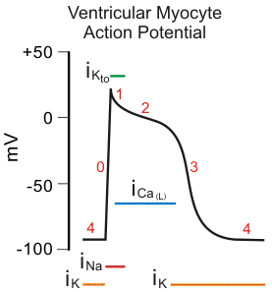
    - Presence of small amount of calcium in the cytosol triggers the release of much larger quantity of calcium from SR = calcium-induced calcium release (CICR)
    - Calcium binds to troponin-C conformation change in troponin-tropomyosin complex actin is exposed allowing acting-myosin binding = contraction of myocyte; in sm calcium binds to calmodulin (not troponin-C) phosphorylation of myosin allowing actin-myosin interaction

    - Therefore
      - CCBs prevent influx of calcium into nodal and myocardial cells, resulting in a slower sinus rate in SAN and reduced AV conduction
      - CCBs prevent calcium influx into cardiomyocytes and vascular sm, resulting in reduced cytosolic calcium and reduced CICR from SR, leadint to reduced cardiac inotropy and vascular tone
        - Vascular beds with low resting tone – GI, venous sm: little vasoD
        - Vascular beds with high resting tone – coronary, arterial sm: bigger vasoD
  - Also some systemic effects
    - L-type channels influence insulin release from pancreatic beta cells
      - CCBs reduced insulin release hyperglycemia
    - Cellular level: calcium influx through L-type channels increased MT uptake of calcium affecting IC ATP levels; lower MT calcium levels (as seen with CCBs) reduced pyruvate dehydrogenase activity lactate accumulation
    - Platelet: aggregation may also be inhibited to some extent with CCBs
    - Endothelin-mediated vasoC is also dependent on L-type calcium channels
- Pharmacology
  - 5 classes – only 3 on the market (no access to diarylaminopropylamine – L-type and T-type blockers, and diphenylpiperazine)
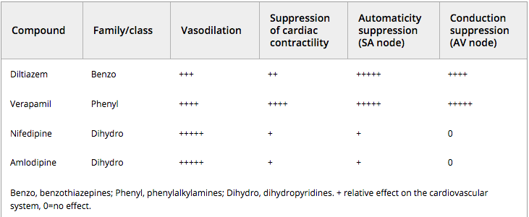
  - Dihydropyridine class: marked effect on vasculature, little to no effect on contractility and conductance
  - Phenylalkylamine and benzothiazepine classes: more pronounced effect on nodal conduction and myocardial contractility
  - Phenylalkylamine – verapamil
    - Non-specific L-type CCB (non specific meaning effect on both vascular and cardiac tissue vasoD, I-, SA and AV node suppression)
    - Rapid absorption
    - Low bioavailability – first pass metabolism
    - Norverapamil = major metabolite (with 20% potency of that of verapamil)
    - Metabolism: liver
    - Excretion: mostly bile in dogs (vs kidney in people)
    - Immediate release and extended release
  - Benzothiazepines - diltiazem
    - Compared to verapamil: a bit less vasoD, a bit less I-, a bit less AV node suppression (same SA node suppression)
    - Immediate release or extended release
    - Low bioavailability – high first pass effect (in cats bioavailability is higher)
    - Widely distributed through most tissues (including milk and placenta)
    - Deacetyldiltiazem = major active metabolite (25-50% potency as coronary vasoD)
    - Enterohepatic recirculation
    - Elimination of diltiazem in dogs and people = blood flow dependent (in cats suggested to be independent of blood flow)
      - The two major organs responsible for clearance are the liver and kidneys. Once a drug is metabolized, it is irreversibly eliminated from the body. Its metabolites, however, must be excreted (usually by the kidneys). Hepatic clearance is defined as the volume of plasma totally cleared per unit time as blood passes through the liver. The rate of hepatic clearance depends on drug delivery to the liver, ie, blood flow (Q) and the extraction (E) ratio of the drug, or fraction of the drug removed as it passes through the liver. Extraction, in turn, is determined by the intrinsic clearance (metabolic capacity) of the liver. Drugs cleared by the liver fall into two major categories. "Flow-limited" drugs are extracted so rapidly that Q becomes the limiting factor of hepatic clearance. Binding to plasma proteins will not influence clearance of such drugs. In contrast, the rate-limiting step of "capacity-limited" drugs is intrinsic clearance, ie, the metabolic capacity of the liver. For such drugs, binding to serum proteins will decrease the rate of clearance.
    - Eliminated in feces (in people 1/3 in urine)
  - Dihydropyridines
    - Marked effects on vascular sm; little effect on contractility or conduction
    - Highly PT-bound
    - Metabolism in liver
    - Eliminated through kidneys
    - High bioavailability – amlodipine
So in general….
- CCBs are well absorbed orally, but the absorption can be delayed in sustained release formulations.
- Extensive hepatic metabolism and first pass clearance
- Extensively protein-bound

- CCB toxicity – clinical signs
  - Toxicity has been noted at therapeutic doses
  - While the various CCBs have distinct differences in their specificity for either vascular sm or heart – in overdoses the tissue specificity may be lost
  - Bradycardia
  - Bradyarrhythmias – (1st, 2nd, 3rd degree heart block, QT interval prolongation, junctional rhythmas) – from slow conduction
  - Hypotension – from vasoD and I-
  - Sinus tachycardia – from carotid sinus reflex stimulation
  - Diltiazem and verapamil: mostly bradycardia, arrhythmias, hypotension
  - Amlodipine: hypotension – and 2ndary sinus tachycardia
  - Other signs: digestive upset, hypothermia (hypotension), CNS depression (hypotension, brady), NCPE, hyperglycemia, hypokalemia, metabolic acidosis (low perfusion), rarely seizures, tremors
  - Pulmonary edema – mechanism? Secondary to aggressive fluid therapy (for hypotension), increased permeability, drug-induced changes to alveolar membrane permeability (changes of cell shape, mediated by PGE₂ or PGF₂), selective precapillary vasoD, neurogenic pulmonary edema (massive sympathetic discharge 2nd to bradycardia and hypotension)
- Diagnosis
  - History
  - CS – hypotension, bradycardia, tachycardia
    - DDX: digoxin, cardiac glycoside plants, beta-blockers, alpha₂- agonists, OPP, type Ia antiarrhythmics, bufadienolides, non toxic causes: MI, other cardiac diseases
  - Drug level – do not necessarily correspond with severity of CS – high performance liquid chromatography

- Tx
  - No specific antidote
  - Decontamination – less than 2 hours for emesis, activated charcoal (+/- repeating), warm water enema (ER formulation)
  - Hemodialysis is NOT expected to be of benefit – highly PT
  - Monitoring: ECG, BP, respiratory system, CNS, BG, acid-base, e-
  - IVFT as needed (careful pulmonary edema)
  - Calcium
    - Increased EC calcium available to cells may increase IC calcium influx
    - May also increase calcium release from SR
    - Adverse effects: hypercalcemia, necrosis if extravasation
    - Bolus or CRI (monitor HR and ECG)
  - Glucagon
    - Cardiac inotrope and chronotrope
    - Simulation of hepatic glycogenolysis increased BG
    - Acts on cardiac G-protein coupled receptors increase in cAMP increased myocardial calcium influx improved contractility and impulse generation correction of hypotension and/or bradycardia
    - Transient effect?
    - $
    - Bolus than CRI
  - Sympathomimetics
    - No one agent has been proved to be consistently effective
    - Dopamine, dobutamine, isoproterenol, epinephrine, phenylephrine
  - Insulin-dextrose
    - In cardiac myocytes stressed from hypoperfusion, there is a shift from F.F.A to glucose utilization for energy; hypoinsulinemia and insulin resistance reduced glucose utilization combined with increased need I-
    - High-dose insulin + dextrose = to maintain euglycemia
      - Enhances glucose uptake by myocytes
      - Suppresses PDE III more cAMP more calcium influx
      - Enhances IC potassium influx hypokalemia prolongation of phase 2 more time for IC calcium influx
      - Decreases capillary vascular resistance through increase NO synthase activity reduced acidosis
    - Ideal dose?
    - Regular insulin boluses vs CRI
    - Monitor BG, potassium
  - Lipid emulsion
    - Lipid sink
    - Increased availability of F.F.A may prevent the myocardium from switching to glucose as its preferred substrate for energy
    - Long chain F.A may also activate myocyte calcium channels increased calcium influx
    - May also increase NO and beta-ketoacids stimulation of insulin release
  - Miscellaneous
    - Temporary pacemaker
      - No effects on vascular tone, no effect on contractility
    - Calcium channel agonists
      - 4-aminopyridine – also potassium channel blocker
        - Blockade of potassium channels increased IC calcium influx
        - At high doses can increase contractility
        - Seizures…
        - Experimental tx only

Questions

- Complete the following chart referable to calcium channel blockers (CCB): (For expected cardiovascular effects, use the following: 0, 1+, 2+, 3+, 4+, 5+)

Compound | Family/Class | Vasodilation | Suppression of cardiac contractility | SA Nodal Suppression | AV Nodal Suppression
Diltiazem
Amlodipine

- Explain possible mechanisms for the development of pulmonary edema following CCB toxicity

- List clinical signs associated with CCB overdose (other than bradycardia and hypotension)

- Name possible treatments for CCB intoxication

- True or False – CCB intoxication can be successfully treated with hemodialysis

Questions & Answers

- Complete the following chart referable to calcium channel blockers (CCB):
(For expected cardiovascular effects, use the following: 0, 1+, 2+, 3+, 4+, 5+)
Compound | Family/Class | Vasodilation | Suppression of cardiac contractility | SA Nodal Suppression | AV Nodal Suppression
Diltiazem | Benzothiazepine | 3+ | 2+ | 5+ | 4+
Verapamil | Phenylalkylamine | 4+ | 4+ | 5+ | 5+
Amlodipine | Dihydropyridine | 5+ | 1+ | 1+ | 0

- Explain possible mechanisms for the development of pulmonary edema following CCB toxicity
  - Severe bradycardia and hypotension massive sympathetic discharge leading to formation of neurogenic pulmonary edema
  - Selective precapilly vasodilation from the CCB combined with excessive IVFT in an attempt to treat hypotension increased hydrostatic pressure and pulmonary edema
  - Direct effect of drugs on alveolar permeability increased permeability

- List clinical signs associated with CCB overdose (other than bradycardia and hypotension)
  - Bradyarrhythmias – AVB, AV dissociation, junctional escape rhythmas, asystole, AIVR
  - GI upset
  - CNS depression, or tremors and agitation, seizures
  - Hyperglycemia
  - Hypothermia
  - Hypokalemia

- Name possible treatments for CCB intoxication
  - Glucagon
  - Calcium
  - ILE
  - Insulin+ dextrose
  - Calcium channel agonists
  - Sympathomimetics

- True or False – CCB intoxication can be successfully treated with hemodialysis
False – highly protein-bound and large volume of distribution

